

**Software Process, SOEN 341/4 S, Winter 2016**

Dr. Shang

Dr. Fancott

Mr. Morse

**TimeTurner** by team YAWD



**Project Scope and Plan Document – Deliverable 1**

|  |  |
| --- | --- |
| **Team members information** | |
| **Name** | **SID** |
| **Daniel Di Corpo** | **26331602** |
| **Dimitri Topaloglou** | **29358269** |
| **Claudia Della Serra** | **26766048** |
| **Philip Lim** | **27485506** |
| **Aline Koftikian** | **27764162** |
| **Ryan Lee** | **27752504** |
| **Erin Benderoff** | **27768478** |
| **Ideawin-Bunthy Koun** | **26314155** |
| **Kevin Yasmine** | **27195346** |
| **Marc-Andre Leclair** | **27754876** |
| **Lori Dalkin** | **27738293** |
| **Bryce Drewery-Schoeler** | **27283199** |

Grading Sheet

|  |  |  |
| --- | --- | --- |
| Section | Evaluation criteria (see instructions in the template for details) | Grading |
| all | 10 marks are allocated for excellence, professionalism and quality of work above and beyond the correct meeting of specifications.. | /10 |
| 1 | Presentation of this document | /5 |
| 2 | Completeness and accuracy with regard to initial project description | /1 |
| 3.1 .  .  3.2  3.3 | Completeness and accuracy of the project functional requirements expressed as formal use cases, including difficulty and importance indicators  completeness and accuracy of the diagram and description of the domain model  completeness and accuracy with regard to initial project description accuracy with regard to initial project description, difficulty and importance ratings | /15  .  /3 .  /1 |
| 4.1 | Description of all team members’ capacities and schedule restrictions | /1 |
| 5 | List of goals removed from the project.  For each goal removed, give justifications in light of the resources available | /`1 |
| 6.1 .  6.2 | Clarity of textual description, validity of rationale, clarity and appropriateness of diagram, list of modules responsibilities  List of technologies used, validity of rationale | /2 .  /1 |
| 7.1 .  7.2 .  7.3 .  7.4  7.5  7.6 | Completeness of list of activities, clarity of their stated purpose, as well as statement of what artifacts they are producing  Completeness of list of artifacts to be produced during the project, validity of roles description of each artifact  Cost estimation of each individual artifact, validity of explanation of cost estimation, total cost estimate  Mapping of activities to individual project members  Accurate and complete presentation of milestones  *Assessment of risks `* | /1 .  /2 .  /2 .  /1  /1  /1 |
| 8 | Early Prototyping | /2 |
| Total |  | /50 |

DO NOT REMOVE THIS PAGE WHEN SUBMITTING YOUR DOCUMENT

**TABLE OF CONTENTS**

1. Introduction 12

2. Project Description 13

3. Goals and Constraints 13

3.1 Functional Requirements 13

3.1.1 Login 13

3.1.2 Logout 13

~~3.1.3~~ ~~Create Course Sequence~~ 14

3.1.4 Browse Course List 14

~~3.1.5~~ ~~View Course Sequence~~ 14

3.1.6 Generate Schedule 14

3.1.7 View a Saved Schedule 14

3.1.8 View Academic Record 14

3.1.9 Remove Course from Schedule 15

~~3.1.10~~ ~~Add Course~~ 15

3.1.11 Save Generated Schedule 15

~~3.1.12~~ ~~Weekly View Of Schedule~~ 15

3.1.13 Use Case Diagram 16

3.1.14 Use Cases 17

3.2 Domain Model 28

3.3 Constraints and Qualities 29

**3.3.1** **Security** 29

**3.3.2** **Performance** 29

**3.3.3** **Cross-Browser Compatibility** 30

**3.3.4** **Ease of Use** 30

4. Resource Evaluation 30

4.1 Human Resources 30

4.2 Technical Resources 35

5. Scoping 36

5.1 Limitations 36

5.2 Scoped Out 36

5.2.1 Administrative Privileges 36

5.2.2 Manual Manipulation of Sequence 36

6. Solution Sketch 37

6.1 Architecture 37

6.1.1 Controller 37

6.1.2 Model 38

6.1.3 View 38

6.2 Technologies in Use 38

**6.2.1** **Programming Languages** 38

6.2.1.1 Server-side 38

***6.2.1.2*** ***Client Side*** 38

6.2.2 IDEs 39

***6.2.2.1*** ***PhpStorm 10*** 39

**6.2.3** **Database Management System** 39

***6.2.3.1*** ***MySQL*** 39

**6.2.4** **Web Server** 39

***6.2.4.1*** ***XAMPP (v1.8.1)*** 39

6.2.5 Source Code Revision Management 40

***6.2.5.1*** ***GitHub*** 40

6.2.6 Deployment Software 40

***6.2.6.1*** ***DeployHQ*** 40

6.2.7 Team Collaboration 40

6.2.7.1 Trello 40

6.2.8 Framework 40

6.2.8.1 Yii 40

7. Plan 41

7.1 Activities 41

7.2 Artifacts 45

7.2.1 1.2. Project Description 45

7.2.2 1.3.1 Functional Requirements 46

7.2.3 1.3.2. Domain Model 46

7.2.4 1.3.3. Constraints and Qualities 46

7.2.5 1.4.1. Human Resources 47

7.2.6 1.4.2. Technical Resources 47

7.2.7 1.5. Scoping 47

7.2.8 1.6.1. Architecture 47

7.2.9 1.6.2. Technologies in Use 47

7.2.10 1.7.1. Activities 47

7.2.11 1.7.2. Artifacts 48

7.2.12 1.7.3. Project Estimates 48

7.2.13 1.7.4. Activities Assignments 48

7.2.14 1.7.5. Schedule 48

7.2.15 1.7.6. Risk 48

7.2.16 1.8. Prototyping 48

7.2.17 2.2. Introduction to Part 2 49

7.2.18 2.3.1. Architecture Diagram 49

7.2.19 2.3.2. Subsystem Interfaces Specification 49

7.2.20 2.4.1. Detailed Design Diagram 49

7.2.21 2.4.2. Unit Description 49

7.2.22 2.5. Dynamic Design Scenario 49

7.2.23 2.6. Estimation 50

7.2.24 2.7. Rapid Prototyping and Risk 50

7.2.25 3.2. Introduction to Part 3 50

7.2.26 3.3.1.1. Tested Items 50

7.2.27 3.3.1.2. Untested Items 50

7.2.28 3.3.2.1. Unit Testing 50

7.2.29 3.3.2.2. Requirements Testing 51

7.2.30 3.3.2.3. Stress Testing 51

7.2.31 3.3.2.4. Security Testing 51

7.2.32 3.4.1. Installation Manual 51

7.2.33 3.4.2. User’s Manual 51

7.2.34 3.5. Final Cost Estimate 51

7.3 Project Estimates 52

7.3.1 Deliverable 0 Estimation 52

7.3.2 Deliverable 1 Estimation 52

7.3.3 Deliverable 2 Estimation 53

7.3.4 Deliverable 3 Estimation 53

7.3.5 Deliverable 4 Estimation 53

7.3.6 Final Estimations 54

7.4 Activities Assignments 54

7.5 Schedule 58

7.6 Risk 59

7.6.1 Language Familiarities 59

7.6.2 Server Uptime 59

7.6.3 Control Version System 59

7.6.4 Time 59

8. Prototyping 60

9. Introduction 63

10. Project Description 63

11. Architectural Design 64

11.1 Architecture Diagram (4+1 View) 64

11.1.1 Physical View 64

11.1.2 Logical View 65

11.1.3 Process View 66

11.1.4 Development View 68

11.1.5 Situational View (Use Cases) 69

11.2 Subsystem Interfaces Specifications 70

11.2.1 IUserInteraction 70

11.2.1.1 Specifications for methods implemented by the Student class 70

11.2.1.2 Specifications for methods implemented by the Administrator class 73

11.2.1.3 Specifications for methods implemented by the SavedUsers class 73

11.2.2 IScheduleManagement 74

11.2.2.1 Specifications for methods implemented by the Schedule class 74

11.2.2.2 Specifications for methods implemented by the SavedSchedules class 77

11.2.3 ICourseManagement 77

11.2.3.1 Specifications for methods implemented by the Course class 78

11.2.3.2 Specifications for methods implemented by the CoursesPassed class 79

11.2.3.3 Specifications for methods implemented by the Section class 80

11.2.3.4 Specifications for methods implemented by the Prerequisites class 81

11.2.4 IPreferenceManagement 81

11.2.4.1 Specifications for methods implemented by the Preferences class 82

11.2.5 ISequenceManagement 82

11.2.5.1 Specifications for methods implemented by the Sequence class 82

12. Detailed Design 83

12.1 Detailed Design Diagram and Unit Descriptions 83

12.1.1 iUserInteraction 83

12.1.2 IScheduleManagement 85

12.1.3 ICourseManagement 87

12.1.4 IPreferenceManagement 89

12.1.5 ISequenceManagement 90

13. Dynamic Design Scenarios 91

13.1 Use Case 1: Login to TimeTurner 91

13.1.1 Fully Dressed Use Case 91

13.1.2 5.1.2 System Sequence Diagrams 92

13.1.3 5.1.3 Contract Diagrams 93

13.2 Use Case 2 : Logout of TimeTurner 95

13.2.1 Fully Dressed Use Case 95

13.2.2 System Sequence Diagrams 96

13.2.3 Contract Diagrams 96

13.3 Use Case 3: Create Course Sequence 98

13.3.1 Fully Dressed Use Case 98

13.3.2 System Sequence Diagram 99

13.3.3 Contract Diagrams 99

13.4 Use Case 4: Browse Course List 102

13.4.1 Fully Dressed Use Case 102

13.4.2 System Sequence Diagram 103

13.4.3 Contract Diagrams 103

13.5 Use Case 5: View Course Sequence 106

13.5.1 Fully Dressed Use Case 106

13.5.2 System Sequence Diagram 107

13.5.3 Contract diagrams 107

13.6 Use Case 6: Generate Schedule 109

13.6.1 Fully Dressed Use Case 109

13.6.2 System Sequence Diagram 110

13.6.3 Contract Diagrams 110

13.7 Use Case 7 – View Saved Schedules 113

13.7.1 Fully Dressed Use Case 113

13.7.2 System Sequence Diagram 114

13.7.3 Contract Diagrams 114

13.8 Use Case 8 – View Academic Record 116

13.8.1 Fully Dressed Use Case 116

13.8.2 System Sequence Diagram 117

13.8.3 Contract Diagrams 117

13.9 Use Case 9 – Drop Course 119

13.9.1 Fully Dressed Use Case 119

13.9.2 System Sequence Diagram 120

13.9.3 Contract Diagrams 120

13.10 Use Case 10 – Add Course 124

13.10.1 Fully Dressed Use Case 124

13.10.2 System Sequence Diagram 125

13.10.3 Contract Diagrams 125

13.11 Use Case 11 – Save Generated Schedule 129

13.11.1 Fully Dressed Use Case 129

13.11.2 System Sequence Diagram 130

13.11.3 Contract Diagrams 130

13.12 Use Case 12 – View Weekly Schedule 133

13.12.1 Fully Dressed Use Case 133

13.12.2 System Sequence Diagram 134

13.12.3 Contract Diagrams 134

14. Estimation 136

14.1 Function Point Estimation 136

14.1.1 Unadjusted Function Points 136

14.2 Module Estimations 137

14.2.1 6.3.4 Total Deliverable Estimates 137

14.3 Updated Gantt Chart 138

15. Rapid Prototyping and Risk 140

15.1 User Interface Mockup 140

15.1.1 Main Layout 140

15.1.2 Login Interface Mockup 141

15.1.3 Generate Schedule Interface Mockup 142

15.2 Risk 142

15.2.1 Framework 142

15.2.2 Time Constraint 143

15.2.3 Control Version System 143

15.2.4 Server Uptime 143

16. Introduction 145

17. Testing Report 145

17.1 Test Coverage 145

17.1.1 Tested Items 145

17.1.1.1 Unit Testing: 145

17.1.1.2 Requirements Testing: 145

17.1.1.3 Stress Testing: 145

17.1.1.4 Security Testing: 146

17.1.2 Untested Items of Interest 146

17.2 Test Cases 146

17.2.1 Unit Testing 146

17.2.1.1 Code for UserScheduleTest: 146

17.2.1.2 Code for LoginForm test: 148

17.2.2 Requirements Testing 149

17.2.2.1 Login 149

17.2.2.2 Logout 150

17.2.2.3 Create Course Sequence 150

17.2.2.4 Browse Course List 150

17.2.2.5 View Course Sequence 151

17.2.2.6 Generate Schedule 151

17.2.2.7 View Saved Schedules 152

17.2.2.8 View Academic Record 153

17.2.2.9 Drop Course 153

17.2.2.10 Add Course 154

17.2.2.11 Saved Generated Schedule 154

17.2.2.12 View Weekly Schedule 154

17.2.2.13 Manage Courses (Administrator) 155

17.2.2.14 Create Course 157

17.2.2.15 View Courses (Administrator) 158

17.2.2.16 Add User 158

17.2.2.17 Search Users 160

17.2.2.18 View User 162

17.2.2.19 Update User 163

17.2.2.20 Delete User 165

17.2.2.21 Browse Users 166

17.2.3 3.3.3 Stress Testing 166

17.2.4 Security Testing 167

17.2.4.1 SQL Inject Me LoginForm 167

17.2.4.2 SQL Inject Me PreferenceForm 168

17.2.4.3 Nikto results: 170

18. System Delivery 173

18.1 Installation Manual 173

18.1.1 Description 173

18.1.2 System requirements 173

18.1.3 Installation steps 173

18.1.4 Virtual Server Installation Testing 180

18.2 User Manual 182

18.2.1 Student Users 182

18.2.1.1 Login 182

18.2.1.2 Logout 182

18.2.1.3 Browse Course List 183

18.2.1.4 Generate Schedule 183

18.2.1.5 Save Generated Schedule 187

18.2.1.6 View A Saved Schedule 188

18.2.1.7 Drop Course 190

18.2.1.8 View Academic Record 191

18.2.2 Administrator Users 192

18.2.2.1 Login 192

18.2.2.2 Logout 192

18.2.2.3 Manage Courses (Administrator) 192

18.2.2.4 Search User 193

18.2.2.5 View Course 194

18.2.2.6 Edit Course 194

18.2.2.7 Delete Course 195

18.2.2.8 Create Course 195

18.2.2.9 Browse Courses 196

18.2.2.10 Add User 197

18.2.2.11 Manage Users 199

18.2.2.12 Search for Users 201

18.2.2.13 Advanced Search for Users 203

18.2.2.14 View User 206

18.2.2.15 Update User 207

18.2.2.16 Delete User 208

18.2.2.17 Viewing Users 210

19. Final Cost Estimation 212

19.1 Final Estimations 212

19.1.1 Deliverable 0 Estimation 212

19.1.2 Deliverable 1 Estimation 212

19.1.3 Deliverable 2 Estimation 213

19.1.4 Deliverable 3 Estimation 213

19.1.5 Deliverable 4 Estimation 214

19.1.6 Final Estimations 214

19.2 Updated Gantt Chart 215

# Introduction

Every year, newly admitted students at Concordia University are delegated a course sequence based on their matriculated program. Students are required create a schedule for themselves based on this course sequence and follow it thoroughly until the end of their degree. New students doing this on their own for the first time, and even experienced students, may encounter a number of difficulties when making schedules to fit this sequence, such as struggling to meet proper course prerequisites and managing time conflicts amongst multiple courses. This process is often long, tedious, and takes away from valuable time students may instead spend studying, working, or engaged in extracurricular activities. The following project, developed by a group of 12 undergraduate Software Engineering students at Concordia University, was created to simplify this process.

TimeTurner will be a web application implemented by Concordia University in order to aid students in planning and creating a schedule of courses for the duration of their degrees. Important factors to be kept in mind throughout the creation of this software system are ease of use, efficiency, speed, and overall effectiveness of the application in making scheduling of classes quick, easy, and personalized to students’ needs. Students will be given a sequence of classes recommended to them by their faculty, much the same as current students in the Faculty of Engineering and Computer Science are given at the start of their degrees. Based on this sequence and each student’s preferences, personalized schedules will be generated for the students’ entire degree, thus saving the students much time and energy.

# Project Description

The proposed and outlined web application, known as TimeTurner, is designed to auto-generate a student’s course sequence from their first semester up until the end of their degree. It takes into account user input preferences and and any previously completed courses or course prerequisites before creating this sequence. Preferences can be made by the student and include options such as night classes or having particular days off. The application will notify the user if a certain preference suggested results in an impossibility or conflict in the sequence. This sequence generator will be able to create a sequence at any point throughout the user’s degree, if sudden change in circumstances were to arise.

The goal of this application is to simplify the method with which students may decide and schedule their courses. If a course must be redone, the generator can decide what other courses should move where in regards to the remaining courses to be completed, which can be done in seconds, rather than hours. It saves the time of the user, in a simple and efficient manner. Ultimately, the system’s end goal will be to simplify a student’s task of creating their own course schedule in order to allow students to redirect their time to other more important activities, thus making course registration much simpler, quicker, and easier.

# Goals and Constraints

## Functional Requirements

Login

This Use Case enables any user to log on onto the scheduler to access their own profile to then effectuate whatever they need to in order to accomplish what they initially needed to. The log in action requests the attention of the server to pull the information that the user requested. This is done by the user entering his personal information ( ID in this case) and his password in the password box. This, if done correctly, will allow the user to see his account information such as his generated schedule.

Logout

When the user is done his work on his TimeTurner profile, he or she will be able to log out from their account, cutting all their connection with any data associated to their username. This means that the user will have to go through the log in action again if he or she wants to access his personal information such as schedule.

~~Create Course Sequence~~

~~Once a student is logged in, they may create a course sequence. This course sequence will prompt the student for preferences upon when they want their classes, how many classes they desire per semester, etc. For instance, this could include morning versus evening classes. The course sequence will include the following four years (assuming the user is a student who just started his or her undergraduate program). Once the course sequence is created, a student will be able to access it to generate a schedule.~~

Browse Course List

This use case allows the user to browse a list of all relevant courses from the course calendar. The user has to log into the system and select the ‘Browse Course List’ option. The system must display a page containing all the courses in order by name. The user can scroll down the page and view any courses he or she is interested in with their description.

~~View Course Sequence~~

~~This use case allows the user to view his or her program’s course sequence according to the user’s preferences or the generic course sequence if a schedule has not yet been generated. The user needs to log into the scheduler and select the ‘View Course Sequence’ option. The system will then display a page which contains the course sequence for the next four years that the student has to follow.~~

Generate Schedule

This use case allows the system to generate a schedule by first allowing the user to select his or her preferences. Once selected, the system will generate a schedule based on these preferences and the student’s records, such as previously enrolled courses, prerequisites and co-requisites as well as currently enrolled courses. The schedule will also be kept inside the system once it has been generated.

View a Saved Schedule

This use case allows the user, a student, to view a previously generated schedule that was saved to the system, either during the current session or a previous session. For this use case, the user must be logged into the system and have at least one schedule saved to the system. First, the user views a list of their saved schedules and selects which one they wish to view. Then, the system displays that schedule for the user to review.

View Academic Record

This use case allows the user, a student, to view their academic record. The academic record includes all completed courses and courses in which the student is currently enrolled. The record displays the name, number of credits and grade (if completed) for each course. The use case requires that the user be logged into the system and have completed and/or be enrolled in at least one course. First, the user requests to view their academic record. The system then produces the record for the user to view.

Remove Course from Schedule

This use case allows the user, a student, to remove a course from their generated schedule. It requires that the user be logged into the system and have generated a schedule containing one or more courses. First, the user selects which course they would like to remove from the schedule. Next, the system prompts the user to confirm if they are sure they wish to remove the course. Once the user confirms the removal, the system removes that course from the schedule and generates a modified schedule which does not contain the deleted course.

~~Add Course~~

~~This use case allows a student to search for and manually add a course to their schedule. The student searches for a course and selects a possible section from what is available to them. The system verifies that the student has completed all prerequisites required to take the course selected. If the student is eligible, the course will be added to the generated schedule.~~

Save Generated Schedule

This use case allows a student to save a schedule they have generated to their accounts. After generating a schedule, the student can request the system save their generated schedule. The system will then record the information pertaining to the desired schedule and save it with the user records. The student can then access this schedule at a later time.

~~Weekly View Of Schedule~~

~~The View Generated Schedule use case allows a student user to view their schedule in a weekly format. The time at which each class starts and ends will be displayed in a visibly appealing manner. Each class will have the teacher, room number, type of class, and course code displayed as well. The default schedule shown would be that of the current week.~~

Manage Courses (Administrator)

The Manage Courses use case allows the user, an Administrator, to make a change to an existing course in the course bank (list of all courses). Besides viewing course details, the changes possible can be to change the course code, change the course description (name), change the number of credits of the course, and delete the course. If no change has been done, the page will return to the previous course bank. If a modification is made, an updated course bank will be saved.

Create Course (Administrator)

The administrator wishes to create a class to be added to the database of courses. Upon viewing the course database, the administrator requests to create a course from the side menu. The system will prompt the administrator for the course information (code, description and amount of credits). Upon entering the course information, the system will record the course as a new course in the database and present the administrator with the course information as it has been recorded.

Browse Course (Administrator)

The Administrator wishes to view all of the courses in the course database. Upon logging in, he selects the course tab at the top of the page. The system will then present the administrator with a page listing all of the courses in the database. The administrator may search through the list for any courses he wishes to view. The side menu will present the administrator with options to manage or create courses.

Use Case Diagram

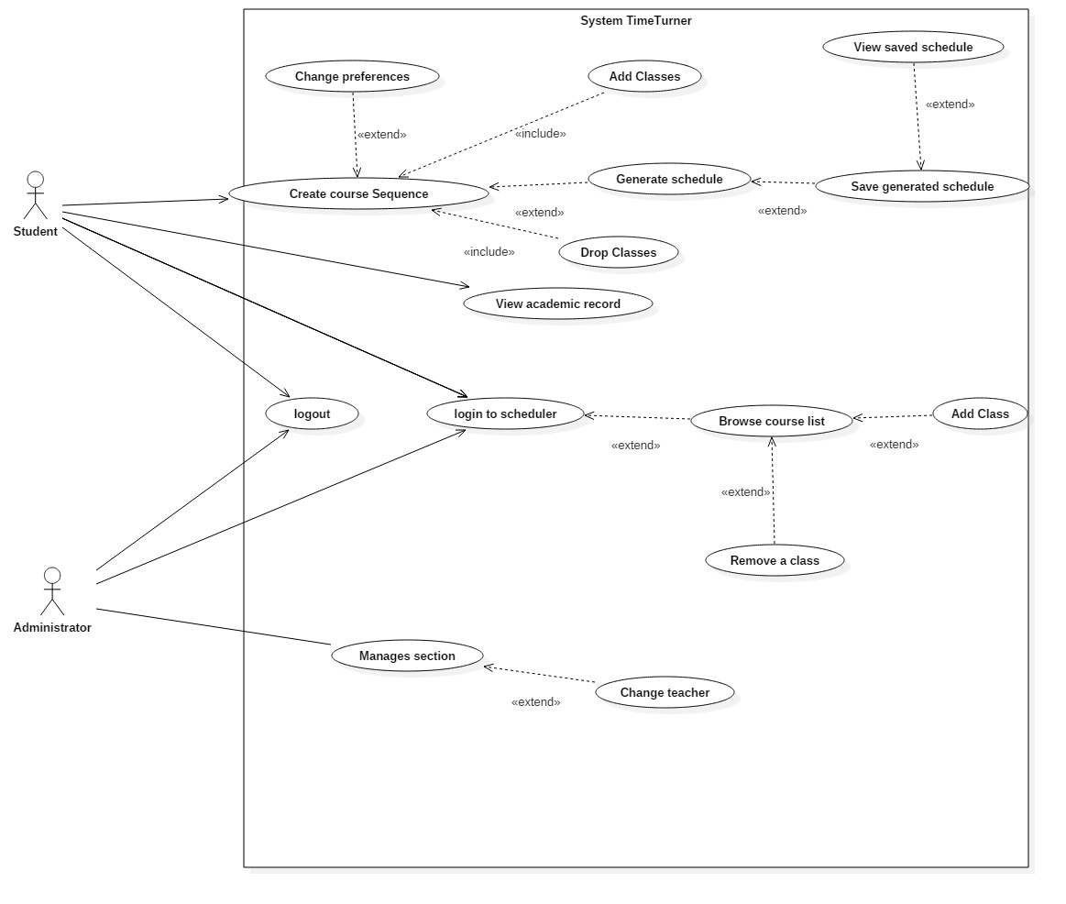

Use Cases

|  |  |  |
| --- | --- | --- |
| Use Case ID: | UC1 | |
| Use Case Name: | Login to TimeTurner | |
| Created By: | Marc-Andre Leclair | Last Updated By: Claudia Della Serra |
| Date Created: | January 25th, 2016 | Last Revision Date: February 8, 2016 |
| Actor(s): | Student, Administrator | |
| Goal/Actor Goals: | A student or Administrator wants to Login in their account | |
| Description/Summary: | The Student or Administrator wants to login into their account. The initial webpage contains a login box where the he or she can enter their username and password. The request is sent and it is check in the database whether or not the account exist or if the password is correct | |
| Preconditions: | * The user has an internet connection. * The user has valid login credentials. | |
| Post-conditions: | The user is authenticated and logged in. | |
| Minimum Guarantee: | User will not log in | |
| Basic Flow: | 1. Student enters its login information 2. System logs student into the system 3. Student is brought to the home page. | |
| Risk assessment: | Low | |
| Importance assessment: | 5/5 | |

|  |  |  |
| --- | --- | --- |
| Use Case ID: | UC2 | |
| Use Case Name: | Logout of Scheduler | |
| Created By: | Marc-Andre Leclair | Last Updated By: Ryan Lee |
| Date Created: | January 25th, 2016 | Last Revision Date: March 17, 2016 |
| Actor(s): | Student, Administrator | |
| Goal/Actor Goals: | A student or Administrator wants to Logout of their account. | |
| Description/Summary: | The Student or Administrator wants to logout of their account. He or she sends a request to the server to close the connection between themselves and the Time Turner. | |
| Preconditions: | The user is logged in their account | |
| Post-conditions: | The user is disconnected from the server and logged out. | |
| Minimum Guarantee: | User will remain logged in | |
| Basic Flow: | 1. The user indicates that they wish to logout of the system. 2. The server terminates the connection. 3. The user is logged out through the webpage. | |
| Risk assessment: | Low | |
| Importance assessment: | 5/5 | |

|  |  |  |
| --- | --- | --- |
| ~~Use Case ID:~~ | ~~UC3~~ | |
| ~~Use Case Name:~~ | ~~Create Course Sequence~~ | |
| ~~Created By:~~ | ~~Marc-Andre Leclair~~ | ~~Last Updated By: Ryan Lee~~ |
| ~~Date Created:~~ | ~~January 25~~~~th~~~~, 2016~~ | ~~Last Revision Date: March 9, 2016~~ |
| ~~Actor(s):~~ | ~~Student~~ | |
| ~~Goal/Actor Goals:~~ | ~~A student wants to create a course sequence~~ | |
| ~~Description/Summary:~~ | ~~The Student wants to create his or her course sequence. The system must provide the user with the option to add their own preferences in order to generate a sequence that is personalized to these preferences.~~ | |
| ~~Preconditions:~~ | * ~~The user is logged into the system~~ * ~~The user is registered in a program.~~ | |
| ~~Post-conditions:~~ | ~~The user has a personalized course sequence for the future~~ | |
| ~~Minimum Guarantee:~~ | ~~No course sequence will be created~~ | |
| ~~Basic Flow:~~ | 1. ~~Student requests to create a sequence.~~ 2. ~~The system must prompt the student to add his or her preferences to the sequence.~~ 3. ~~The student selects zero, one, or more preferences.~~ 4. ~~The system prompts the student to confirm their preferences~~ 5. ~~The student confirms his choices.~~ 6. ~~The course sequence is created and shown to the student.~~ | |
| ~~Risk assessment:~~ | ~~High~~ | |
| ~~Importance assessment:~~ | ~~5/5~~ | |

|  |  |  |
| --- | --- | --- |
| Use Case ID: | UC4 | |
| Use Case Name: | Browse Course List | |
| Created By: | Ideawin-Bunthy Koun | Last Updated By: Ryan Lee |
| Date Created: | January 25th, 2016 | Last Revision Date: March 9, 2016 |
| Actor(s): | Student | |
| Goal/Actor Goals: | Browse the list of courses from the course calendar. | |
| Description/Summary: | The user wishes to view available courses and access information pertaining to them. The system must display such information, including sections, times, and locations. | |
| Preconditions: | * User must be logged in as a Student. * Course list must be available. | |
| Post-conditions: | A list of courses is displayed. | |
| Minimum Guarantee: | The system fails to display a list of courses and displays an error message to the user. | |
| Basic Flow: | 1. Student selects the ‘Browse Course List” feature. 2. System retrieves list of courses. 3. System displays list of courses. 4. User selects a course from that list. 5. System displays information about the selected course. | |
| Risk assessment: | Medium | |
| Importance assessment: | 3/5 | |

|  |  |  |
| --- | --- | --- |
| ~~Use Case ID:~~ | ~~UC5~~ | |
| ~~Use Case Name:~~ | ~~View Course Sequence~~ | |
| ~~Created By:~~ | ~~Ideawin-Bunthy Koun~~ | ~~Last Updated By: Ryan Lee~~ |
| ~~Date Created:~~ | ~~January 25~~~~th~~~~, 2016~~ | ~~Last Revision Date: March 9, 2016~~ |
| ~~Actor(s):~~ | ~~Student~~ | |
| ~~Goal/Actor Goals:~~ | ~~Allows the user to view their expected progression in the program.~~ | |
| ~~Description/Summary:~~ | ~~User can view a complete course sequence of the program the student is enrolled in. The Sequence will show the courses the Student is expected to take, and the order he or she is expected to take them in.~~ | |
| ~~Preconditions:~~ | * ~~User must be logged in as a Student~~ * ~~The system has access to a course sequence.~~ | |
| ~~Post-conditions:~~ | ~~The system displays a course sequence.~~ | |
| ~~Minimum Guarantee:~~ | ~~The system fails to display a course sequence and displays an error message to the user.~~ | |
| ~~Basic Flow:~~ | 1. ~~Student selects the option to view his or her course sequence.~~ 2. ~~System retrieves the sequence.~~ 3. ~~Course sequence is displayed to the student.~~ | |
| ~~Risk assessment:~~ | ~~Medium~~ | |
| ~~Importance assessment:~~ | ~~4/5~~ | |

|  |  |  |
| --- | --- | --- |
| Use Case ID: | UC6 | |
| Use Case Name: | Generate Schedule | |
| Created By: | Ideawin-Bunthy Koun | Last Updated By: Ryan Lee |
| Date Created: | January 25th, 2016 | Last Revision Date: March 9, 2016 |
| Actor(s): | Student | |
| Goal/Actor Goals: | Obtain a suggested schedule for the next four years. | |
| Description/Summary: | The system can generate a 4-year schedule for the user based on the student’s preferences and constraints and on prerequisite and co-requisite policy. | |
| Preconditions: | * User must be logged in as a Student. * The system must have access to course database. * The system must have access to the student’s records. | |
| Post-conditions: | The system generates a schedule with no overlaps. | |
| Minimum Guarantee: | The system fails to generate a schedule and displays an error message to the user. | |
| Basic Flow: | 1. User selects the ‘Generate Schedule’ feature. 2. System retrieves list of preferences. 3. User selects his or her options and preferences. 4. System prompts user to confirm preferences. 5. System responds by displaying a schedule that meets the user’s preferences and constraints. | |
| Risk assessment: | High | |
| Importance assessment: | 5/5 | |

|  |  |  |
| --- | --- | --- |
| Use Case ID: | UC7 | |
| Use Case Name: | View Saved Schedules | |
| Created By: | Erin Benderoff | Last Updated By: Claudia Della Serra |
| Date Created: | February 7, 2016 | Last Revision Date: February 14, 2016 |
| Actor(s): | Student | |
| Goal/Actor Goals: | The user wishes to view a previously saved schedule. | |
| Description/Summary: | The user selects a schedule from a list of their previously saved schedules. The system must display this schedule for the user to review. | |
| Preconditions: | * User is logged into the system. * User has previously generated one or more schedules * User has saved at least one generated schedule | |
| Post-conditions: | The system displays the saved schedule | |
| Minimum Guarantee: | Saved schedules remain in the system unchanged. | |
| Basic Flow: | 1. The user indicates their wish to view a saved schedule 2. The system prompts the user with a list of saved schedules 3. The user selects which semester’s schedule to view 4. The system displays the chosen schedule | |
| Risk assessment: | Medium | |
| Importance assessment: | 3/5 | |

|  |  |  |
| --- | --- | --- |
| Use Case ID: | UC8 | |
| Use Case Name: | View Academic Record | |
| Created By: | Erin Benderoff | Last Updated By: Claudia Della Serra |
| Date Created: | February 7, 2016 | Last Revision Date: February 14, 2016 |
| Actor(s): | Student | |
| Goal/Actor Goals: | The user wishes to view a list of his or her completed courses and grades for those courses. | |
| Description/Summary: | The system displays the user’s academic record, which includes completed courses and courses currently being taken. | |
| Preconditions: | * User is logged into the system. * User has completed at least one course and/or is presently enrolled in at least one course. | |
| Post-conditions: | The system displays the user’s academic record. | |
| Minimum Guarantee: | The academic record remains in the system unmodified. | |
| Basic Flow: | 1. The user requests to view their academic record 2. The system generates a list of the user’s completed courses, as well as courses in which the user is currently enrolled. | |
| Risk assessment: | Low | |
| Importance assessment: | 1/5 | |

|  |  |  |
| --- | --- | --- |
| Use Case ID: | UC9 | |
| Use Case Name: | Drop Course | |
| Created By: | Erin Benderoff | Last Updated By: Claudia Della Serra |
| Date Created: | February 7, 2016 | Last Revision Date: February 14, 2016 |
| Actor(s): | Student | |
| Goal/Actor Goals: | The user wishes to remove a course from a generated schedule. | |
| Description/Summary: | The user selects which course he or she would like to remove from the schedule. The system must delete this course from the schedule. | |
| Preconditions: | * User is logged into the system. * User has generated a schedule containing at least one course. * User has chosen to view a saved schedule | |
| Post-conditions: | The chosen course has been removed from the user’s schedule. | |
| Minimum Guarantee: | The courses on the user’s schedule remain unchanged. | |
| Basic Flow: | 1. User selects a schedule they wish to view 2. System returns the desired Schedule 3. The user chooses a course from his or her schedule to view. 4. The system displays the course information 5. The user indicates they wish to remove the course from the schedule 6. The System prompts the user for confirmation. 7. The user confirms dropping of the course 8. The produces a modified schedule without the removed course. | |
| Risk assessment: | High | |
| Importance assessment: | 4/5 | |

|  |  |  |
| --- | --- | --- |
| ~~Use Case ID:~~ | ~~UC10~~ | |
| ~~Use Case Name:~~ | ~~Add Course~~ | |
| ~~Created By:~~ | ~~Lori Dalkin~~ | ~~Last Updated By: Claudia Della Serra~~ |
| ~~Date Created:~~ | ~~February 7, 2016~~ | ~~Last Revision Date: February 14, 2016~~ |
| ~~Actor(s):~~ | ~~Student~~ | |
| ~~Goal/Actor Goals:~~ | ~~Add a course to a generated schedule.~~ | |
| ~~Description/Summary:~~ | ~~Specific courses can be added to a schedule generated by a user. The user must search for the course and manually add it to their schedule.~~ | |
| ~~Preconditions:~~ | * ~~The user is logged in to their account~~ * ~~A schedule has been generated~~ | |
| ~~Post-conditions:~~ | ~~The specified course is added to the schedule.~~ | |
| ~~Minimum Guarantee:~~ | ~~The user’s schedule remains unchanged and no new course is added~~ | |
| ~~Basic Flow:~~ | 1. ~~User requests to view schedule.~~ 2. ~~System displays the indicated schedule.~~ 3. ~~User indicates they wish to add a course~~ 4. ~~The system displays a search screen prompting the user to enter the name of the course~~ 5. ~~The user types in the name of the course they wish to add~~ 6. ~~The system displays a list of corresponding courses and sections~~ 7. ~~User selects the specific section of the course they wish to add.~~ 8. ~~The system prompts the user to confirm their selected course~~ 9. ~~The user confirms their wish to add the course~~ 10. ~~The system returns a modified schedule.~~ | |
| ~~Risk assessment:~~ | ~~Medium~~ | |
| ~~Importance assessment:~~ | ~~3/5~~ | |

|  |  |  |
| --- | --- | --- |
| Use Case ID: | UC11 | |
| Use Case Name: | Save Generated Schedule | |
| Created By: | Lori Dalkin | Last Updated By: Claudia Della Serra |
| Date Created: | February 7, 2016 | Last Revision Date: February 14, 2016 |
| Actor(s): | Student | |
| Goal/Actor Goals: | The user wishes to save a schedule they have generated. | |
| Description/Summary: | A generated schedule can be saved in order to be accessed and viewed later on by the user. This schedule consists of courses the user is satisfied with and wishes to keep on their schedule. | |
| Preconditions: | * The user is logged on to their account * A schedule has been generated containing at least one course. | |
| Post-conditions: | The system saves the generated schedule to the user’s account. | |
| Minimum Guarantee: | The user’s account remains unchanged. | |
| Basic Flow: | 1. User indicated their wish to generate a schedule 2. The system prompts the user with a list of semesters for which they wish to generate a schedule 3. The user indicates which semester they wish to generate a schedule for 4. The system displays a generated schedule for the indicated semester 5. The user will indicates that they want to save the generated schedule. 6. The system will display a message telling the user that the schedule has been saved. | |
| Risk assessment: | Medium | |
| Importance: | 4/5 | |

|  |  |  |
| --- | --- | --- |
| ~~Use Case ID:~~ | ~~UC12~~ | |
| ~~Use Case Name:~~ | ~~View Weekly Schedule~~ | |
| ~~Created By:~~ | ~~Bryce Drewery Schoeler~~ | ~~Last Updated By: Claudia Della Serra~~ |
| ~~Date Created:~~ | ~~February 7, 2016~~ | ~~Last Revision Date: February 14, 2016~~ |
| ~~Actor(s):~~ | ~~Student~~ | |
| ~~Goal/Actor Goals:~~ | ~~A student wants to view weekly schedule.~~ | |
| ~~Description/Summary:~~ | ~~The student wishes to see their class schedule for the current week. The student will specify a week to be displayed. The system must display the schedule for that week.~~ | |
| ~~Preconditions:~~ | * ~~The student has been authenticated~~ * ~~A schedule has been generated and saved~~ | |
| ~~Post-conditions:~~ | ~~The schedule is shown on screen.~~ | |
| ~~Minimum Guarantee:~~ | ~~The schedule fails to be displayed.~~ | |
| ~~Basic Flow:~~ | 1. ~~Student requests to see a saved schedule.~~ 2. ~~The system prompts the student to select a week.~~ 3. ~~Student selects a week~~ 4. ~~The systems display the schedule for that week~~ | |
| ~~Risk assessment:~~ | ~~Medium~~ | |
| ~~Importance assessment:~~ | ~~3/5~~ | |

|  |  |  |
| --- | --- | --- |
| Use Case ID: | UC13 | |
| Use Case Name: | Manage Courses | |
| Created By: | Aline Koftikian | Last Updated By: Claudia Della Serra |
| Date Created: | Marc 25th, 2016 | Last Revision Date: April 7, 2016 |
| Actor(s): | Primary Actor(s): Administrator | |
| Goal/Actor Goals: | An administrator wants to modify available courses | |
| Description/Summary: | The Administrator is given access to the course bank and can search for a specific course, view course I.D., edit course details and/or delete course. | |
| Preconditions: | * The user is authenticated * There is at least one course in the course bank | |
| Post-conditions: | A course has been modified | |
| Minimum Guarantee: | No course will be modified | |
| Basic Flow: | 1. Administrator requests to manage courses 2. System displays course bank 3. Administrator chooses a course to modify 4. Administrator chooses what modification they would like to make 5. Administrator confirms change 6. Updated course bank appears on page | |
| Risk assessment: | 4/5 | |
| Importance assessment: | 3/5 | |

|  |  |  |
| --- | --- | --- |
| Use Case ID: | UC14 | |
| Use Case Name: | Create Course | |
| Created By: | Claudia Della Serra | Last Updated By: |
| Date Created: | Marc 26th, 2016 | Last Revision Date: |
| Actor(s): | Primary Actor(s): Administrator | |
| Goal/Actor Goals: | Administrator wishes to add a course to the database of courses | |
| Description/Summary: | The Administrator wishes to add a course to the system’s database of courses by entering its course code, the course description, and the amount of credits awarded by the course. A course may be a section, a tutorial, or a lab. | |
| Preconditions: | * The administrator has logged in. * The administrator has viewed the list of courses in the database. | |
| Post-conditions: | The course is added to the database of courses | |
| Minimum Guarantee: | The database of courses will remain unaltered. | |
| Basic Flow: | 1. Administrator requests to create a course 2. The system presents a page asking for the course id, the course description, and the amount of credits awarded by the course. 3. The Administrator enters the course information and presses submit 4. The system presents the course information, with the options to manage the course or view all courses in the database | |
| Risk assessment: | 3/5 | |
| Importance assessment: | 5/5 | |

|  |  |  |
| --- | --- | --- |
| Use Case ID: | UC15 | |
| Use Case Name: | Browse Courses | |
| Created By: | Claudia Della Serra | Last Updated By: |
| Date Created: | Marc 26th, 2016 | Last Revision Date: |
| Actor(s): | Primary Actor(s): Administrator | |
| Goal/Actor Goals: | Administrator wishes to view the database of courses | |
| Description/Summary: | The Administrator wishes to add view the system’s database of courses. From here, the administrator may choose to add a course or manage courses. | |
| Preconditions: | * The administrator has logged in. | |
| Post-conditions: | The course database will be presented | |
| Minimum Guarantee: | The administrator will remain on the home page. | |
| Basic Flow: | 1. Administrator requests to view the course database 2. The system presents a page listing all the courses in the database | |
| Risk assessment: | 2/5 | |
| Importance assessment: | 4/5 | |

## Domain Model

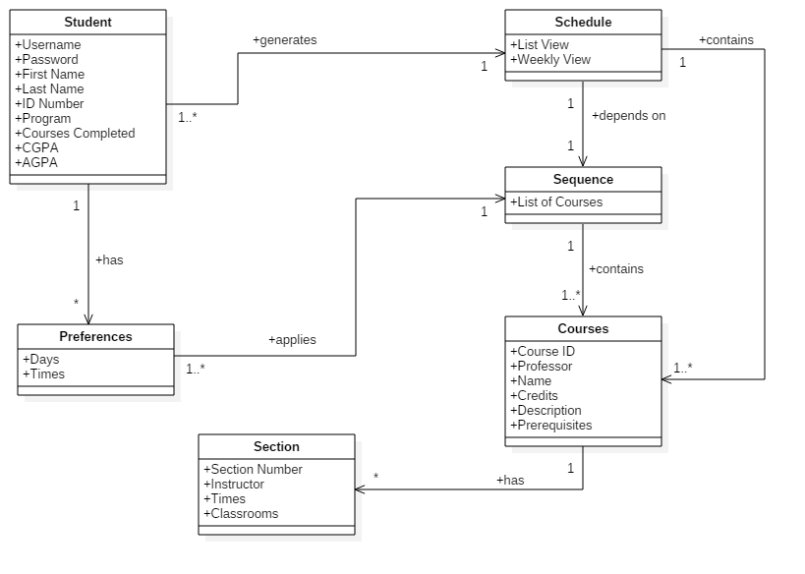

Figure 2. Domain Model

## Constraints and Qualities

### **Security**

Security is a crucial aspect of any software. One of the most important security requirements is to make sure there are no SQL injections that could breach and break our database. In order to assist in preventing SQL injections, we will be using prepared statements prior to query executing which is provided by PHP’s internal libraries. The possibility of having the database breached could potentially expose user personal user information or perhaps destroy content. The exposure of passwords is a concern in case of breach as they should be hashed and salted upon entry by using hashing algorithms such as *sha512* and *bcrypt*. This would essentially diminish any chance hackers have to brute force password entries.

### **Performance**

Performance is important especially when working with large data sets. The user must be able to navigate and use the site without having to wait for data generation. The application shall also ensure that database design is robust with the use of proper table indexing and storage engines and cache sizes. This will essentially allow for quicker SQL query executions that are expected to return data within 100 nanoseconds. The performance shall also account for larger data execution, such as the schedule generator with a performance factor speed of no more than 5 seconds.

### **Cross-Browser Compatibility**

There are cases where web applications do not necessarily comply with all possible web browsers. For example, certain aspects of CSS and HTML might work for one browser but break in another. This application shall ensure that the CSS and HTML model will be compliant with the browser’s boundaries. Ensuring browser compliance, the application shall be able to run on virtually any operating system that has any of the following browsers: Safari, Opera, Internet Explorer, Firefox and Chrome.

### **Ease of Use**

The application shall be straightforward and lightweight in order to ensure that students can start working on their schedule planner immediately. The use of Ajax technology will also minimize content and page refreshes thereby allowing users to navigate without losing the scope of the data they were working on.

# Resource Evaluation

## Human Resources

Our team of Undergraduate Students is a strong team of 12 individuals with varying skills and strengths. Our team has a diverse background, both socially and in terms of past work experiences. We also possess a good gender ratio of 7 males and 5 females. With both knowledgeable leaders and dedicated team players, we work efficiently together while also complementing each other’s strengths and weaknesses. Each member of our team brings their own outlook towards the project that will ultimately create a well-rounded project that can fit the needs of many. Below are the names of the 12 members along with the following information:

* The different skills and knowledge of languages they possess.
* Their experiences with past occupations, school projects and personal projects. Other relevant experiences that can add insight towards the project.
* Their primary role during the project.
* Their strengths that will help towards the success of the project.
* Their approximate availability per week, including both group meetings and personal work time.

|  |  |
| --- | --- |
| **Name** | **Daniel Di Corpo** |
| **Skills** | C++, JAVA, PROLOGUE, LISP, PHP, HTML |
| **Experience** | Technical DEC in Comp. Sci., Image Programing Specialist at Matrox |
| **Role** | Project Team Lead, System Architecture and Distribution of Tasks |
| **Strengths** | Leadership, Team Player, Management skills, Communication |
| **Availability** | 7 hours/week |

|  |  |
| --- | --- |
| **Name** | **Dimitri Topaloglou** |
| **Skills** | PHP, CSS, C++, C#, HTML, SQL, JAVASCRIPT, JQUERY, JAVA, PROLOGUE, CLOS, ASP.NET |
| **Experience** | Seven years of experience in web application development. |
| **Role** | Coding team Technical Lead, system designer, frontend + backend developer |
| **Strengths** | Advanced coder, quick learner, opened to new ideas |
| **Availability** | 7 hours/week |

|  |  |
| --- | --- |
| **Name** | **Claudia Della Serra** |
| **Skills** | HTML, CSS, JAVA,  JAVASCRIPT, PROLOGUE, LISP, CLOS, ASPECTJ, PYTHON |
| **Experience** | Developed 2 Android applications, certified tutor in English reading and writing, multiple years of experience in document editing. |
| **Role** | Documentation Team Lead, writing, editing and consolidation of documents |
| **Strengths** | Quick learner, team player, leadership and management skills |
| **Availability** | 7 hours/week |

|  |  |
| --- | --- |
| **Name** | **Aline Koftikian** |
| **Skills** | JAVA, HTML5, CSS3, JAVASCRIPT, C#, PROLOG, ASPECTJ, COMMON LISP, PYTHON |
| **Experience** | Developed two mobile (Android) applications w/ teams. |
| **Role** | Documentation team member, in charge of diagrams + logo |
| **Strengths** | Team player, open minded, organized |
| **Availability** | 7 hours/week |

|  |  |
| --- | --- |
| **Name** | **Kevin Yasmine** |
| **Skills** | JAVA, HTML5, CSS3, JAVASCRIPT, PROLOG, ASPECTJ, COMMON LISP, CLOS, Photoshop/Paint.Net |
| **Experience** | Class projects/assignments, extracurricular Android App Development using Android Studio. |
| **Role** | Documentation team member |
| **Strengths** | Team player, ability to see the big picture in large projects |
| **Availability** | 7 hours/week |

|  |  |
| --- | --- |
| **Name** | **Ideawin-Bunthy Koun** |
| **Skills** | JAVA, HTML5, CSS3, PHP, JAVASCRIPT, PROLOG, ASPECTJ, COMMON LISP |
| **Experience** | Academic projects/assignments, attended two hackathons where Android Studio was used, developed Android applications. |
| **Role** | Coding team member as a Front-End developer |
| **Strengths** | Fast learner, eager to learn new technologies, team player |
| **Availability** | 7 hours/week |

|  |  |
| --- | --- |
| **Name** | **Philip Lim** |
| **Skills** | JAVA, HTML5, CSS3, JAVASCRIPT, PHP, MYSQL, PROLOG, COMMON LISP |
| **Experience** | Completed an internship as a programmer analyst: involved Java programming using IntelliJ IDEA and documenting the code  Developed an apartment renting website (academic project)  Completed various academic assignments/projects in Java |
| **Role** | Documentation team member |
| **Strengths** | Flexible, active listener, team player |
| **Availability** | 7 hours/week |

|  |  |
| --- | --- |
| **Name** | **Ryan Lee** |
| **Skills** | JAVA, HTML, CSS, JAVASCRIPT, PHP, PROLOG, LISP, C#, PYTHON, RUBY |
| **Experience** | Competed in 2 hackathon and made applications using java and android studio, implementing APIs provided by companies. |
| **Role** | Documentation team member |
| **Strengths** | Team player, Communicative abilities, problem solving |
| **Availability** | 7 hours/week |

|  |  |
| --- | --- |
| **Name** | **Lori Dalkin** |
| **Skills** | PHP, CSS, HTML,  JAVASCRIPT,  JAVA, PROLOGUE, CLOS, ASPECTJ, PYTHON(basic), C#(basic) |
| **Experience** | Attended two hackathons where two android apps using java and android studio were developed. |
| **Role** | Coding team member. Back end and front end developer. |
| **Strengths** | Quick learner, enthusiasm for learning new languages, creative. |
| **Availability** | 7 hours/week |

|  |  |
| --- | --- |
| **Name** | **Bryce Drewery Schoeler** |
| **Skills** | PHP, CSS, HTML,  JAVASCRIPT,  JAVA, PROLOGUE, ASPECTJ, PYTHON, C++, C# |
| **Experience** | Developed android apps at hackathons. |
| **Role** | Coding team member. Back end and database developer. |
| **Strengths** | Enthusiastic learner, Good grasp of theoretical computer science. Excellent at solving logical problems. |
| **Availability** | 7 hours/week |

|  |  |
| --- | --- |
| **Name** | **Erin Benderoff** |
| **Skills** | PHP, CSS, HTML, JAVASCRIPT, JAVA, PROLOG, CLOS, ASPECTJ, PYTHON (beginner), MySQL |
| **Experience** | Made two Android applications at hackathons |
| **Role** | Coding team member. Mainly front end but will also do a bit of back end. |
| **Strengths** | Detail-oriented, motivated, fast learner, easy to get along with |
| **Availability** | 7 hours/week |

|  |  |
| --- | --- |
| **Name** | **Marc-Andre Leclair** |
| **Skills** | PHP, CSS, HTML, JAVASCRIPT, JAVA, PROLOG, RUBY, C#, Visual Basic.net, MySQL |
| **Experience** | Created two android app at two different hackathons |
| **Role** | Coding team member. Mostly back end attending to php and the database but also some front-end |
| **Strengths** | Love to learn, strong team player, fast learner |
| **Availability** | 8 hours/week |

## Technical Resources

Each developer’s computer must have the same XAMPP version installed in order to align the Apache and PHP version as found in the production environment. This is to avoid any conflicts and bugs which can be caused due to incompatible versions of PHP or Apache’s server core files.

XAMPP (64-bit environment) includes the following pre-installed software packages:

* Database: MySQL 5
* Web Server: Apache HTTP Server 2.0
* Primary language: PHP 6.0 and Python 2.7
* Database User Interface: phpMyAdmin

The production environment in question has the following infrastructure:

* CPU: Intel i7
* OS: Windows Server 2012
* RAM: 16GB
* DISK DRIVE: 500 GB (Solid State)
* Network Speed: 10 Mbps

The production environment is hosted on a team member’s own computer. This decision was made in order to have a better overlook of the server and have complete control of the environment.

Main software packages used in the project include:

* Languages: HTML, CSS, PHP, JQuery, JavaScript, SQL
* IDE: PhpStorm 10
* Framework: Yii 1.1.16
* Version Control Systems: GitHub, Gitbash, GitHub Desktop
* Team Collaboration Tools: GitHub, Facebook Chat, Trello
* OS: Windows, Linux
* UML and Diagrams: StarUML
* Documentation tools: Google Drive, Microsoft Word
* Graphical Design Tool: Photoshop

# Scoping

When the Project was first announced and the groups were formed, the team spent a lot of time discussing what the Scheduler should include. Many features came up, such as administrative privileges, manual manipulation of the sequence, etc. However, after working on the plan and blueprints of the project, it became clear that there are many requirements and constraints that would limit the additional features that we wanted to include.

## Limitations

Taking into consideration section 3 and 4, our biggest limitation is time. Some features would be an asset to have, but given that the project should be developed in only a few weeks, it is impossible to include them all while maintaining Security, Performance, Cross-Browser Compatibility and Ease of Use (see section 3.3).

## Scoped Out

Administrative Privileges

Initially, the team wanted to include Teachers and Administrators that are able to do different tasks, such as change class time, drop students, add students, change teachers, bypass prerequisites, etc., but given our time constraint and our limited experience as students, this aspect was scoped out. Such activities include

* Managing a Section
* Adding a Course to the Course List
* Changing the Time of a Course
* Etc.

Manual Manipulation of Sequence

Another feature that was scoped out, is to allow students do add and drop individual classes. The team realized that the main function of the Scheduler is to automatically create a full, four-year schedule. We decided to optimize this function so that it runs well, instead of giving multiple – less efficient – ways of adding classes.

# Solution Sketch

## Architecture

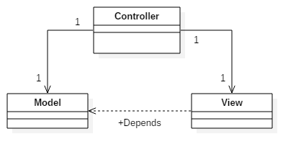

Time Turner’s architecture will follow a Model-View-Controller architecture (MVC). This MVC architecture is best suited for this project because it isolates our application to 3 different layers, data, logic and presentation. With these clear separation of concerns, changing any of these components might not affect the other two components. This is a preferred for team based environments since all 3 components can be coded at the same time.

We have chosen to use the Yii Framework for its ease of use, modular components and its exceptional handling of applications with big traffic flow such as portals and content management systems. We have chosen this framework for its high speed of development and work, integration with Javascript, can handle multiple types of databases and convenient and flexible caching system which will help for caching validation.

A general work flow starts off with a user request. This is handles by the controller, which will separate what needs to be sent to the model component and the view component. Anything that needs data retrieval or sequence generation, will be sent to the model component, which is in conjunction with our domain model. Once the data has been retrieved, it is sent back to the controller to be packaged and sent to the viewer. Once the view component has all the information, it will generate, what will be, in the end, the display on the user’s web browser. Then, once a new request is sent, the process will start over again.

Controller

This is the data of the MVC. With a web application, the user will make a request for a web page which will be handled by the controller. The controller will evaluate the request, sending any logic operations to the model component. Once the controller has collected all of the necessary information, it will send all its data to the view component, which will generate an HTML output to the user.

Model

This is the logic of the MVC. With the user information given from the controller, and with the use of the underlying logical data structure, such as our domain model, processes such as, generate sequence, can be utilized and sent back to the controller. One controller does not have exclusivity over the model component, since multiple pages may need the same information, many controllers can access the model component.

View

This is the presentation of the MVC. With the proper session handling from the controller and relevant data from the modeller, the viewer can generate an HTML output with CSS and Javascript, which will, in-turn, be viewed on the user’s web browser.

## Technologies in Use

### ProgrammingLanguages

Server-side

6.2.1.1.1 PHP

PHP is the main server-side language that will be handling business logic and SQL database queries. PHP was chosen due to the syntax similarities of other major Object-Oriented programming languages, allowing for a quicker learning experience.

#### ***Client Side***

6.2.1.2.1 JavaScript

JavaScript a multi-paradigm scripting language that is supported and natively embedded by all major browsers including Internet Explorer, Firefox, Safari and Chrome. It is mainly used for dynamic client side manipulation of the DOM and allows for a dynamic browsing experience.

6.2.1.2.2 jQuery

jQuery is essentially a JavaScript script library that allows programmers to write less lines of code in order to perform the same functionality in the native JavaScript environment. It allows for quick DOM manipulation with very few lines of code, animations, client side validation, form input handling and quick Ajax calls.

6.2.1.2.3 HTML (Hyper Text Markup Language)

HTML is the primary markup language used to create web layout and provide structure to web content. Of course, it is also natively supported in every major web browser.

6.2.1.2.4 CSS (Cascading Style Sheet)

CSS is used primarily for styling purposes that is supported by all major browsers with some detailed exceptions in portability. The essence of CSS is to separate styling from the markup language, such as HTML.

IDEs

#### ***PhpStorm 10***

PhpStorm is a powerful IDE provided by JetBrains that is integrated with an extensive Git support system and provides direct database management without the use of any other third party application.

### DatabaseManagementSystem

#### ***MySQL***

MySQL is an open-source database management system that provides more than enough features required to for the scope of the web application. It also provides InnoDB storage engine access which supports transactions, enabling to undo database query commits.

### WebServer

#### ***XAMPP (v1.8.1)***

XAMPP 1.8.1 is a free open-source, cross-platform web server solution package which includes Apache HTTP Server, MySQL and PHP functionalities.

Source Code Revision Management

#### ***GitHub***

GitHub is a popular source code revision management system that allows for developers to clone source code repositories and provide a non-destructive means of working in isolation from the original repository. In turn, this provides a better overview of which developer is working on which portion of the code, thereby providing a flexible version control workflow.

Deployment Software

#### ***DeployHQ***

DeployHQ is an online service that allows automatic and manual deployment of sources code from any type of repository service such as GitHub. It is used to automatically deploy source code directly to the main hosting server from a selected GitHub branch of your choice in a seamless manner. The service is installed via a webhook service, integrated within GitHub and source code deployment occurs upon a commit done in the master branch. It also provides rollback options.

Team Collaboration

Trello

Trello is a free team collaboration tool that organizes task into board spaces. It provides an overview of what tasks need to be done, tracks due dates and assigns tasks to collaborators. It also provides a mobile app version which allows to push notifications to users’ mobile when the project board was updated, allowing collaborators to respond to tasks accordingly.

Framework

Yii

Yii is a highly extensible, open source framework designed for web applications and is based on an MVC architecture. It shortens development time with the use of Gii, an incorporated tool that quickly creates on-the-fly templates for models, controllers, forms, modules, extensions and CRUD control actions and views. This allows developers to minimize repetitive tasks and enforces the MVC architecture according to Yii’s specifications. It also comes with a pre-built web template to allow unfamiliar developers to get a quick start in learning how to properly create models, views and controllers.

# Plan

## Activities

|  |  |  |
| --- | --- | --- |
| Activity | Purpose/Description | Artifact(s) produced |
| 7.1.1  Form and divide team | Forming a team allows the project to start. Dividing the team into a coding and documentation sub-teams allows members to focus on particular tasks. Such division requires the evaluation of the strengths and weaknesses of all members to determine their role. | 1.4.1 Human Resources |
| 7.1.2  Complete the system overview | The system overview consists of finding a name for the system, determining the main purposes and elements involved in it, and drawing a domain model of the system along with the description of each entity found in the domain model. | Deliverable 0  1.3.2 Domain Model |
| 7.1.3  Write a project description | The project description introduces the entire document. It informs the reader about its goals, the information to be found in it, as well as the purposes and objectives of the project. | 1.2 Project Description |
| 7.1.4  Determine the functional requirements and draw use case diagrams accordingly | Determine the requirements that the system should have, including those that may later be scoped out, their relative importance and relative difficulty. Define the actions that must take place in the software and illustrate each requirement by the mean of a use case diagram. | 1.3.1 Functional Requirements |
| 7.1.5  Review and correct domain model | Make any necessary changes according to the feedbacks of Deliverable 0. | 1.3.2 Domain Model |
| 7.1.6  Find and describe constraints and qualities | Describe any design constraints, qualities and non-functional requirements that the system should meet. | 1.3.3 Constraints and Qualities |
| 7.1.7  Review and format human resources document | After the profile of each team member has been determined, the document should be revised and formatted correctly. | 1.4.1 Human Resources |
| 7.1.8  Determine technical resources | List the computer resources and tools available to complete the project. | 1.4.2 Technical Resources |
| 7.1.9  Reduce the amount of features to be realistic according to time and resources | Outline the scope of the software. List all features, goals and qualities that are scoped out, and provide an explanation for each element that is scoped out. | 1.5 Scoping |
| 7.1.10  Choose the architecture of the system | Explain the high-level architecture of the system, and give a design rationale. A diagram should accompany the explanation. | 1.6.1 Architecture |
| 7.1.11  Decide which technologies are relevant to the project development | List technologies that will be used in the project and give a rationale for each of them. | 1.6.2 Technologies in Use |
| 7.1.12  List and describe the main activities involved in the project | List all activities that produce at least one artifact and include a description for each activity. | 1.7.1 Activities |
| 7.1.13  List all artifacts | List and describe all artifacts that need to be produced for the project. | 1.7.2 Artifacts |
| 7.1.14  Estimate the cost and time of production | Estimate the cost and time of production of each artifact and sum them up. | 1.7.3 Project Estimates |
| 7.1.15  Delegate activities to different team members | Assign each activities of the project to a team member or to a group of team members. | 1.7.4 Activities Assignments |
| 7.1.16  Produce a schedule for the project | Create a schedule/timeline of all activities for the project using a Gantt chart. Start dates, due dates, names of activities, and participants are all information to be included in the schedule. | 1.7.5 Schedule |
| 7.1.17  Determine the risks of the project | Outline and explain the risks associated and presented by this project. | 1.7.6 Risk |
| 7.1.18  Produce a prototype report | Describe the work done in the development of the prototype. Explain how the chosen technologies are appropriate, and how the team members are comfortable using such technologies. | 1.8 Prototyping |
| 7.1.19  Ensure professionalism of the document | Assemble all parts of deliverable 1. Ensure the document is professional looking and well-organized. | Deliverable 1 |
| 7.1.20  Update the introduction for Deliverable 2 | Update the introduction to give the reader an overview of the content found in Deliverable 2: Architecture and Design | 2.2 Introduction to Part 2 |
| 7.1.21  Produce an architecture diagram | Produce a 4+1 Architectural View. Include a rationale for the design. Explain any differences between the old design and this one. | 2.3.1 Architecture Diagram |
| 7.1.22  Specify the interactions between the components of the software | Describe the interactions between the components of the software through their interfaces. Include the function calls, the description of the parameters and the range of accepted values of those parameters. | 2.3.2 Subsystem Interfaces Specifications |
| 7.1.23  Illustrate the internal structure of the system | Provide a graphical representation of the structure of each subsystem by means of a UML class diagram. A description of each class should be included. | 2.4.1 Detailed Design Diagram |
| 7.1.24  Describe each class in the subsystem | Provide the programmers with the descriptions of each class in the UML diagram along with any necessary detailed relevant to the development. | 2.4.2 Unit Description |
| 7.1.25  Produce dynamic design scenarios | Draw the dynamic design of two use cases. | 2.5 Dynamic Design Scenario |
| 7.1.26  Update project estimates | Update the cost of the project for each module and include the cost of integration, testing and documentation. | 2.6 Estimation |
| 7.1.27  Produce a report about the prototype and risk | List and describe all elements that have been implemented and describe the effect that those implementations had on the design decisions, risks, estimate and scope. | 2.7 Rapid Prototyping and Risk |
| 7.1.28  Ensure professionalism of the document | Assemble all parts of deliverable 2. Ensure the document is professional looking and well-organized. | Deliverable 2 |
| 7.1.29  Update introduction | Update the introduction so that it includes an overview of the content presented in deliverable 3. | 3.2 Introduction |
| 7.1.30  List all tested items | Create a list of all items that have been tested, the test cases that were used, and a rationale for the test. | 3.3.1.1 Tested Items |
| 7.1.31  List all untested items | Create a list of items that are to be tested, an explanation of why those items should be tested, and how they could be tested. | 3.3.1.2 Untested Items |
| 7.1.32  Unit testing report | Describe the test cases, the technique used, the code used and the result of the testing for two units. | 3.3.2.1 Unit Testing |
| 7.1.33  Requirements testing report | Provide a list of test cases for all tested requirements by means of scenario of system usage and system reaction. | 3.3.2.2 Requirements Testing |
| 7.1.34  Stress testing report | Describe situations of extreme system usage, the tests designed to evaluate the performance of the system under such condition, and the test results. | 3.3.2.3 Stress Testing |
| 7.1.35  Security testing report | Describe tests performed to protect the system against security threats such as SQL injections and automated tools. | 3.3.2.4 Security Testing |
| 7.1.36  Installation manual redaction | Guide any administrators to install and execute the software. | 3.4.1 Installation Manual |
| 7.1.37  User’s manual redaction | Guide any users to use the system with all of its features. | 3.4.2 User’s Manual |
| 7.1.38  Update cost estimate | Update the table of costs with all components of all phases. | 3.5 Final Cost Estimate |
| 7.1.39  Ensure professionalism of the document | Assemble all parts of deliverable 2. Ensure the document is professional looking and well-organized. | Deliverable 3 |
| 7.1.40  Correction of various part of the deliverables | Make all necessary changes in the deliverables for the final report. | Corrected deliverables |
| 7.1.41  Assemble all deliverables | Put all corrected/updated deliverables together for the final report. Ensure professionalism of the document. | Final report |

## Artifacts

1.2. Project Description

The project description is an introduction to the entire project. It’s a brief that allows the reader and the user of the system to understand the goal and purpose of the project. This document must be presented as an opening to the rest of the manual, and must include the idea, objective, background, approach, and result of the entire project.

1.3.1 Functional Requirements

Requirements are the tasks that are necessary for the completion of the system. They are the components of the system that must be documented, measured and tested in order to ensure the ideal conclusion to the project in question. The requirements that need to be specified for this system are functional and non-functional requirements. The functional requirements are the tasks that define what the system is trying to accomplish. These are the elementary actions that constitute the main goal of the system. They include the user viewing weekly schedule, adding classes, dropping classes, swapping, etc.

Each individual requirement must be presented as a use case. A use case is a description of the behavior of a system that explains the process and results obtained through interactions of the user with the system. The functional requirements must be known before writing use cases, because they are the details that compose the main actions and tasks of the system. The use cases are present in both list form and diagram form.

* Use Cases: The list-based use cases are full formal documents that list all use cases of the system in detail, with each property of the use case explained in full detail. These include the name of the use case, the general description, the actors, preconditions, postconditions, etc.
* Use Case Diagram: Use case diagrams are used to depict a visual representation of the use cases listed. The actors, which typically include the user or an external entity, are depicted using stick figures. The use cases themselves are drawn as circles with a name that describes the title of the action that can be initiated by the actors. There are lines connected from users to the use cases called connections, which describe the actor’s interactions with those use cases.

1.3.2. Domain Model

The Domain Model is the model that describes all core concepts and an overview of the system at hand. Its main purpose is to list the objects of interest that form the system, and presents their attributes, constraints, and relationships between them. The model is designed in UML format, with arrows describing relationships from one object to another, and ensuring that there are multiplicity values at both ends of the arrow denoting multiplicity factors of the relationship. The finalized domain model will come with a description that will provide a more detailed explanation of the model as well as each object present in the model.

1.3.3. Constraints and Qualities

The constraints and qualities segment describes the main standards of quality and non-functional requirements that are expected to be met by the system. The non-functional requirements are the general properties of the system. They are the constraints and qualities that will make up the system when in use. These include response times, maintenance times, security, etc. It’s important that the constraints and qualities are as specific as possible, which means they must have concrete metric specifications wherever possible.

1.4.1. Human Resources

The human resources of a project is the group of individuals who compose the main workforce of the project. They are the source of labor of a project, and in the case of large projects, are typically divided into smaller groups for more organized work.

1.4.2. Technical Resources

The technical resources of a project are the computer resources that will be used to complete the project. This includes the computer programs, software, libraries, and websites that are available for use.

1.5. Scoping

The scoping section describes all elements, features, qualities, and goals that have been scoped out from the end result. Each scoped element must come with a description of what it is, in addition to a paragraph that describes why it was chosen to be scoped out. These scoped elements have been typically scoped out in the early phases of a project, where the requirements are being planned and discussed in between team members.

1.6.1. Architecture

The architecture of a project is the high-level system architecture that is planned for the complete project. It must be presented with a UML class diagram that describes the details and relationships between different components of the system, along with a detailed description of the mindset behind the architecture (also known as a design rationale). In addition, each module of the architecture must be accompanied with its own design rationale and responsibilities.

1.6.2. Technologies in Use

This segment must provide a technical description of all the technologies that will be used to build the project. These include programming languages, libraries, servers, databases, IDE and compilers, etc. For each technology listed, there must be a short description that explains the rational for the choice and use of the specific tool.

1.7.1. Activities

The activities section is a section that will list a step-by-step process of how the separate artifacts of the project will be produced in order to reach the completion of the project. Each activity must be presented with a clear purpose, description, and must produce at least one artifact in consequence.

1.7.2. Artifacts

An artifact is a by-product that is produced as a consequence of the development of a software project. The artifacts segment will list each document that will be produced in the project. Each artifact listed must come with a description that provides details about the role of that specific document in the completion of the project.

1.7.3. Project Estimates

The project estimates section is for providing a realistic estimate for the cost, as well as the schedule for the length of the project. This is done by summing the evaluated cost of each artifact that’s produced throughout the conception of the project. Each cost must be backed up by a basis of the estimation.

1.7.4. Activities Assignments

The activities assignments are the specific assignments of tasks and activities that are made to each team member based on the members’ skills, requirements, capacities, limitations and schedules.

1.7.5. Schedule

The schedule section must present all the project’s deadlines, milestones, sprints, iterations and other target dates in the form of a diagram or table. A Gantt chart is the ideal way to present a schedule as it outlines the dates all important events from start to finish in a clean and organized fashion.

1.7.6. Risk

The risk section will present all elements of risk of the project, including both early factors and late factors of risk. Each risk must be accompanied by a description and a consequence should the risk occur. They may be presented in a table or list form.

1.8. Prototyping

The prototype section is a description of what work has been completed so far in terms of developing a prototype of the project. A prototype is an early model that is built before the final release of a system or device. The goal of this section is to decide whether the tools and technologies chosen for the completion of the project are appropriate for the final release.

2.2. Introduction to Part 2

The second introduction will introduce the user to the second large deliverable of the project. It is simply a brief description of what information is included in the entire document.

2.3.1. Architecture Diagram

The architecture diagram section is an improved and more detailed version of the architecture diagram presented in the previous deliverable. The system must be divided into at least two systems for this diagram. It must include a high-level description of the architecture of the system in addition to descriptions for each separate module included in the system, accompanied with the visual diagram.

2.3.2. Subsystem Interfaces Specification

The subsystem interfaces specification section is the section that will describe the specifications of the interactions between the software interfaces of the components of the project. These are most likely presented as the function calls and message passing that occur. They must be accompanied with descriptions of the parameters passed of the function calls, including possible valid and invalid ranges of values.

2.4.1. Detailed Design Diagram

The detailed design diagram is a diagram that describes the internal structure of the subsystems depicted in the project. This must be presented as a UML diagram, and must include descriptions that explain the rationale of the designs, in addition to any extra information that is not present in the diagram.

2.4.2. Unit Description

The unit description section is the section that lists each class that’s present in the subsystem and accompanies them with a description of the purpose and function of the class. In addition, they are accompanied by all attributes and methods of the class. They may also be notes and reminders that are there to give any extra information for the programmers who are implementing the classes.

2.5. Dynamic Design Scenario

The dynamic design scenario is a list of two vital and substantial use cases of the system. These use cases must have at least 3 system operations, and the scenarios listed must include system sequence diagrams and operational contracts.

2.6. Estimation

The estimation section is a list of all modules that have been identified so far, accompanied by a new estimate for each one. The revision must also include the newly estimated costs of integration, testing, and additional documentation.

2.7. Rapid Prototyping and Risk

The rapid prototyping and risk section lists the prototypes of the system completed so far. The list must be accompanied by all information pertaining to the models, including classes, modules, drivers, frameworks, database, and other technologies used. Each prototype has a description of the effect of its model, in addition to the effects on the risks previously mentioned, the effects on the estimate, and the changes made in the scope because of them.

3.2. Introduction to Part 3

The third introduction will introduce the user to the third large deliverable of the project. It is simply a brief description of what information is included in the entire document.

3.3.1.1. Tested Items

The tested items section is a list of all items and components that have been tested so far, including the test cases that were applied during the process. Each tested item is accompanied with a description that explains the test case along with why the testing was necessary.

3.3.1.2. Untested Items

The untested items section is a list of all items and components that have yet to be tested, but are deemed necessary to be tested. They are accompanied with an explanation that highlights why it should be tested, along with how it would be tested.

3.3.2.1. Unit Testing

The unit testing section includes two mid-level testable units of the system, which could be modules, classes, or subsystems. Each test unit is accompanied by a list of test cases and the code for the drivers used. In addition, an explanation of the techniques and description of the test are provided, along with the results of the testing.

3.3.2.2. Requirements Testing

The requirements testing section is a list of test cases that accompany each tested requirement of the system. This includes a realistic scenario of the system usage during the test, along with the expected reaction of the system under the conditions of the test.

3.3.2.3. Stress Testing

The stress testing section is a description of the potential extreme situations of system usage. This is necessary to view the behavior of the system in unlikely but extreme conditions to ensure stability of the system as a whole. A design of tests is provided along with the description that verifies how the system performs under those extreme conditions.

3.3.2.4. Security Testing

The security testing section is a description of the tests that have been undergone to ensure maximum security of the system. This includes SQL injection attack resistance to avoid breach of user information.

3.4.1. Installation Manual

The installation manual is a report that is aimed for a competent administrator. It is a precise description of the steps to take to install (i.e. from a compressed file or disk) and execute the software. The reader is expected to install the system simply using the code and this manual provided.

3.4.2. User’s Manual

The installation manual is a document that is aimed for the general user. It is a precise description of how to use the system, and it provides guidelines for all usable components present. All features of the system must be included and described in this document.

3.5. Final Cost Estimate

The final cost estimate is a table that neatly lists all components that are and have been present in the completion of the project. These estimates include documentation, design, implementation, data acquisition, and testing costs.

## Project Estimates

Deliverable 0 Estimation

|  |  |
| --- | --- |
| **Task Names** | **Cost (Hours)** |
| Domain Model | 6 |
| Identification of Technologies | 12 |
| Team Members | 0.5 |
| Implementation Discussion | 5 |
| DMO Descriptions | 6 |
| **Total** | **29.5** |

Deliverable 1 Estimation

|  |  |
| --- | --- |
| Task Names | Cost (Hours) |
| Requirements | 10 |
| Use Case Diagrams/Models | 8 |
| Resources | 5 |
| Scope | 5 |
| Architecture | 7 |
| **Total** | **35** |

Deliverable 2 Estimation

|  |  |
| --- | --- |
| Task Names | Cost (Hours) |
| Programming Architecture | 100 |
| Use Case Implementation | 50 |
| Design Discussion/Implementation | 25 |
| Writing up Test Cases | 15 |
| **Total** | **190** |

Deliverable 3 Estimation

|  |  |
| --- | --- |
| Task Names | Cost (Hours) |
| Test the Test Cases | 30 |
| Debugging/Optimizing code based on test cases | 15 |
| User Performance Test | 20 |
| Debugging/Optimizing code based on user tests | 10 |
| **Total** | **75** |

Deliverable 4 Estimation

|  |  |
| --- | --- |
| Task Names | Cost (Hours) |
| Final Optimizations | 20 |
| Compiling data into one file | 30 |
| Final Test on System | 10 |
| **Total** | **60** |

Final Estimations

|  |  |
| --- | --- |
| Deliverable Names | Cost (Hours) |
| Deliverable 0 | 29.5 |
| Deliverable 1 | 35 |
| Deliverable 2 | 190 |
| Deliverable 3 | 75 |
| Deliverable 4 | 60 |
| **Total** | **389.5** |

## Activities Assignments

|  |  |
| --- | --- |
| Activity | Assigned member(s) |
| 7.1.1  Form and divide team | Claudia Della Serra  Dimitri Topaloglou  Philip Lim  Ryan Lee  Daniel Di Corpo  Erin Benderoff  Aline Koftikian  Ideawin-Bunthy Koun  Kevin Yasmine  Marc-Andre Leclair  Lori Dalkin  Bryce Drewery-Schoeler |
| 7.1.2  Complete the system overview | Claudia Della Serra  Dimitri Topaloglou  Philip Lim  Ryan Lee  Daniel Di Corpo  Erin Benderoff  Aline Koftikian  Ideawin-Bunthy Koun  Kevin Yasmine  Marc-Andre Leclair  Lori Dalkin  Bryce Drewery-Schoeler |
| 7.1.3  Write a project description | Ryan Lee |
| 7.1.4  Determine the functional requirements and draw use case diagrams accordingly | Dimitri Topaloglou  Bryce Drewery-Schoeler  Ideawin-Bunthy Koun  Erin Benderoff  Lori Dalkin  Marc Leclair  Claudia Della Serra  Daniel Di Corpo |
| 7.1.5  Review and correct domain model | Aline Koftikian |
| 7.1.6  Find and describe constraints and qualities | Dimitri Topaloglou |
| 7.1.7  Review and format human resources document | Lori Dalkin |
| 7.1.8  Determine technical resources | Dimitri Topaloglou |
| 7.1.9  Reduce the amount of features to be realistic according to time and resources | Kevin Yasmine |
| 7.1.10  Choose the architecture of the system | Daniel Di Corpo |
| 7.1.11  Decide which technologies are relevant to the project development | Dimitri Topaloglou |
| 7.1.12  List and describe the main activities involved in the project | Philip Lim |
| 7.1.13  List all artifacts | Aline Koftikian |
| 7.1.14  Estimate the cost and time of production | Daniel Di Corpo |
| 7.1.15  Delegate activities to different team members | Philip Lim |
| 7.1.16  Produce a schedule for the project | Ryan Lee |
| 7.1.17  Determine the risks of the project | Dimitri Topaloglou  Kevin Yasmine |
| 7.1.18  Produce a prototype report | Lori Dalkin |
| 7.1.19  Ensure professionalism of the document | Claudia Della Serra |
| 7.1.20  Update the introduction for Deliverable 2 | Ryan Lee |
| 7.1.21  Produce an architecture diagram | Aline Koftikian  Dimitri Topaloglou  Daniel Di Corpo |
| 7.1.22  Specify the interactions between the components of the software | Ideawin-Bunthy Koun  Marc-Andre Leclair  Philip Lim |
| 7.1.23  Illustrate the internal structure of the system | Erin Benderoff  Aline Koftikian |
| 7.1.24  Describe each class in the subsystem | Kevin Yasmine  Lori Dalkin  Bryce Drewery-Schoeler |
| 7.1.25  Produce dynamic design scenarios | Ryan Lee  Claudia Della Serra |
| 7.1.26  Update project estimates | Daniel Di Corpo |
| 7.1.27  Produce a report about the prototype and risk | Dimitri Topaloglou |
| 7.1.28  Ensure professionalism of the document | Claudia Della Serra |
| 7.1.29  Update introduction | Ryan Lee |
| 7.1.30  List all tested items | Claudia Della Serra |
| 7.1.31  List all untested items | Ryan Lee |
| 7.1.32  Unit testing report | Lori Dalkin  Aline Koftikian |
| 7.1.33  Requirements testing report | Erin Benderoff  Philip Lim |
| 7.1.34  Stress testing report | Ideawin-Bunthy Koun  Kevin Yasmine |
| 7.1.35  Security testing report | Bryce Drewery-Schoeler  Marc-Andre Leclair |
| 7.1.36  Installation manual redaction | Claudia Della Serra  Dimitri Topaloglou  Philip Lim  Ryan Lee  Aline Koftikian  Kevin Yasmine |
| 7.1.37  User’s manual redaction | Daniel Di Corpo  Claudia Della Serra  Philip Lim  Ryan Lee  Aline Koftikian  Kevin Yasmine |
| 7.1.38  Update cost estimate | Daniel Di Corpo |
| 7.1.39  Ensure professionalism of the document | Claudia Della Serra |
| 7.1.40  Correction of various part of the deliverables | Claudia Della Serra  Dimitri Topaloglou  Philip Lim  Ryan Lee  Daniel Di Corpo  Erin Benderoff  Aline Koftikian  Ideawin-Bunthy Koun  Kevin Yasmine  Marc-Andre Leclair  Lori Dalkin  Bryce Drewery-Schoeler |
| 7.1.41  Assemble all deliverables | Claudia Della Serra |

## Schedule

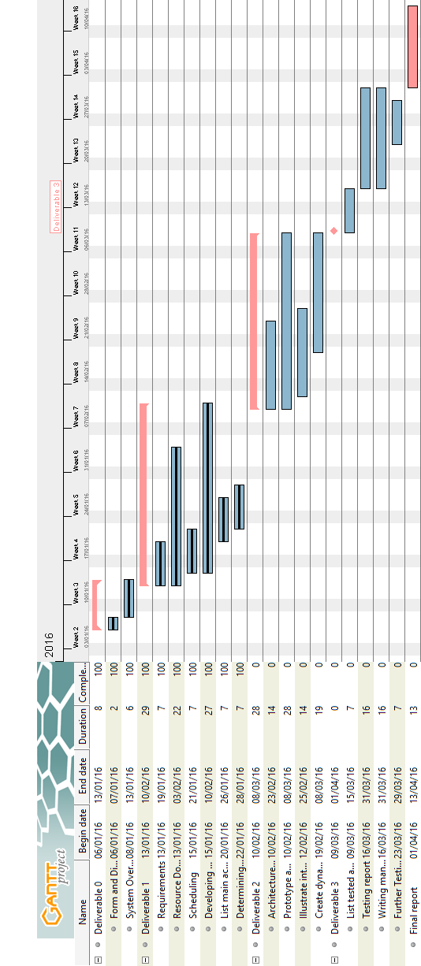

## Risk

Language Familiarities

The main languages used in this project revolve around PHP, SQL, JavaScript and jQuery; not all team members may have much experience using such languages.The language unfamiliarity risks causing further deadline delays due to the learning curves involved in learning a new language. Debugging issues can also arise due to potential inexperience with a certain programming language.

Mitigation of such a risk will involve the use of extensive research on languages, as well as the aid of other team members in learning and passing on knowledge of programming languages.

Server Uptime

This production environment of this project is set up at a team member’s own home. This could potentially cause a problem should a power outage occur or the server computer crashing. This can hinder deployment and may ultimately cause certain downtime until the issue is resolved.

Control Version System

The control version system in use is GitHub. However, GitHub requires an extensive learning curve to master and have full control over. This may cause unforeseen delays should there be an issue with the repository.

Mitigation of this risk will involve all team members becoming familiar with GitHub early on in the project. Working with their own repositories, learning how to add, commit, push, branch, and make pull requests on their own time, and learning how issues and milestones work will aid in reducing the potential of the risk occurring.

Time

One of the main concerns with a project this size is time constraint. With the given timeframe, it is uncertain whether there will be adequate time to complete the project in its entirety without the possibility of lacking certain functionality. Essentially, assessing some of the aforementioned risks, time is a common concern.

In order to attempt to mitigate such risks, tasks will be divided heavily amongst group members; given that the group consists of 12 members, dividing tasks up will serve to maximize time spent working on the project and time to completion of tasks.

|  |  |  |  |  |
| --- | --- | --- | --- | --- |
| Risk Table | | | | |
| Risk Summary | Risk Category | Probability | Impact (1-4) | RMMM |
| Server Uptime | Technology | Medium | 1 | **7.6.2** |
| Time | Estimation | High | 1 | **7.6.4** |
| Control Version System | People | High | 2 | **7.6.3** |
| Language Familiarities | People | Low | 3 | **7.6.1** |

# Prototyping

The prototype has three functioning pages, the login, the courses and the users page. The log in page allows the user to log in to the website only if their credentials check out. The website sends a request to the database to check if the username and password combination is valid. The current working pair of credentials is: Username= admin, Password= 1234. The update user page allows the user to change their information. This change is transmitted to the database and modifies the user's table. The course page allows the user to view a list of courses from the database. Currently all core class needed for the Software Engineering program are available to see on this list. The user may see information about ten classes at a time and can press the next and previous arrow to move through the list. In this prototype, all users created are admins. In a later iteration, the general user will have more restricted access to the database.

The Yii framework is used to construct this prototype. No members of the group were familiar with this framework thus building the prototype allowed the group members to learn the basics of this framework. This framework follows the MVC architecture format. Yii greatly simplified the processes of making classes to retrieve and modify information from the database by generating the model, view and controller class code in php. This prototype demonstrates that this framework is capable of performing all the specified project requirements.

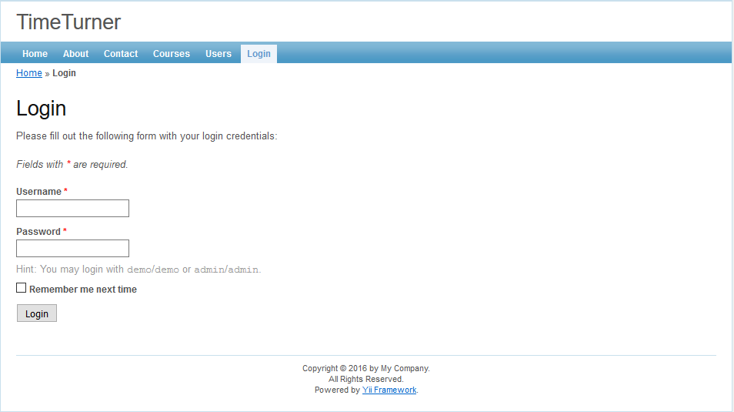

**Project Design Document – Deliverable 2**

# Introduction

The following section covers the design of TimeTurner in detail. This design is partitioned into different views and diagrams, starting with the 4+1 architecture view. This provides 5 individual views on the system which include logical, development, process, physical and scenario views. Following, will be descriptions of the subsystems, along with the classes included in each. Accompanying each class will be an in depth description of the class and their respective class diagrams. The final section includes all the dynamic design scenarios for each given situation defined by the use cases.

# Architectural Design

## Architecture Diagram (4+1 View)

Physical View

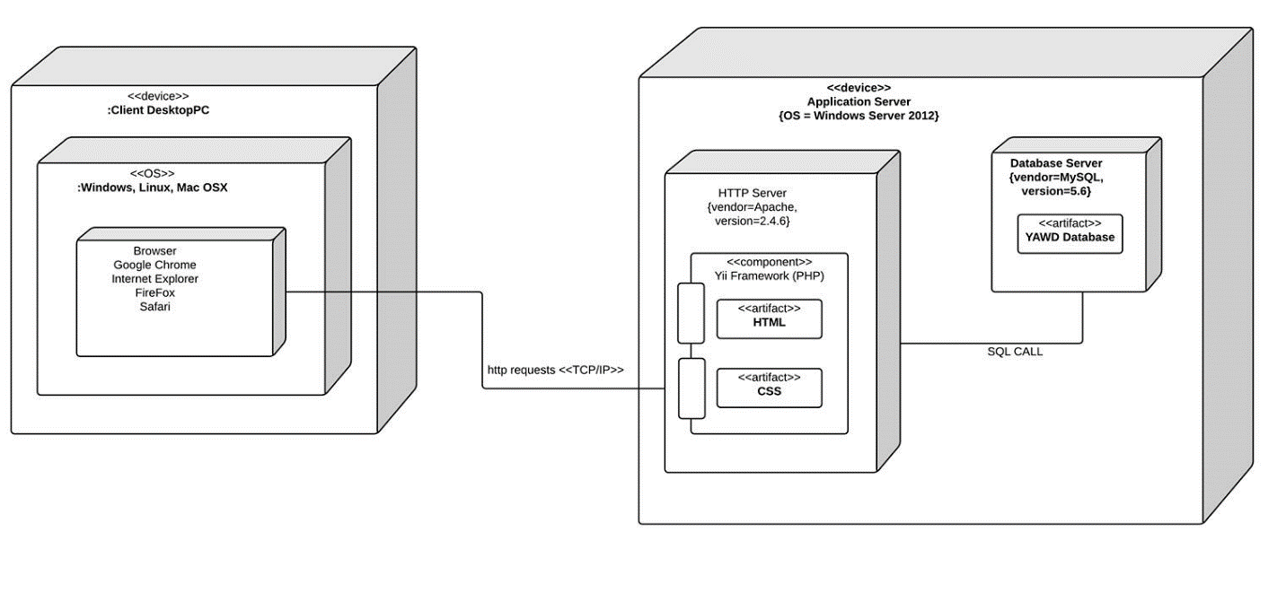

*Figure 3.1.1 Deployment diagram representing the physical view*

This diagram illustrates the physical deployment of the system. The system is a web-based application which uses a MVC architecture. The server component is located on the application server that runs Windows Server 2012. The server runs the Apache HTTP server supported by a MySQL database server. The database deploys seven tables, holding the information of saved users, all course, section, and subsection information, all prerequisites applying to those courses, the completed courses of each user, and each user’s saved schedules.

The system itself is deployed by the Yii framework, running on the Apache server, which takes care of the model, view and controller modules. The view modules are also deployed by various AJAX, HTML, and CSS files to provide the user with an appealing interface. The framework works closely with the database in order through SQL calls to keep all tables updated as users perform tasks on the system; this includes updating their list of courses completed and creation and upkeep of schedules.

The client component could be used on any device that has a supported web browser such as Google Chrome, Internet Explorer and Mozilla Firefox. Communication between client and server are done through HTTP request and responses.

Logical View

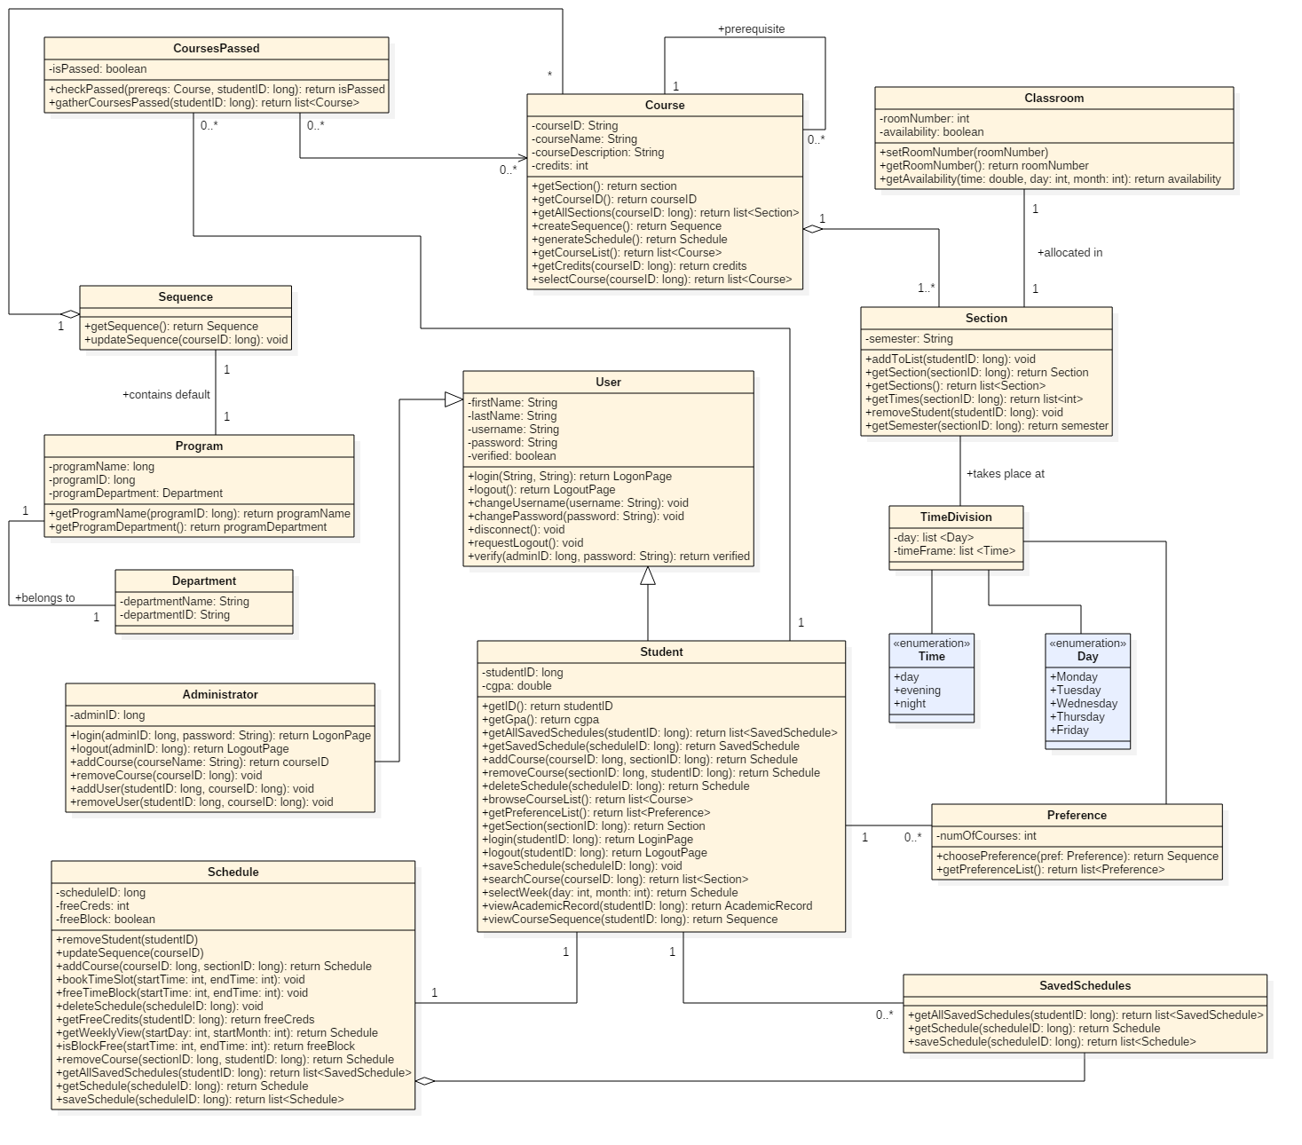

*Figure 3.1.2 Class diagram representing the logical view*

The logical view of the system’s architecture is represented by a full class diagram. The Student and Administrator classes are subclasses of the User superclass, where they inherit the methods of the latter, and overwrite the login() and logout() functions. The User class is an aggregate of SavedUsers, since the SavedUsers is comprised of many Users.

A student has a number of saved schedules, represented by the SavedSchedules class, a single schedule, and a number of preferences, which are the students preferred times and days of the week for classes.

The Section class is also related to the TimeDivision class by being offered at those times. Sections are also taken place in classrooms, therefore explaining the relationship between the two classes. It’s also related to the Course class through aggregation.

The Course class is an aggregation of the Section class, because a course is composed of many sections. A course has a number of prerequisites represented by the Prerequisites class, and a class CoursesPassed inherits from the Course class, which represents the courses from the Course class that have or have not been credited.

The Sequence class is an aggregation of the Course class, because a sequence is composed of courses. A program also contains its own default sequence of courses, which is shown with the relationship between the Program and Sequence classes. In addition, a program belongs to a department.

Process View

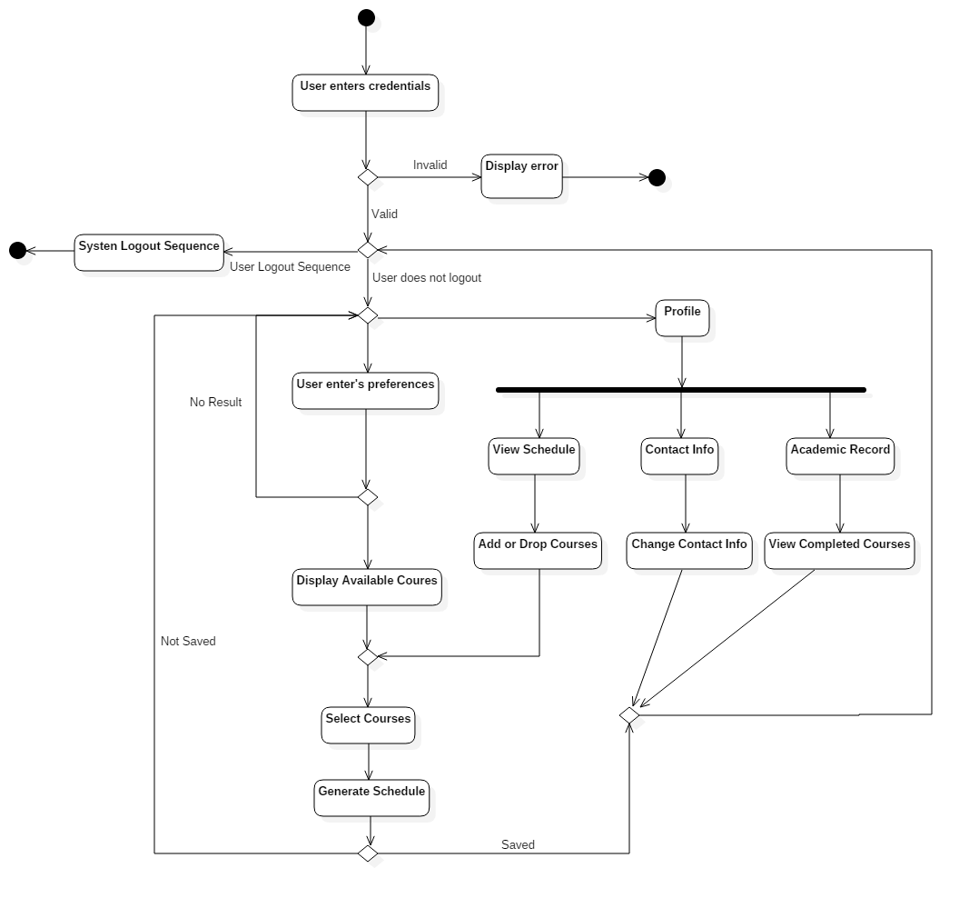

*Figure 3.1.3 Activity diagram representing the process view*

The main activity sequence in Time Turner shows the flow of events for a student course sequence generator and profile view. The flow of events start with the student user entering his credentials, which is verified. If the user enters invalid information, an error occurs, an error message is sent and the user is sent back to the login page.

From this point, the user has 3 options:

1. **Logout:** The user chooses to logout. The system will go through the proper sequence and return to the home page.
2. **Profile:** The user chooses to go to the profile page. Once there, the user has 3 options, contact info, academic record or view schedule. If contact info is chosen, the user is able to change his/her info and the system will return them to the home page. If academic record is chosen, the user is able to view completed courses and the system will send them back to the home page. If view schedule is chosen, the user is able to add and remove specific courses from their generated list. At this point, their choices will be verified and they must generate a new schedule.
3. **Generate Schedule:** The user chooses to enter preferences. Once the user has selected their prefered selection, the system will show available classes. If no result has been shown, the user must make a new selection for their preferences. If classes have been shown, the user is able to select their preferred lectures/tutorials/labs with checkboxes. Once selected, the system will generate a schedule and save it to the user’s profile.

Development View

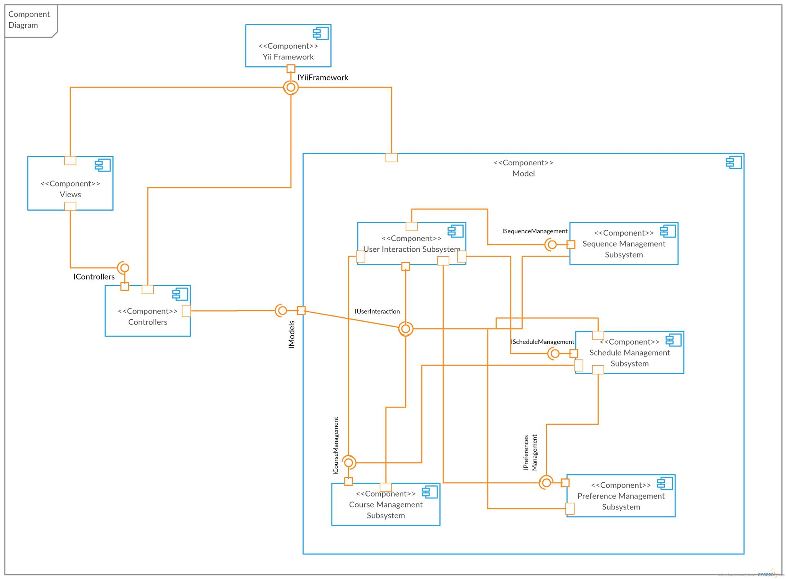

*Figure 3.1.4 Component diagram representing the development view*

Time Turner is broken down into three main components which are based on the MVC architecture. Each of these components are dependent on the Yii framework which provides services to the rest of the application.

The Views component is comprised of all the user interfaces for Time Turner and is the component in which the user first interacts with the system. The Controllers component is paired with an interface from the view component to provide access to the system.

The Models component is by far the most complex and is composed of 5 unique subsystems components. The point of interest to the various subsystems of the model component is the User Interaction Subsystem which is comprised of classes to give services to the user such as, viewing the course sequence and searching for courses. Classes of the User Interaction Subsystem will call upon methods from other subsystems such as the Sequence Management Subsystem, to view the user’s current sequence, Schedule Management Subsystem to generate schedules and register for courses, Preference Management Subsystem to record user’s requirements and Courses Management Subsystem to view courses offered by the university. To complete these tasks, many of these subsystems must communicate with each other, such as the Schedule Management Subsystem which works with the Courses Management Subsystem in order to know which classes are available to the student. It is also necessary for the User Interaction Subsystem to give information about the user to the subsystems in order to ensure that tasks are completed properly.

Situational View (Use Cases)



*Figure 3.1.5 Use case diagram representing the situational view*

The situational, or “+1”, view of the system’s architecture is represented by a full use case diagram. The use cases of the Student and Administator users are depicted in the diagram, represented by the ellipses.

The actions a student can perform are logging into the scheduler, creating their course sequence, viewing their academic record, and logging out of the scheduler. Creating the course sequence is comprised of several actions, including changing the preferences of the sequence, adding classes to the sequence, dropping classes, and generating schedule. The generating schedule use case is an extension of the saving schedule use case, which is an extension of viewing the schedule use case.

The administrator ‘s actions include login, logout, and manage sections. Similar to the student’s use cases, the login use case is an extension of the browsing course list use case, which is an extension of adding and removing classes. In addition, the administrator manages a section, which includes the action of changing the section’s teacher.

## Subsystem Interfaces Specifications

The system consists of five interfaces: IUserInteraction, IScheduleManagement, ICourseManagement, IPreferenceManagement and ISequenceManagement. Each of these interfaces provides a set of methods that components can publicly access. The classes that implement these interfaces are the ones presented in the architecture diagram (See Section 3.1.2) and the use of the method calls are explained in further detail in dynamic design scenarios (See Section 5).

IUserInteraction

The user interaction interface provides basic methods that a user (administrator or student) will use to interact with the system. Those interactions include login and logout operations. This interface also allows a user to consult data related to courses and schedules, but no modifications on those data are allowed through this interface. The classes implementing the provided methods are the Student, Administrator and SavedUsers classes.

Specifications for methods implemented by the Student class

|  |
| --- |
| **Method** |
| browseCourseList() list of Course objects |
| **Specification** |
| ***Description:***  Retrieves and returns a list of courses that a student can take.  ***Input parameter(s):***  none  ***Return type:***  list of Course objects |

|  |
| --- |
| **Method** |
| getSavedSchedule(scheduleID:long) Schedule |
| **Specification** |
| ***Description:***  Given a schedule ID, retrieves and returns a specific saved schedule that represents the schedule of a semester.  ***Input parameter(s):***  scheduleID:long representing the schedule ID  ***Condition(s) for validity:***  scheduleID ≥ 0  ***Return type:***  Schedule |

|  |
| --- |
| **Method** |
| login(studentID:long, password:String) LogonPage |
| **Specification** |
| ***Description:***  Logs a student into the system, provided that the student ID and password passed as parameters are valid.  ***Input parameter(s):***  studentID:long representing the ID of the student to be logged in  password:String representing the password entered by the user  ***Conditions for validity:***  studentID ≥ 0  password is not empty  ***Return type:***  LogonPage |

|  |
| --- |
| **Method** |
| logout(studentID:long) LogoutPage |
| **Specification** |
| ***Description:***  Logs a student out of the system.  ***Input parameter(s):***  studentID:long representing the ID of the student to be logged out  ***Conditions for validity:***  studentID ≥ 0  ***Return type:***  LogoutPage |

|  |
| --- |
| **Method** |
| searchCourse(courseID:long) list of Section objects |
| **Specification** |
| ***Description:***  Retrieves and returns information about a course, including the course’s sections, given the course ID.  ***Input parameter(s):***  courseID:long representing the course ID  ***Conditions for validity:***  courseID ≥ 0  ***Return type:***  list of Section objects |

|  |
| --- |
| **Method** |
| selectWeek(day:int, month:int) Schedule |
| **Specification** |
| ***Description:***  Provides the caller with a weekly schedule view given the day and month as valid integer values for the targeted week.  ***Input parameter(s):***  day:int representing a calendar day in the targeted week  month:int representing the month of the targeted week  ***Conditions for validity:***  1 ≤ day ≤ 31  1 ≤ month ≤ 12  ***Return type:***  Schedule |

|  |
| --- |
| **Method** |
| viewAcademicRecord(studentID:long) AcademicRecord |
| **Specification** |
| ***Description:***  Allows to view the academic record of a student given the student’s ID.  ***Input parameter(s):***  studentID:long representing the ID of the student  ***Conditions for validity:***  studentID ≥ 0  ***Return type:***  AcademicRecord |

|  |
| --- |
| **Method** |
| viewCourseSequence(studentID:long) Sequence |
| **Specification** |
| ***Description:***  Retrieves and returns the sequence of a student given the ID of the student.  ***Input parameter(s):***  studentID:long representing the ID of the student  ***Conditions for validity:***  studentID ≥ 0  ***Return type:***  Sequence |

Specifications for methods implemented by the Administrator class

|  |
| --- |
| **Method** |
| login(adminID:long, password:String) LogonPage |
| **Specification** |
| ***Description:***  Logs an administrator into the system, provided that the admin ID and password passed as parameters are valid.  ***Input parameter(s):***  adminID:long representing the ID of the administrator to be logged in  password:String representing the password entered by the user  ***Conditions for validity:***  adminID ≥ 0  password is not empty  ***Return type:***  LogonPage |

|  |
| --- |
| **Method** |
| logout(adminID:long) LogoutPage |
| **Specification** |
| ***Description:***  Logs an administrator out of the system.  ***Input parameter(s):***  adminID:long representing the ID of the administrator to be logged out  ***Conditions for validity:***  adminID ≥ 0  ***Return type:***  LogoutPage |

Specifications for methods implemented by the SavedUsers class

|  |
| --- |
| **Method** |
| disconnect() |
| **Specification** |
| ***Description:***  Disconnects a user from the system.  ***Input parameter(s):***  none  ***Return type:***  void |

|  |
| --- |
| **Method** |
| requestLogout() |
| **Specification** |
| ***Description:***  Logs a user out of the system.  ***Input parameter(s):***  none  ***Return type:***  void |

|  |
| --- |
| **Method** |
| verify(userID:long, password:String) boolean |
| **Specification** |
| ***Description:***  Verifies that a userID matches the password associated with it. Returns true if the given information is valid, false otherwise.  ***Input parameter(s):***  userID:long representing the ID of the user  password:String representing the password the user entered  ***Conditions for validity:***  userID ≥ 0  password is not empty  ***Return type:***  boolean |

IScheduleManagement

The IScheduleManagement interface consists of a set of methods that allow another component to access and modify data about a schedule. The classes Schedule and SavedSchedules implement the provided methods.

Specifications for methods implemented by the Schedule class

|  |
| --- |
| **Method** |
| addCourse(courseID:long, sectionID:long) Schedule |
| **Specification** |
| ***Description:***  Adds a course given the course ID and the section ID to a student’s schedule.  ***Input parameter(s):***  courseID:long representing the ID of the course  sectionID:long representing the ID of the section  ***Conditions for validity:***  courseID ≥ 0  sectionID ≥ 0  ***Return type:***  Schedule |

|  |
| --- |
| **Method** |
| bookTimeSlot(startTime:int, endTime:int) |
| **Specification** |
| ***Description:***  Sets time slots in a scheduled as occupied given the starting and ending time of the time block to book.  ***Input parameter(s):***  startTime:int representing the time at which the time block starts  endTime:int representing the time at which the time block ends  ***Conditions for validity:***  0 ≤ startTime ≤ endTime  ***Return type:***  void |

|  |
| --- |
| **Method** |
| deleteSchedule(scheduleID:long) |
| **Specification** |
| ***Description:***  Deletes a schedule given its schedule ID.  ***Input parameter(s):***  scheduleID:long representing the ID of the schedule to be deleted  ***Conditions for validity:***  scheduleID ≥ 0  ***Return type:***  void |

|  |
| --- |
| **Method** |
| freeTimeBlock(startTime:int, endTime:int) |
| **Specification** |
| ***Description:***  Frees a time block of a schedule given the start and end time of the block.  ***Input parameter(s):***  startTime:int representing the time at which the time block starts  endTime:int representing the time at which the time block ends  ***Conditions for validity:***  0 ≤ startTime ≤ endTime  ***Return type:***  void |

|  |
| --- |
| **Method** |
| getFreeCredits(studentID:long) int |
| **Specification** |
| ***Description:***  Returns the number of free credits a student is still allowed to take.  ***Input parameter(s):***  studentID:long representing the ID of the student  ***Conditions for validity:***  studentID ≥ 0  ***Return type:***  int |

|  |
| --- |
| **Method** |
| getWeeklyView(startDay:int, startMonth:int) Schedule |
| **Specification** |
| ***Description:***  Generates a weekly view of a schedule given the starting date.  ***Input parameter(s):***  startDay:int representing the day on which the week starts  startMonth:int representing the month in which the week is found  ***Conditions for validity:***  1 ≤ startDay ≤ 31  1 ≤ startMonth ≤ 12  ***Return type:***  Schedule |

|  |
| --- |
| **Method** |
| isBlockFree(startTime:int, endTime:int) boolean |
| **Specification** |
| ***Description:***  Verifies whether a time block defined by the given starting and ending time is free in a schedule.  ***Input parameter(s):***  startTime:int representing the time at which the time block starts  endTime:int representing the time at which the time block ends  ***Conditions for validity:***  0 ≤ startTime ≤ endTime  ***Return type:***  boolean |

|  |
| --- |
| **Method** |
| removeCourse(sectionID:long, studentID:long) Schedule |
| **Specification** |
| ***Description:***  Removes a given course section from the schedule of a student.  ***Input parameter(s):***  sectionID:long representing the ID of the section to be removed  studentID:long representing the ID of the student  ***Conditions for validity:***  sectionID ≥ 0  studentID ≥ 0  ***Return type:***  Schedule |

Specifications for methods implemented by the SavedSchedules class

|  |
| --- |
| **Method** |
| getAllSavedSchedules(studentID:long) list of Schedule objects |
| **Specification** |
| ***Description:***  Retrieves and returns all saved schedules of a student given its student ID.  ***Input parameter(s):***  studentID:long representing the student ID  ***Condition(s) for validity:***  studentID ≥ 0  ***Return type:***  list of Schedule objects |

|  |
| --- |
| **Method** |
| getSchedule(scheduleID:long) Schedule |
| **Specification** |
| ***Description:***  Retrieves and returns the schedule of a semester given the ID of the schedule.  ***Input parameter(s):***  scheduleID:long representing the ID of the schedule  ***Conditions for validity:***  scheduleID ≥ 0  ***Return type:***  Schedule |

|  |
| --- |
| **Method** |
| saveSchedule(scheduleID:long) list of Schedule objects |
| **Specification** |
| ***Description:***  Saves a new schedule related to a student given the schedule ID, then returns an updated list of schedules that have been saved.  ***Input parameter(s):***  scheduleID:long representing the ID of the schedule to be saved  ***Conditions for validity:***  scheduleID ≥ 0  ***Return type:***  list of Schedule objects |

ICourseManagement

The ICourseManagement interface allows to consult information about academic courses as well as the sections of each course. It also allows to perform modification on courses, such as adding and removing students from a course. The ICourseManagement interface is also responsible for creating course sequences and generating schedules. The Course, CoursesPassed, Section and Prerequisites classes are the ones implementing the provided methods.

Specifications for methods implemented by the Course class

|  |
| --- |
| **Method** |
| createSequence() Sequence |
| **Specification** |
| ***Description:***  Creates and returns a course sequence for a student.  ***Input parameter(s):***  none  ***Return type:***  Sequence |

|  |
| --- |
| **Method** |
| generateSchedule() Schedule |
| **Specification** |
| ***Description:***  Generates and returns a student’s schedule.  ***Input parameter(s):***  none  ***Return type:***  Schedule |

|  |
| --- |
| **Method** |
| getAllSections(courseID:long) list of Section objects |
| **Specification** |
| ***Description:***  Returns a list containing all the sections of a course.  ***Input parameter(s):***  courseID:long representing the ID of the course to be consulted  ***Conditions for validity:***  courseID ≥ 0  ***Return type:***  list of Section objects |

|  |
| --- |
| **Method** |
| getCourseList() list of Course objects |
| **Specification** |
| ***Description:***  Returns a list containing all courses that a student can take.  ***Input parameter(s):***  none  ***Return type:***  list of Course objects |

|  |
| --- |
| **Method** |
| getCredits(courseID:long) int |
| **Specification** |
| ***Description:***  Returns the number of assigned credits of a course.  ***Input parameter(s):***  courseID:long representing the ID of the course  ***Conditions for validity:***  courseID ≥ 0  ***Return type:***  int |

|  |
| --- |
| **Method** |
| selectCourse(courseID:long) list of Section objects and Prerequisite objects |
| **Specification** |
| ***Description:***  Given the ID of the selected course, returns information including the sections and prerequisites of that course.  ***Input parameter(s):***  courseID:long representing the ID of the course  ***Conditions for validity:***  courseID ≥ 0  ***Return type:***  (mixed) list of Section objects and Prerequisite objects |

Specifications for methods implemented by the CoursesPassed class

|  |
| --- |
| **Method** |
| checkPassed(prereqs:Course, studentID:long) boolean |
| **Specification** |
| ***Description:***  Verifies that a student has passed a prerequisite course. Returns true if the student has passed, false otherwise.  ***Input parameter(s):***  courseID:long representing the ID of the prerequisite course  studentID:long representing the ID of the student to verify  ***Conditions for validity:***  courseID ≥ 0  studentID ≥ 0  ***Return type:***  Boolean |

|  |
| --- |
| **Method** |
| gatherCoursesPassed(studentID:long) list of Course objects |
| **Specification** |
| ***Description:***  Retrieves and returns a list of courses that a student has successfully completed.  ***Input parameter(s):***  studentID:long representing the ID of the student  ***Conditions for validity:***  studentID ≥ 0  ***Return type:***  list of Course objects |

Specifications for methods implemented by the Section class

|  |
| --- |
| **Method** |
| addToList(studentID:long) |
| **Specification** |
| ***Description:***  Adds a student to the list of registered student for a section given the student ID.  ***Input parameter(s):***  studentID:long representing the ID of the student  ***Conditions for validity:***  studentID ≥ 0  ***Return type:***  void |

|  |
| --- |
| **Method** |
| getSection(sectionID:long) Section |
| **Specification** |
| ***Description:***  Retrieves and returns information about a course given the section ID.  ***Input parameter(s):***  sectionID:long representing the ID of the section  ***Conditions for validity:***  sectionID ≥ 0  ***Return type:***  Section |

|  |
| --- |
| **Method** |
| getSections() list of Section objects |
| **Specification** |
| ***Description:***  Retrieves and returns a list of section associated with a course.  ***Input parameter(s):***  none  ***Return type:***  list of Section objects |

|  |
| --- |
| **Method** |
| getTimes(sectionID:long) list of int |
| **Specification** |
| ***Description:***  Returns a list of integers representing the starting and ending time of each time block that a section holds.  ***Input parameter(s):***  sectionID:long representing the ID of the section  ***Conditions for validity:***  sectionID ≥ 0  ***Return type:***  list of int |

|  |
| --- |
| **Method** |
| removeStudent(studentID:long) |
| **Specification** |
| ***Description:***  Removes a student from the list of registered student of a course.  ***Input parameter(s):***  studentID:long representing the ID of the student to be removed  ***Conditions for validity:***  studentID ≥ 0  ***Return type:***  void |

Specifications for methods implemented by the Prerequisites class

|  |
| --- |
| **Method** |
| getPrerequisites() list of Prerequisite objects |
| **Specification** |
| ***Description:***  Returns a list of prerequisites for a course, or an empty list if no prerequisite courses are required for a course.  ***Input parameter(s):***  none  ***Return type:***  list of Prerequisite objects |

IPreferenceManagement

The preference management interface allows to access and modify data related to the scheduling preferences of a student. The only class implementing the methods provided by this interface is the Preferences class.

Specifications for methods implemented by the Preferences class

|  |
| --- |
| **Method** |
| choosePreference(pref:Preference) Sequence |
| **Specification** |
| ***Description:***  Adds a preference to the list of scheduling preferences of a student and returns the list of all chosen preferences.  ***Input parameter(s):***  pref:Preference representing a chosen preference  ***Conditions for validity:***  pref != null  ***Return type:***  list of Preference objects |

|  |
| --- |
| **Method** |
| getPreferenceList() list of Preference objects |
| **Specification** |
| ***Description:***  Retrieves and returns a list of preferences assigned to a student.  ***Input parameter(s):***  none  ***Return type:***  list of Preference objects |

ISequenceManagement

The sequence management interface provides methods to access and modify the course sequence of a student. The only class implementing the provided methods is the Sequence class.

Specifications for methods implemented by the Sequence class

|  |
| --- |
| **Method** |
| getSequence() Sequence |
| **Specification** |
| ***Description:***  Returns an object representing a course sequence of a student.  ***Input parameter(s):***  none  ***Return type:***  Sequence |

|  |
| --- |
| **Method** |
| updateSequence(courseID:long) |
| **Specification** |
| ***Description:***  Updates a course sequence after a course removal given the ID of the course removed.  ***Input parameter(s):***  courseID:long representing the ID of the course removed  ***Conditions for validity:***  courseID ≥ 0  ***Return type:***  void |

# Detailed Design

## Detailed Design Diagram and Unit Descriptions

iUserInteraction

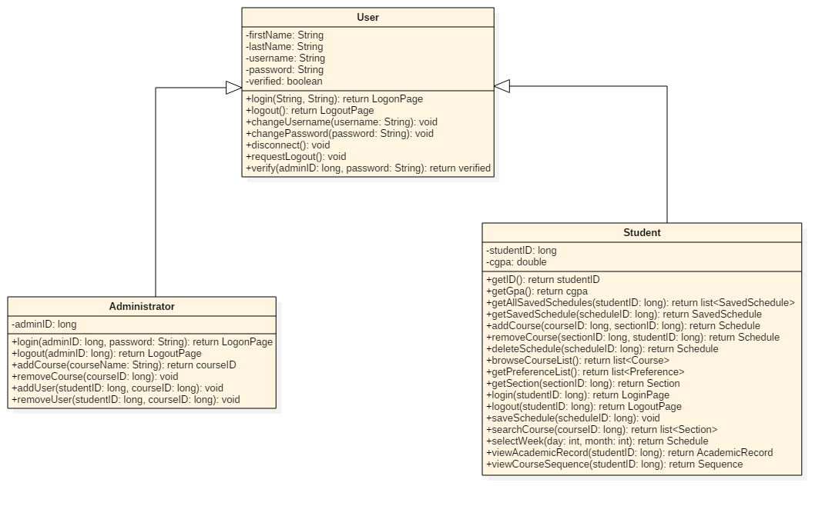

*Figure 4.1.1 IUserInteraction subsystem class diagram*

This subsystem is responsible to every interaction made between the User and the System, such as logging in, browsing the course list, setting preferences, adding courses, logging out, etc. The classes in this subsystem are the Student, Administrator and SavedUsers classes. Therefore, this subsystem represents the functions behind the user interface of the system.

|  |
| --- |
| **Student Class** |
| **Description** |
| This class models students, which are users that interact with the program directly. |
| **Attributes** |
| studentID: long  the studentID is a unique identifier for every student  cgpa: double  the cgpa is the cumulative GPA of each student |
| **Methods** |
| * getAllSavedSchedules(studentID:long) list of Schedule objects   returns a list of all the previous and upcoming schedules of a student   * getSavedSchedule(scheduleID:long) Schedule   returns the saved schedule of a student   * addCourse(courseID:long, sectionID:long) Schedule   adds a course with section sectionID to the student’s sequence   * removeCourse(sectionID:long, studentID:long) Schedule   removes a course from the student’s sequence   * deleteSchedule(scheduleID: long) Schedule   deletes the entire schedule   * browseCourseList() list of Course objects   returns a list of all the available courses   * getPreferenceList() list of Preference objects   returns the student’s preferences   * getSection(sectionID:long) Section   returns the section   * login(studentID:long, password:String) LogonPage   gives the student access to the system   * logout(studentID:long) LogoutPage   disconnects student from the system   * saveSchedule(scheduleID:long)   saves changes to the schedule   * searchCourse(courseID:long) list of Section objects   takes a course ID as input and returns the matched results   * selectWeek(day:int, month:int) Schedule   returns a schedule of the selecteddate   * viewAcademicRecord(studentID:long) AcademicRecord   returns the student’s academic record   * viewCourseSequence(studentID:long) Sequence   returns the student’s sequence |

|  |
| --- |
| **Administrator Class** |
| **Description** |
| Administrators are users that interact with the program directly. They log in, make changes in the schedule, then log out. |
| **Attributes** |
| adminID: long  the adminID is a unique identifier for each administrator |
| **Methods** |
| * login(adminID:long, password:String) LogonPage * logout(adminID:long) LogoutPage |

|  |
| --- |
| **SavedUsers Class** |
| **Description** |
| SavedUsers is the class that verifies if a user is legitimate or not, and allows it to logout. |
| **Attributes** |
| verified: Boolean  this attribute is the state of the user which determines whether his login is successful or not |
| **Methods** |
| * disconnect() void   disconnects the student from the system   * requestLogout() void   makes a request to disconnect   * verify(adminID: long, password: String) verified   verifies if the login info is correct |

IScheduleManagement

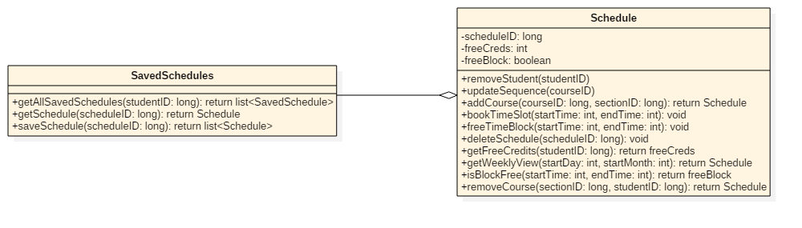

*Figure 4.1.2 IScheduleManagement subsystem class diagram*

The Schedule Management subsystem, consisting of the Schedule and SavedSchedules classes, is responsible for all schedule operations. In other words, whenever another one of the subsystems wants to modify or interact with a schedule or the list of schedules, they interact with this subsystem which in turn does the operations.

|  |
| --- |
| **Schedule Class** |
| **Description** |
| This class manages courses in a schedule, and ensures that courses don’t overlap |
| **Attributes** |
| scheduleID: long  every schedule has a unique long identifier  freeCreds: int  freeCreds is the amount of remaining free credits that the student can take in a semester  freeBlock: boolean  freeBlock is a Boolean which determines whether the time for a class is free or not |
| **Methods** |
| * removeStudent(studentID)   removes the student   * updateSequence(courseID)   updates the sequence after changes are made   * addCourse(courseID:long, sectionID:long) Schedule   adds a course to the schedule   * bookTimeSlot(startTime:int, endTime:int)   books a timeslot for a course to prevent overlap   * freeTimeBlock(startTime:int, endTime:int)   frees a timeslot that was booked   * deleteSchedule(scheduleID:long)   deletes a schedule   * getFreeCredits(studentID:long) int   returns the amount of credits still available   * getWeeklyView(startDay:int, startMonth:int) Schedule   returns a weekly view of the schedule   * isBlockFree(startTime:int, endTime:int) Boolean   computes if the timeslot is available and returns true or false   * removeCourse(sectionID:long, studentID:long) Schedule   removes a course from the schedule |

|  |
| --- |
| **SavedSchedules** |
| **Description** |
| This class manages schedules as a whole. It could get a schedule, save it, or get a list off all schedules that are in the system. |
| **Attributes** |
| None |
| **Methods** |
| * getAllSavedSchedules(studentID:long) list of Schedule objects   returns all schedules available in the system   * getSchedule(scheduleID:long) Schedule   returns a single schedule that has the id scheduleID   * saveSchedule(scheduleID:long) list of Schedule objects   saves changes made to schedules |

ICourseManagement

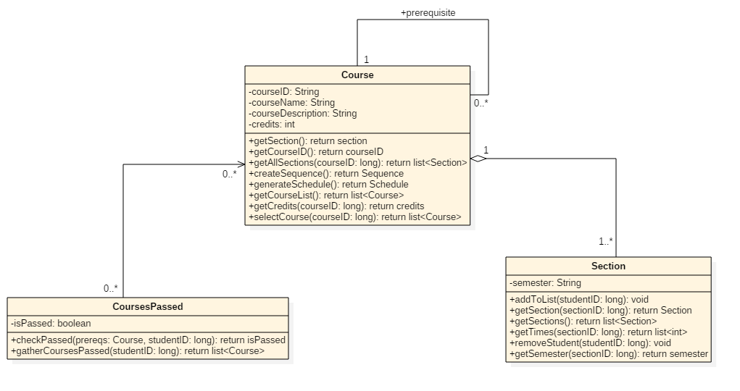

*Figure 4.1.3 ICourseManagement subsystem class diagram*

The Course, CoursesPassed, Section and Prerequisite classes make up this subsystem. Because the Courses are much more complex than a name (they contain sections, times, prerequisites, etc.), we cannot have a single class take care of everything. Instead, we have the Course Management subsystem which uses the above classes to modify and interact with the Courses.

|  |
| --- |
| **Course Class** |
| **Description** |
| The Course class contains all the information on the classes available. |
| **Attributes** |
| courseID: String  every course has a unique String identifier  courseName: String  every course has a name  courseDescription: String  courses have a String description  credits: int  this attribute is an integer value of the credits the course is worth |
| **Methods** |
| * getSection() section   returns a section of a class   * getCourseList() list of Course objects   returns a list of available courses   * getAllSections(courseID:long) list of Section objects   returns a list of all available sections   * createSequence() Sequence   initializes a sequence   * generateSchedule() Schedule   generates a schedule based on preferences   * getCourseList() list<Course>   gets a list of courses in a schedule   * getCredits(courseID:long) int   returns the credits of a course   * selectCourse(courseID:long) list of Section objects and Prerequisite objects   selects a course that has the ID courseID |

|  |
| --- |
| **CoursesPassed Class** |
| **Description** |
| This class is responsible for confirming and returning the passed courses. |
| **Attributes** |
| isPassed: Boolean  this attribute is a Boolean value that determines if a course is already passed or not |
| **Methods** |
| * checkPassed(prereqs:Course, studentID:long) boolean   checks if a course is passed by student with ID studentID   * gatherCoursesPassed(studentID:long) list of Course objects   returns a list of passed courses for student with ID studentID |

|  |
| --- |
| **Section Class** |
| **Description** |
| A course can have multiple sections; this class contains the different sections and is responsible for adding and removing students from the sections. |
| **Attributes** |
| semester: String  the semester String is a value which determines which semester the course is in |
| **Methods** |
| * addToList(studentID:long)   adds a student to a section   * getSection(sectionID:long) Section   returns a section with the ID sectionID   * getSections() list of Section objects   returns a list of available sections   * getTimes(sectionID:long) list of int   returns the time of section with ID sectionID   * removeStudent(studentID:long)   removes student with ID studentID from a section |

|  |
| --- |
| **Prerequisite Class** |
| **Description** |
| Each course has a list of prerequisites. This class returns this list. |
| **Attributes** |
| None |
| **Methods** |
| * getPrerequisites() list of Prerequisite objects   returns the prerequisites of a course |

IPreferenceManagement

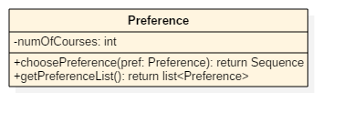

*Figure 4.1.4 IPreferenceManagement subsystem class diagram*

Though this subsystem only contains one class: the Preference class, tt is responsible for taking the students preferences and giving it to another subsystem to help create a schedule according to the student’s needs. These preferences dictate the sections that are shown to the student in order to choose from to build their schedules.

|  |
| --- |
| **Preference Class** |
| **Description** |
| This class manages the user’s preference and generates a sequence, and is capable of returning all the preferences in the system. |
| **Attributes** |
| numOfCourses: int  numOfCourses is an integer attribute that determines how many courses a student wishes to take |
| **Methods** |
| * choosePreference(pref:Preference) Sequence   applies the preferences set by the user and returns a sequence   * getPreferenceList() list of Preference objects   gets the preferences set by the user |

ISequenceManagement

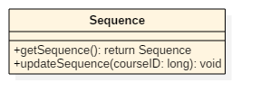

*Figure 4.1.5 ISequenceManagement subsystem class diagram*

This subsystem also contains one class, the Sequence class. It is responsible for returning the Sequence of a student to a user who wishes to view it, or to update the sequence by removing courses (when a student completes a course). The sequence dictates which classes a student may take in any given semester, and is updated when a student adds or drops a class on their schedule.

|  |
| --- |
| **Sequence Class** |
| **Description** |
| This class allows other classes to get the Sequence of a student, and the class also is capable of updating the sequence whenever a course is completed. |
| **Attributes** |
| None |
| **Methods** |
| * getSequence() Sequence   returns a sequence of a student   * updateSequence(courseID:long)   whenever a course is passed, this method is used to remove the course from the sequence |

# Dynamic Design Scenarios

Use Case 1: Login to TimeTurner

Fully Dressed Use Case

|  |  |  |
| --- | --- | --- |
| Use Case ID: | UC1 | |
| Use Case Name: | Login to TimeTurner | |
| Created By: | Marc-Andre Leclair | Last Updated By: Claudia Della Serra |
| Date Created: | January 25th, 2016 | Last Revision Date: February 8, 2016 |
| Actor(s): | Student, Administrator | |
| Goal/Actor Goals: | A student or Administrator wants to Login in their account | |
| Description/Summary: | The Student or Administrator wants to login into their account. The initial webpage contains a login box where the he or she can enter their username and password. The request is sent and it is check in the database whether or not the account exist or if the password is correct | |
| Preconditions: | * The user has an internet connection. * The user has valid login credentials. | |
| Post-conditions: | The user is authenticated and logged in. | |
| Minimum Guarantee: | User will not log in | |
| Basic Flow: | 1. Student enters its login information 2. Server verifies if it is in the database 3. Student is logged in and brought to the home page. | |
| Risk assessment: | Low | |
| Importance assessment: | 5/5 | |

5.1.2 System Sequence Diagrams

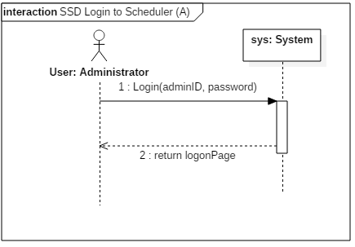

*Figure 5.1.1 Administrator login system sequence diagram*

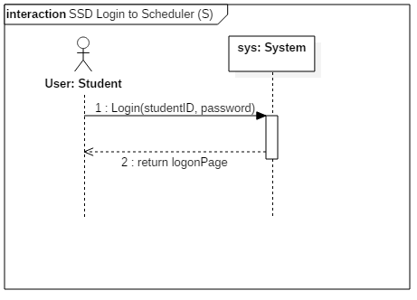

*Figure 5.1.2 Student login system sequence diagram*

5.1.3 Contract Diagrams

|  |  |  |
| --- | --- | --- |
| Contract 1.1 | Login | |
| Created By: | Ryan Lee | Last Updated By: Ryan Lee |
| Date Created: | March 17, 2016 | Last Revision Date: March 17, 2016 |
| Operation: | login(adminID: long) | |
| Cross-reference: | UC1 | |
| Preconditions: | * The user has an internet connection. * The user has valid login credentials. | |
| Post-conditions: | * The user is logged into their account. (instance creation) * A connection to the servers is established. (association creation) | |

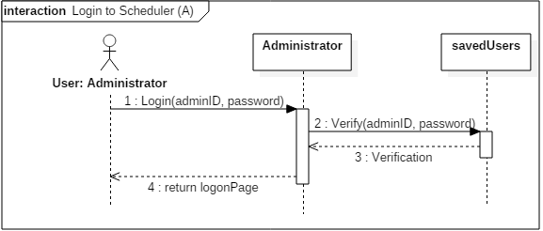

*Figure 5.1.3 Administrator login contract diagram*

|  |  |  |
| --- | --- | --- |
| Contract 1.2 | Login | |
| Created By: | Ryan Lee | Last Updated By: Ryan Lee |
| Date Created: | March 17, 2016 | Last Revision Date: March 17, 2016 |
| Operation: | login(studentID: long) | |
| Cross-reference: | UC1 | |
| Preconditions: | * The user has an internet connection. * The user has valid login credentials. | |
| Post-conditions: | * The user is logged in. (instance creation) * A connection to the servers is established. (association creation) | |

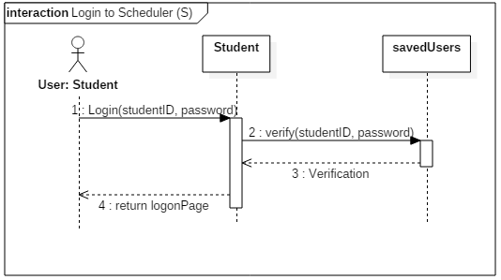

*Figure 5.1.4 Student login contract diagram*

Use Case 2 : Logout of TimeTurner

Fully Dressed Use Case

|  |  |  |
| --- | --- | --- |
| Use Case ID: | UC2 | |
| Use Case Name: | Logout of Scheduler | |
| Created By: | Marc-Andre Leclair | Last Updated By: Ryan Lee |
| Date Created: | January 25th, 2016 | Last Revision Date: March 17, 2016 |
| Actor(s): | Student, Administrator | |
| Goal/Actor Goals: | A student or Administrator wants to Logout of their account. | |
| Description/Summary: | The Student or Administrator wants to logout of their account. He or she sends a request to the server to close the connection between themselves and the Time Turner. | |
| Preconditions: | The user is logged in their account | |
| Post-conditions: | The user is disconnected from the server and logged out. | |
| Minimum Guarantee: | User will remain logged in | |
| Basic Flow: | 1. The user indicates that they wish to logout of the system. 2. The server terminates the connection. 3. The user is logged out through the webpage. | |
| Risk assessment: | Low | |
| Importance assessment: | 5/5 | |

System Sequence Diagrams

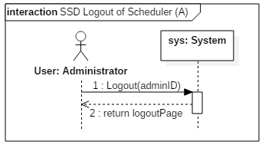

*Figure 5.2.1 Administrator logout system sequence diagram*

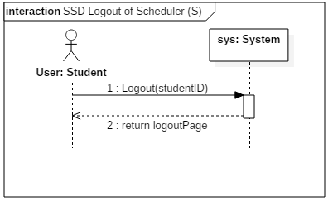

*Figure 5.2.2 Student logout system sequence diagram*

Contract Diagrams

|  |  |  |
| --- | --- | --- |
| Contract 2.1 | Logout | |
| Created By: | Ryan Lee | Last Updated By: Ryan Lee |
| Date Created: | March 17, 2016 | Last Revision Date: March 17, 2016 |
| Operation: | logout(adminID: long) | |
| Cross-reference: | UC2 | |
| Preconditions: | * The user is logged into their account. | |
| Post-conditions: | * The user is disconnected from the server and logged out. (instance deletion) | |

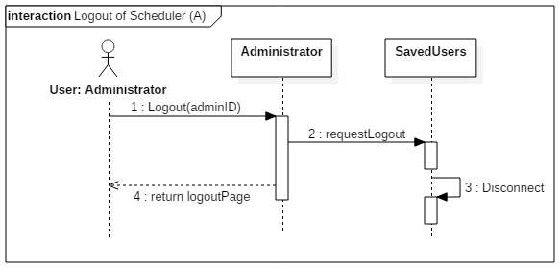

*Figure 5.2.3 Administrator logout contract diagram*

|  |  |  |
| --- | --- | --- |
| Contract 2.2 | Logout | |
| Created By: | Ryan Lee | Last Updated By: Ryan Lee |
| Date Created: | March 17, 2016 | Last Revision Date: March 17, 2016 |
| Operation: | logout(studentID: long) | |
| Cross-reference: | UC2 | |
| Preconditions: | * The user is logged into their account. | |
| Post-conditions: | * The user is disconnected from the server and logged out. (instance deletion) | |

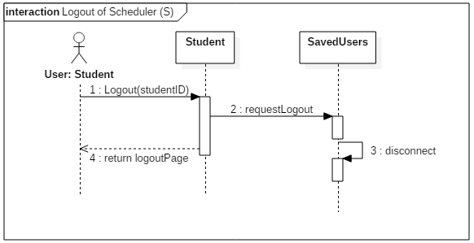

*Figure 5.2.4 Student logout contract diagram*

Use Case 4: Browse Course List

Fully Dressed Use Case

|  |  |  |
| --- | --- | --- |
| Use Case ID: | UC4 | |
| Use Case Name: | Browse Course List | |
| Created By: | Ideawin-Bunthy Koun | Last Updated By: Ryan Lee |
| Date Created: | January 25th, 2016 | Last Revision Date: March 9, 2016 |
| Actor(s): | Student | |
| Goal/Actor Goals: | Browse the list of courses from the course calendar. | |
| Description/Summary: | The user wishes to view available courses and access information pertaining to them. The system must display such information, including sections, times, and locations. | |
| Preconditions: | * User must be logged in as a Student. * Course list must be available. | |
| Post-conditions: | A list of courses is displayed. | |
| Minimum Guarantee: | The system fails to display a list of courses and displays an error message to the user. | |
| Basic Flow: | 1. Student selects the ‘Browse Course List” feature. 2. System retrieves list of courses. 3. System displays list of courses. 4. User selects a course from that list. 5. System displays information about the selected course. | |
| Risk assessment: | Medium | |
| Importance assessment: | 3/5 | |

System Sequence Diagram

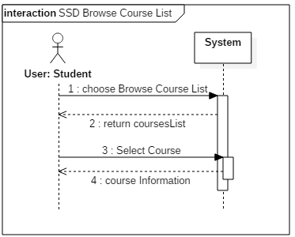

*Figure 5.4.1 Browse course list system sequence diagram*

Contract Diagrams

|  |  |  |
| --- | --- | --- |
| Contract 4.1 | browseCourseList | |
| Created By: | Ryan Lee | Last Updated By: Ryan Lee |
| Date Created: | March 17, 2016 | Last Revision Date: March 17, 2016 |
| Operation: | getCourseList( ) | |
| Cross-reference: | UC4 | |
| Preconditions: | * User must be logged in as a Student. * Course list must be available. | |
| Post-conditions: | None | |

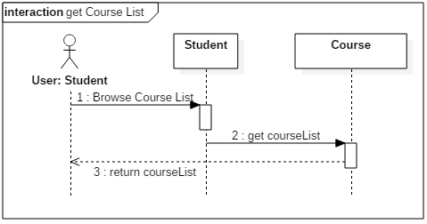

*Figure 5.4.2 getCourseList contract diagram*

|  |  |  |
| --- | --- | --- |
| Contract 4.2 | selectCourse | |
| Created By: | Ryan Lee | Last Updated By: Ryan Lee |
| Date Created: | March 17, 2016 | Last Revision Date: March 17, 2016 |
| Operation: | selectCourse(courseID: long) | |
| Cross-reference: | UC4 | |
| Preconditions: | * User must be logged in as a Student. * Course list must be available. | |
| Post-conditions: | None | |

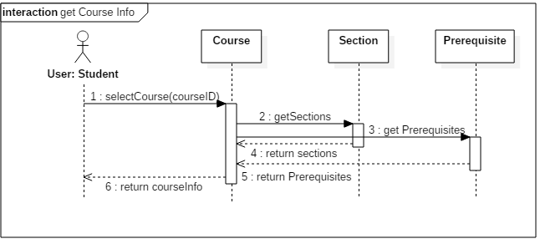

*Figure 5.4.3 getCourseInfo contract diagram*

Use Case 6: Generate Schedule

Fully Dressed Use Case

|  |  |  |
| --- | --- | --- |
| Use Case ID: | UC6 | |
| Use Case Name: | Generate Schedule | |
| Created By: | Ideawin-Bunthy Koun | Last Updated By: Ryan Lee |
| Date Created: | January 25th, 2016 | Last Revision Date: March 9, 2016 |
| Actor(s): | Student | |
| Goal/Actor Goals: | Obtain a suggested schedule for the next four years. | |
| Description/Summary: | The system can generate a 4-year schedule for the user based on the student’s preferences and constraints and on prerequisite and co-requisite policy. | |
| Preconditions: | * User must be logged in as a Student. * The system must have access to course database. * The system must have access to the student’s records. | |
| Post-conditions: | The system generates a schedule with no overlaps. | |
| Minimum Guarantee: | The system fails to generate a schedule and displays an error message to the user. | |
| Basic Flow: | 1. User selects the ‘Generate Schedule’ feature. 2. System retrieves list of preferences. 3. User selects his or her options and preferences. 4. System prompts user to confirm preferences. 5. System responds by displaying a schedule that meets the user’s preferences and constraints. | |
| Risk assessment: | High | |
| Importance assessment: | 5/5 | |

System Sequence Diagram

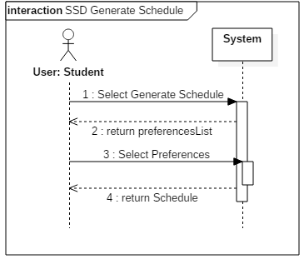

*Figure 5.6.1 Generate Schedule System Sequence Diagram*

Contract Diagrams

|  |  |  |
| --- | --- | --- |
| Contract 6.1 | getPreferenceList | |
| Created By: | Ryan Lee | Last Updated By: Ryan Lee |
| Date Created: | March 17, 2016 | Last Revision Date: March 17, 2016 |
| Operation: | getPreferenceList() | |
| Cross-reference: | UC6 | |
| Preconditions: | * User must be logged in as a Student. * The system must have access to course database. * The system must have access to the student’s records. | |
| Post-conditions: | None | |

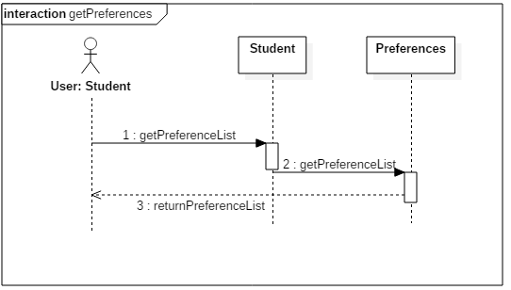

*Figure 5.6.2 getPreferences contract diagram*

|  |  |  |
| --- | --- | --- |
| Contract 6.2 | choosePreferences | |
| Created By: | Ryan Lee | Last Updated By: Ryan Lee |
| Date Created: | March 17, 2016 | Last Revision Date: March 17, 2016 |
| Operation: | choosePreferences (studentID: long) | |
| Cross-reference: | UC6 | |
| Preconditions: | * User must be logged in as a Student. * The system must have access to course database. * The system must have access to the student’s records. | |
| Post-conditions: | * An instance of Schedule, schd, will be created (instance creation) * Schd will be added to student’s saved schedules. (attribute modification, association creation) | |

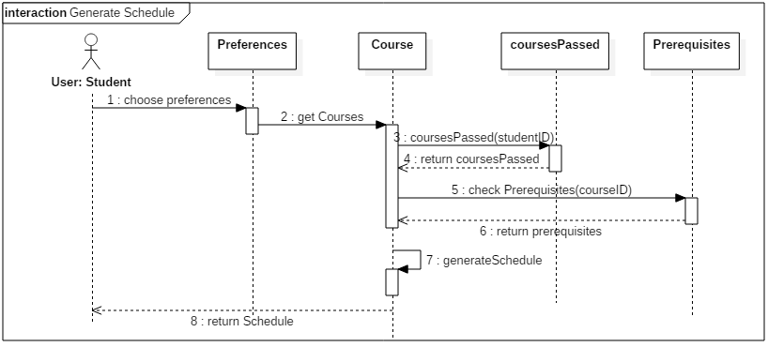

*Figure 5.6.3 generateSchedule contract diagram*

Use Case 7 – View Saved Schedules

Fully Dressed Use Case

|  |  |  |
| --- | --- | --- |
| Use Case ID: | UC7 | |
| Use Case Name: | View Saved Schedules | |
| Created By: | Erin Benderoff | Last Updated By: Claudia Della Serra |
| Date Created: | February 7, 2016 | Last Revision Date: February 14, 2016 |
| Actor(s): | Student | |
| Goal/Actor Goals: | The user wishes to view a previously saved schedule. | |
| Description/Summary: | The user selects a schedule from a list of their previously saved schedules. The system must display this schedule for the user to review. | |
| Preconditions: | * User is logged into the system. * User has previously generated one or more schedules * User has saved at least one generated schedule | |
| Post-conditions: | The system displays the saved schedule | |
| Minimum Guarantee: | Saved schedules remain in the system unchanged. | |
| Basic Flow: | 1. The user indicates their wish to view a saved schedule 2. The system prompts the user with a list of saved schedules 3. The user selects which semester’s schedule to view 4. The system displays the chosen schedule | |
| Risk assessment: | Medium | |
| Importance assessment: | 3/5 | |

System Sequence Diagram

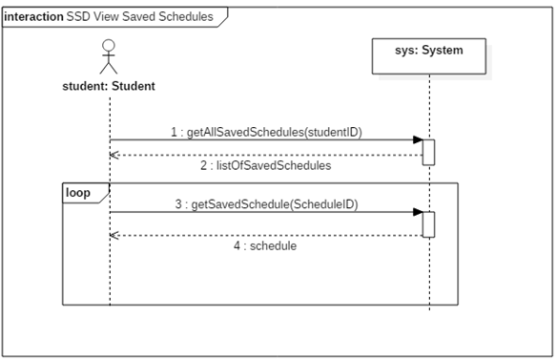

*Figure 5.7.1 View Saved Schedules system sequence diagram*

Contract Diagrams

|  |  |  |
| --- | --- | --- |
| Contract 7.1 | getAllSavedSchedules | |
| Created By: | Claudia Della Serra | Last Updated By: Claudia Della Serra |
| Date Created: | March 2, 2016 | Last Revision Date: March 2, 2016 |
| Operation: | viewSavedSchedules(studentID: long) : list<SavedSchedule> | |
| Cross-reference: | UC7 | |
| Preconditions: | * User is logged into the system. * User has previously generated one or more schedules * User has saved at least one generated schedule | |
| Post-conditions: | * A list of SavedSchedules is generated (instance creation) * The list is returned to the Student (association creation) | |

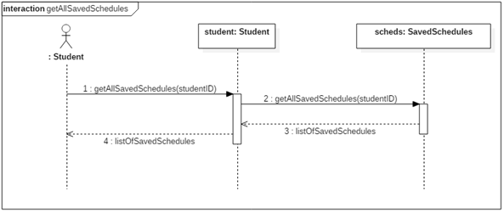

*Figure 5.7.2 getAllSavedSchedules contract diagrams*

|  |  |  |
| --- | --- | --- |
| Contract 7.2 | getSavedSchedule | |
| Created By: | Claudia Della Serra | Last Updated By: Claudia Della Serra |
| Date Created: | March 2, 2016 | Last Revision Date: March 2, 2016 |
| Operation: | getSavedSchedule(scheduleID: long) : Schedule | |
| Cross-reference: | UC7 | |
| Preconditions: | * User is logged into the system. * User has previously generated one or more schedules * User has saved at least one generated schedule | |
| Post-conditions: | * A previously saved schedule is retrieved (instance creation) * The saved schedule is returned to the Student (association Creation) | |

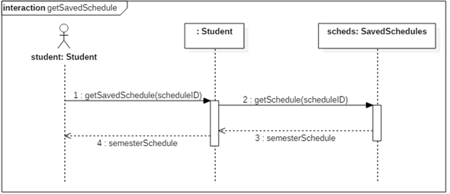

*Figure 5.7.3 getSavedSchedule contract diagram*

Use Case 8 – View Academic Record

Fully Dressed Use Case

|  |  |  |
| --- | --- | --- |
| Use Case ID: | UC8 | |
| Use Case Name: | View Academic Record | |
| Created By: | Erin Benderoff | Last Updated By: Claudia Della Serra |
| Date Created: | February 7, 2016 | Last Revision Date: February 14, 2016 |
| Actor(s): | Student | |
| Goal/Actor Goals: | The user wishes to view a list of his or her completed courses and grades for those courses. | |
| Description/Summary: | The system displays the user’s academic record, which includes completed courses and courses currently being taken. | |
| Preconditions: | * User is logged into the system. * User has completed at least one course and/or is presently enrolled in at least one course. | |
| Post-conditions: | The system displays the user’s academic record. | |
| Minimum Guarantee: | The academic record remains in the system unmodified. | |
| Basic Flow: | 1. The user requests to view their academic record 2. The system generates a list of the user’s completed courses, as well as courses in which the user is currently enrolled. | |
| Risk assessment: | Low | |
| Importance assessment: | 1/5 | |

System Sequence Diagram

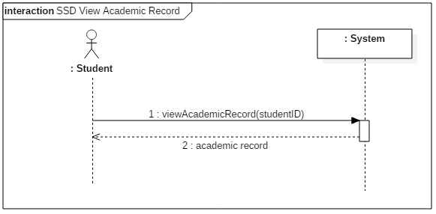

*Figure 5.8.1 View Academic Record System Sequence Diagram*

Contract Diagrams

|  |  |  |
| --- | --- | --- |
| Contract 8.1 | viewAcademicRecord | |
| Created By: | Claudia Della Serra | Last Updated By: Claudia Della Serra |
| Date Created: | March 2, 2016 | Last Revision Date: March 2, 2016 |
| Operation: | viewAcademicRecord (studentID: long) : list<Course> | |
| Cross-reference: | UC8 | |
| Preconditions: | * User is logged into the system. * User has completed or is presently enrolled in at least one course | |
| Post-conditions: | * A list of classes passedis dynamically created for the student (instance creation) * The academic record is returned to the student (association creation) | |

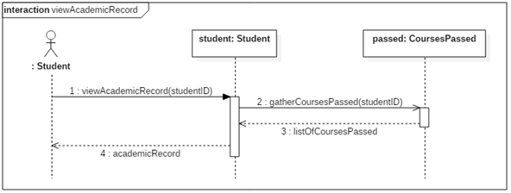

*Figure 5.8.2 viewAcademicRecord contract diagram*

Use Case 9 – Drop Course

Fully Dressed Use Case

|  |  |  |
| --- | --- | --- |
| Use Case ID: | UC9 | |
| Use Case Name: | Drop Course | |
| Created By: | Erin Benderoff | Last Updated By: Claudia Della Serra |
| Date Created: | February 7, 2016 | Last Revision Date: February 14, 2016 |
| Actor(s): | Student | |
| Goal/Actor Goals: | The user wishes to remove a course from a generated schedule. | |
| Description/Summary: | The user selects which course he or she would like to remove from the schedule. The system must delete this course from the schedule. | |
| Preconditions: | * User is logged into the system. * User has generated a schedule containing at least one course. * User has chosen to view a saved schedule | |
| Post-conditions: | The chosen course has been removed from the user’s schedule. | |
| Minimum Guarantee: | The courses on the user’s schedule remain unchanged. | |
| Basic Flow: | 1. User selects a schedule they wish to view 2. System returns the desired Schedule 3. The user chooses a course from his or her schedule to view. 4. The system displays the course information 5. The user indicates they wish to remove the course from the schedule 6. The System prompts the user for confirmation. 7. The user confirms dropping of the course 8. The produces a modified schedule without the removed course. | |
| Risk assessment: | High | |
| Importance assessment: | 4/5 | |

System Sequence Diagram

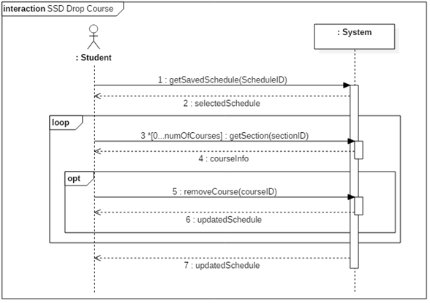

*Figure 5.9.1 Drop Course system sequence diagram*

Contract Diagrams

|  |  |  |
| --- | --- | --- |
| Contract 9.1 | getSavedSchedule | |
| Created By: | Claudia Della Serra | Last Updated By: Claudia Della Serra |
| Date Created: | March 2, 2016 | Last Revision Date: March 2, 2016 |
| Operation: | getSavedSchedule(scheduleID: long) | |
| Cross-reference: | UC9, UC7, Contract 7.2 | |
| Preconditions: | * User is logged into the system. * User has generated and saved a schedule * User has requested to view a list of saved schedules | |
| Post-conditions: | * An instance of a saved schedule is retrieved (instance creation) * The schedule is returned to the Student (association creation) | |

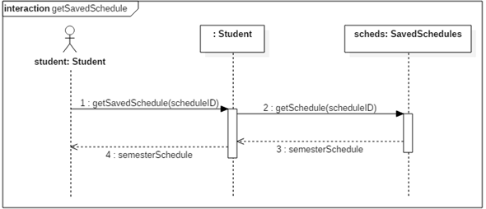

*Figure 5.9.2 getSavedSchedule contract diagram*

|  |  |  |
| --- | --- | --- |
| Contract 9.2 | getSection | |
| Created By: | Claudia Della Serra | Last Updated By: Claudia Della Serra |
| Date Created: | March 2, 2016 | Last Revision Date: March 2, 2016 |
| Operation: | viewCourseInfo(sectionID: long) : Section | |
| Cross-reference: | UC9 | |
| Preconditions: | * User is logged into the system. * User has generated and saved a schedule * User has requested to view a saved schedule | |
| Post-conditions: | * The desired Section object is created (instance creation) * The Section is returned to the Student (association creation) | |

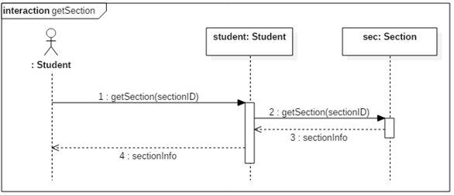

*Figure 5.9.3 getSection contract diagram*

|  |  |  |
| --- | --- | --- |
| Contract 9.3 | removeCourse | |
| Created By: | Claudia Della Serra | Last Updated By: Claudia Della Serra |
| Date Created: | March 2, 2016 | Last Revision Date: March 2, 2016 |
| Operation: | removeCourse(sectionID: long, studentID: long) : Schedule | |
| Cross-reference: | UC9 | |
| Preconditions: | * User is logged into the system. * User has generated and saved a schedule * User has requested to view a saved schedule * User has requested to view course registration info | |
| Post-conditions: | * The student will be removed from the section’s registration list (attribute modification, association removed) * The course will be removed from the student’s schedule (association modification) * The student’s course sequence will be updated (attribute modification) | |

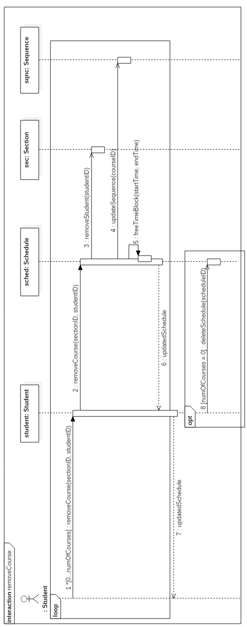

*Figure 5.9.4 removeCourse contract diagram*

Use Case 11 – Save Generated Schedule

Fully Dressed Use Case

|  |  |  |
| --- | --- | --- |
| Use Case ID: | UC11 | |
| Use Case Name: | Save Generated Schedule | |
| Created By: | Lori Dalkin | Last Updated By: Claudia Della Serra |
| Date Created: | February 7, 2016 | Last Revision Date: February 14, 2016 |
| Actor(s): | Student | |
| Goal/Actor Goals: | The user wishes to save a schedule they have generated. | |
| Description/Summary: | A generated schedule can be saved in order to be accessed and viewed later on by the user. This schedule consists of courses the user is satisfied with and wishes to keep on their schedule. | |
| Preconditions: | * The user is logged on to their account * A schedule has been generated containing at least one course. | |
| Post-conditions: | The system saves the generated schedule to the user’s account. | |
| Minimum Guarantee: | The user’s account remains unchanged. | |
| Basic Flow: | 1. User indicated their wish to generate a schedule 2. The system prompts the user with a list of semesters for which they wish to generate a schedule 3. The user indicates which semester they wish to generate a schedule for 4. The system displays a generated schedule for the indicated semester 5. The user will indicates that they want to save the generated schedule. 6. The system will display a message telling the user that the schedule has been saved. | |
| Risk assessment: | Medium | |
| Importance: | 4/5 | |

System Sequence Diagram

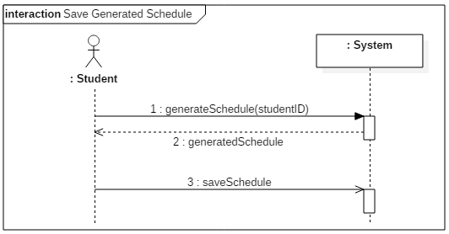

*Figure 5.11.1 Save Generated Schedule system sequence diagram*

Contract Diagrams

|  |  |  |
| --- | --- | --- |
| Contract 11.1 | generateSchedule | |
| Created By: | Claudia Della Serra | Last Updated By: Claudia Della Serra |
| Date Created: | March 2, 2016 | Last Revision Date: March 2, 2016 |
| Operation: | generateSchedule(studentID) | |
| Cross-reference: | UC11, UC6, contract 6.2 | |
| Preconditions: | * User is logged into the system. * User is enrolled in a program | |
| Postconditions: | * A Schedule object is generated (Instance creation) * The Schedule is associated to the student (association creation) | |

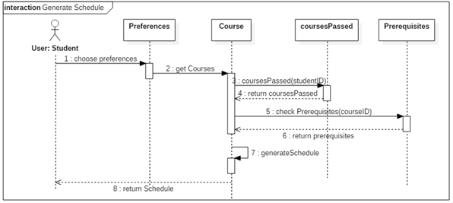

*Figure 5.11.2 generateSchedule contract diagram*

|  |  |  |
| --- | --- | --- |
| Contract 11.2 | saveGeneratedSchedule | |
| Created By: | Claudia Della Serra | Last Updated By: Claudia Della Serra |
| Date Created: | March 2, 2016 | Last Revision Date: March 2, 2016 |
| Operation: | saveGeneratedSchedule(scheduleID): list<Schedule> | |
| Cross-reference: | UC11 | |
| Preconditions: | * User is logged into the system. * User is enrolled in a program * User has generated a schedule | |
| Post-conditions: | * A schedule for that semester will be saved to the student’s account (association formed) * The schedule will be added to the list of saved schedules (attribute modification) | |

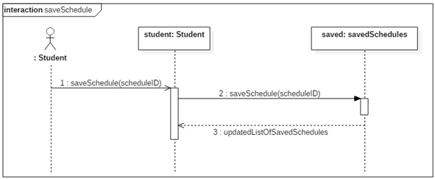

*Figure 5.11.3 saveSchedule contract diagram*

5.14 Create course

5.14.1 Fully Dressed Use Case

|  |  |  |
| --- | --- | --- |
| Use Case ID: | UC14 | |
| Use Case Name: | Create Course | |
| Created By: | Claudia Della Serra | Last Updated By: |
| Date Created: | Marc 26th, 2016 | Last Revision Date: |
| Actor(s): | Primary Actor(s): Administrator | |
| Goal/Actor Goals: | Administrator wishes to add a course to the database of courses | |
| Description/Summary: | The Administrator wishes to add a course to the system’s database of courses by entering its course code, the course description, and the amount of credits awarded by the course. A course may be a section, a tutorial, or a lab. | |
| Preconditions: | * The administrator has logged in. * The administrator has viewed the list of courses in the database. | |
| Post-conditions: | The course is added to the database of courses | |
| Minimum Guarantee: | The database of courses will remain unaltered. | |
| Basic Flow: | 1. Administrator requests to create a course 2. The system presents a page asking for the course id, the course description, and the amount of credits awarded by the course. 3. The Administrator enters the course information and presses submit 4. The system presents the course information, with the options to manage the course or view all courses in the database | |
| Risk assessment: | 3/5 | |
| Importance assessment: | 5/5 | |

5.14.2 System Sequence Diagram

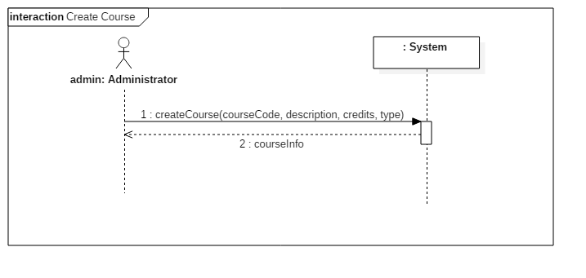

5.14.3 Contract Diagrams

|  |  |  |
| --- | --- | --- |
| Contract 14.1 | createCourse | |
| Created By: | Claudia Della Serra | Last Updated By: Claudia Della Serra |
| Date Created: | March 2, 2016 | Last Revision Date: March 2, 2016 |
| Operation: | createCourse(courseCode: String, description: String, credits: int, type: String) : Course | |
| Cross-reference: | UC14 | |
| Preconditions: | * User is logged into the system as an Administrator. * User has requested to create a course | |
| Post-conditions: | * A new Course is created (instance creation) * The new Course is displayed to the Administrator (association formed) | |

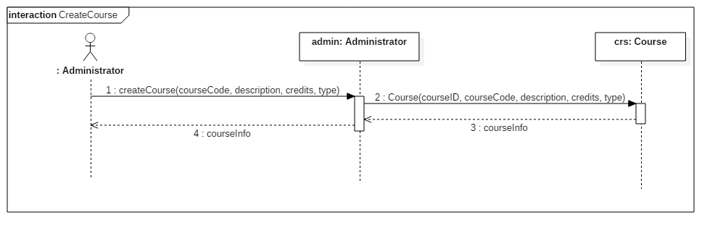

5.15 Browse Courses (Administrator)

5.15.1 Fully Dressed Use Case

|  |  |  |
| --- | --- | --- |
| Use Case ID: | UC15 | |
| Use Case Name: | Browse Courses | |
| Created By: | Claudia Della Serra | Last Updated By: |
| Date Created: | Marc 26th, 2016 | Last Revision Date: |
| Actor(s): | Primary Actor(s): Administrator | |
| Goal/Actor Goals: | Administrator wishes to view the database of courses | |
| Description/Summary: | The Administrator wishes to add view the system’s database of courses. From here, the administrator may choose to add a course or manage courses. | |
| Preconditions: | * The administrator has logged in. | |
| Post-conditions: | The course database will be presented | |
| Minimum Guarantee: | The administrator will remain on the home page. | |
| Basic Flow: | * + - 1. Administrator requests to view the course database       2. The system presents a page listing all the courses in the database | |
| Risk assessment: | 2/5 | |
| Importance assessment: | 4/5 | |

15.2 System Sequence Diagram

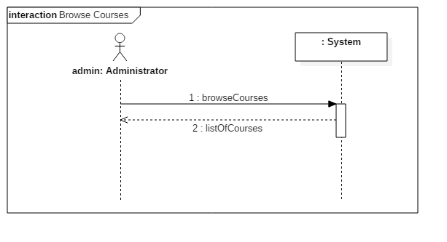

15.3 Contract Diagrams

|  |  |  |
| --- | --- | --- |
| Contract 15.1 | browseCourses | |
| Created By: | Claudia Della Serra | Last Updated By: Claudia Della Serra |
| Date Created: | March 2, 2016 | Last Revision Date: March 2, 2016 |
| Operation: | browseCourses() : list<Course> | |
| Cross-reference: | UC14 | |
| Preconditions: | * User is logged into the system as an Administrator. | |
| Post-conditions: | * A new list of Courses is created (instance creation) * The new list of Courses is displayed to the Administrator (association formed) | |

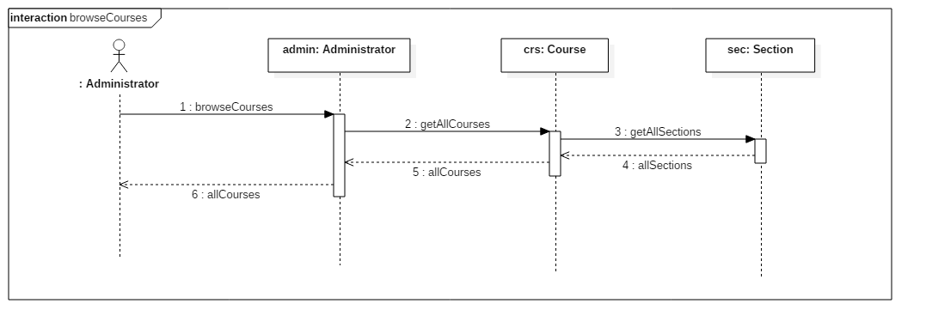

# Estimation

The current cost and time estimation has been updated from previous estimations made in deliverable 1 by considering the estimated lines of code that will be produced in the implementation of the TimeTurner system. An estimated person-months amount was calculated, and then this amount applied to previous estimations made in conjunction with estimations based on time-logs taken from activities performed in the production of the Deliverable 2 document.

Function Point Estimation

Unadjusted Function Points

|  |  |  |  |  |  |  |  |  |  |  |  |  |  |  |
| --- | --- | --- | --- | --- | --- | --- | --- | --- | --- | --- | --- | --- | --- | --- |
| **Function Type** | | **Functional Complexity** | | | | | |  | | **Complexity Totals** | | | | **Function Type Totals** |
| ILF | | 0 Low | | | | | | X 7 | | 0 | | | |  |
|  | | 10 Average | | | | | | X10 | | 100 | | | |  |
|  | | 0 High | | | | | | X15 | | 0 | | | | 100 |
|  | | | | | | | | | | | | | | |
| EIF | | | | 0 Low | | | X 5 | | 0 | | | | |  |
|  | | | | 0 Average | | | X7 | | 0 | | | | |  |
|  | | | | 0 High | | | X10 | | 0 | | | | | 0 |
|  | | | | | | | | | | | | | | |
| EI | | | | | 0 Low | | | X3 | | | 0 | | |  |
|  | | | | | 4 Average | | | X4 | | | 16 | | |  |
|  | | | | | 0 High | | | X6 | | | 0 | | | 16 |
|  | | | | | | | | | | | | | | |
| EQ | | | 0 Low | | | | X 3 | | | | | | 0 |  |
|  | | | 0 Average | | | | X4 | | | | | | 0 |  |
|  | | | 6 High | | | | X6 | | | | | | 36 | 36 |
|  | | | | | | | | | | | | | | |
| EO | 0 Low | | | | | X 4 | | | | | | 0 | |  |
|  | 5 Average | | | | | X5 | | | | | | 25 | |  |
|  | 0 High | | | | | X7 | | | | | | 0 | | 25 |
|  | | | | | | | | | | | | | | |
| **Unadjusted Function Point Count** | | | | | | | | | | | | | | 177 |
| **SLOC/FP for PHP [1]** | | | | | | | | | | | | | | 67 |
| **Total SLOC** | | | | | | | | | | | | | | 11859 |
| **COCOMO II estimated person-months effort** | | | | | | | | | | | | | | 43.8 |

[1] taken from <https://www.cs.helsinki.fi/u/taina/ohtu/fp.html>

Internal function points were calculated based on the database tables given for Users, User Schedules, Completed Courses, Courses, Sections, Subsections, and Prerequisites. External Outputs, External Queries and External Inputs were calculated based on methods found in the above sections (see Section 3.2 Subsystem Interface Specification). Given the above estimated lines of code, this value was put into the COCOMO II engine, with the Software Scale Drivers modified as follows:

* Pecedentedness: Low
  + Due to the fact that not very much experience in programming a large system such as this one has been previously incurred by many of the team members.
* Architecture/Risk Resolution: high
  + Due to the fact that much planning in architecture and design has been undergone, and that risk assessment and analysis has been performed since the start of the project.
* Process Maturity: low
  + Due to the fact that the team has only begun using software process management, and does not have much experience in handling projects in this manner
* Development flexibility: high
  + Due to the fact that very vague requirements were given by instructors, thus the flexibility to implement these requirements, and create our own, was very high.
* Team cohesion: high
  + The team has had much experience working together on previous assignments, labs, etc. thus team cohesion is high and group work and communication are excellent.

Module Estimations

Given the estimated time of 43.8 person-months, and previous time estimates that were performed in the first version of the project, new time estimates have been made. Given that all team members are currently full-time students and working on other projects throughout the course of this project development, our person-months are based on a rough estimate of 4.85 hours per person per task; such an estimate is taken from the time logs of one team member working on the Deliverable 2 task of creating system sequence and contract diagrams (times were divided by 2 due to the fact that all system sequence diagrams were implemented rather than just 2 major ones). This results in a 424.86 person-hours estimate for the entire project. Thus, previous estimates are updated as follows:

6.3.4 Total Deliverable Estimates

|  |  |  |
| --- | --- | --- |
| **Deliverable Names** | **Cost (Hours)** | **Revised Cost (Hours)** |
| Deliverable 0 | 29.5 | 29.5 |
| Deliverable 1 | 35 | 35 |
| Deliverable 2 | 190 | 194 |
| Deliverable 3 | 75 | 97 |
| Deliverable 4 | 60 | 48.5 |
| **Total** | **389.5** | **404** |

Updated Gantt Chart

The following updated version of the initial Gantt chart shows the progress of the project and its current state of development.

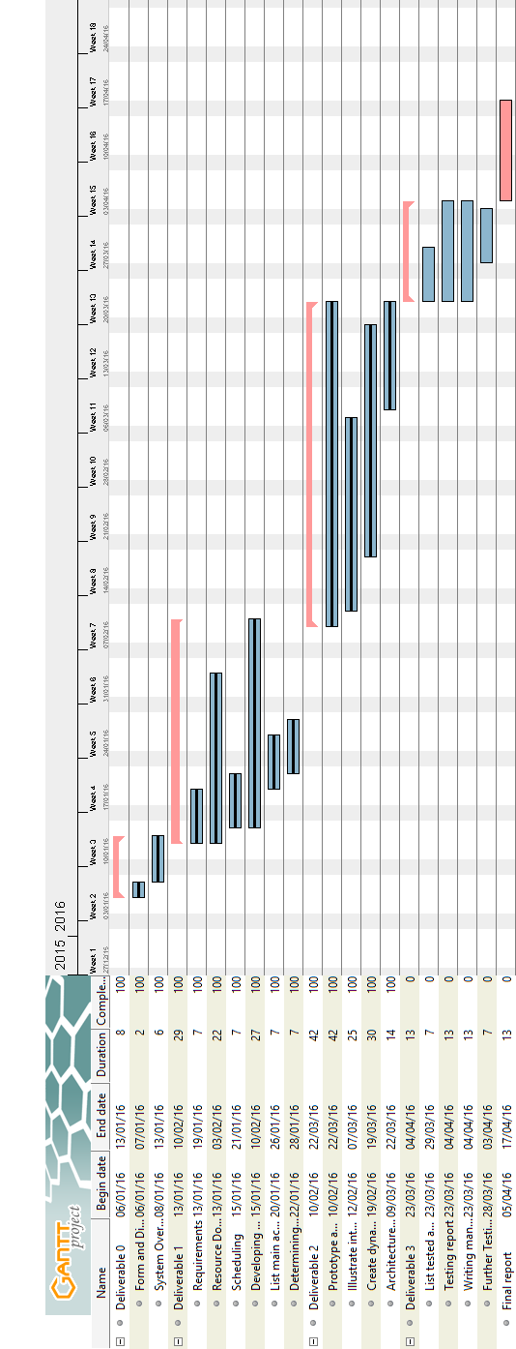

*Figure 6.3.1 Updated Gantt Chart*

# Rapid Prototyping and Risk

In order to minimize risk, a quick prototype of the system is made. A quick mockup of the system, shown below, is produced to ensure that the project is headed in the right direction and reduce overall risk in the early development phase of the project.

The prototype has also helped us view how the final project will look like and has inspired us to come up with ideas on what a user should expect from a schedule planner in terms of features, layout and ease-of-use.

User Interface Mockup

Main Layout

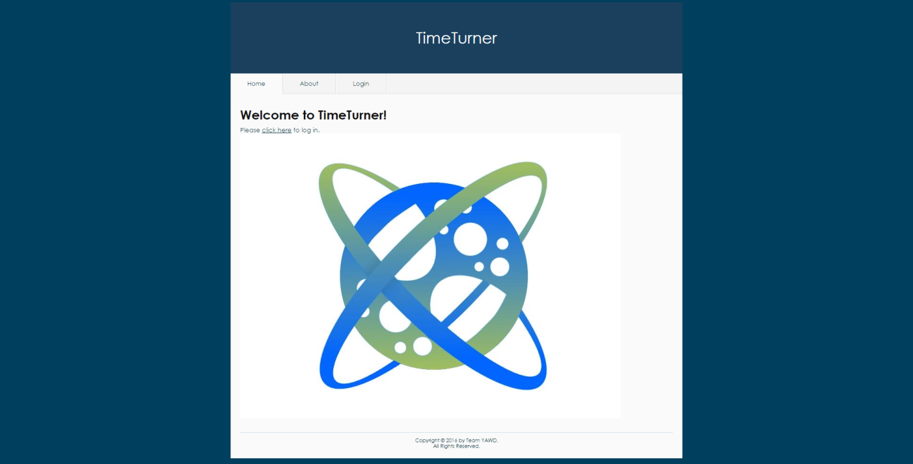

*Figure 1. Main layout of the system*

Upon accessing the TimeTurner website, the user is welcomed with a message and has the choice to login via the tab or by clicking the “click here” link. These will redirect the user to the Login page. The Yii framework was used to generate this layout, as it already contains a few themes.

Login Interface Mockup

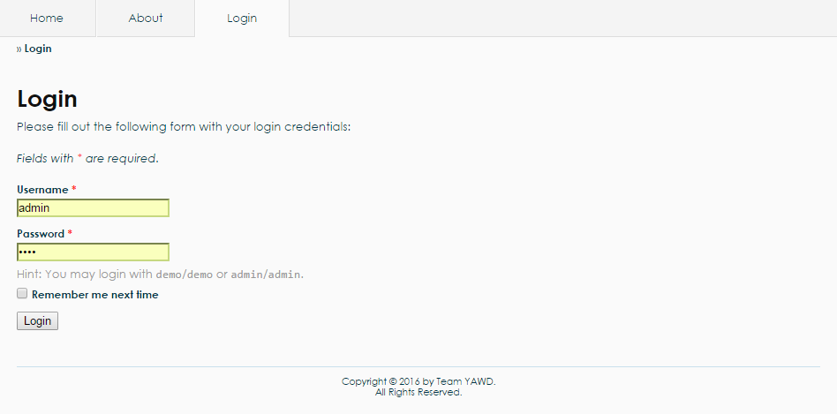

*Figure 2. Login interface mockup*

For the Login interface, there is an authentication form which has been generated by the Yii framework. The user may enter as an admin or as a student. A username and a password are required. Upon clicking the “Login” button, the system will query the database to check if the username and password are valid. The system will redirect to another page if the login is successful, else it will display an error message.

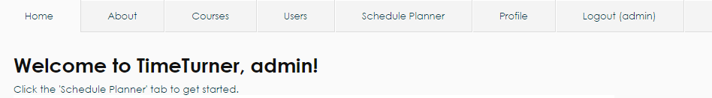

*Figure 3. User menu for an administrator*

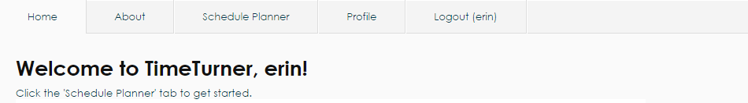

*Figure 4. User menu for a student*

If the administrator logs in, additional tabs appear on top. These are “Courses”, “Users”, “Schedule Planner”, “Profile” as well as a “Logout” tab, as shown in Figure 3. If logged in as a student, the user cannot see the “Courses” and “Users” tabs, as shown in Figure 4, as these can only be modified by the administrator.

Generate Schedule Interface Mockup

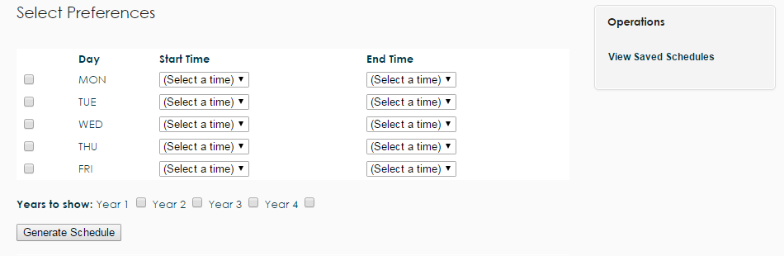

*Figure 5. Generate schedule interface mockup*

All users have a “Schedule Planner” tab, which upon clicking, redirects the user to the page as shown in Figure 5. The user can select their preferences by checking one or more days of the week and select a starting and ending time. The user has the option of choosing which years can be displayed. Additionally, the “Viewed Saved Schedules” operation on the right navigation bar can be selected to view schedules that were previously generated and saved.

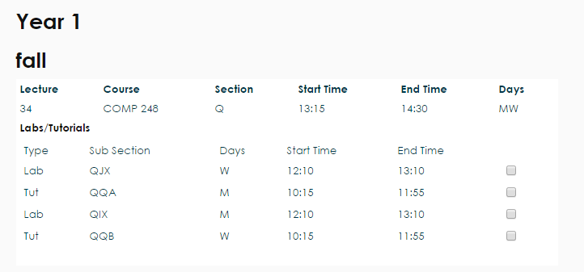

*Figure 6. Classes sections view*

Upon clicking the “Generate Schedule” button, classes are displayed along with their sections, as shown in Figure 6. The user may check the boxes next to the preferred sections.

Risk

Framework

One of the main risks involved in this project is the use of an unfamiliar framework. The current framework in use is Yii, which is based on MVC architecture in PHP. Due to the fact that most of the development team has never worked with a large framework, the learning curve tends to be very high. As such, possible delays might arise during development due to unforeseen problems that might come up while working with Yii. Though one of the major advantages of using this framework, is that it is loaded with features that make development much quicker in the long run; entire modules can be created on the fly with little effort. Depending on the learning curve progress, Yii can either create a healthy environment for development or hurt production..

Time Constraint

As deadline approaches, the realization of some features of software will have to be scoped out; only certain core components will be placed in order to meet a good portion of the major requirements of the scheduler.

Control Version System

Since the control version system in use is GitHub, the development team opted to use PhpStorm 10, an IDE provided by JetBrains, since it is integrated with Git. This adds up to the learning curve, since the team members have to learn an unfamiliar program, as well as how it works with Git. Using a framework requires working with many files, thus the project needs to be carefully managed. At times, PhpStorm 10 would not synchronize properly with the project’s repository on GitHub, which adds up to the time required to spend on learning and working on other components of the project. Therefore, learning how to properly use Git with PhpStorm can arise in possible delays during development due to team members’ inexperience with them.

Server Uptime

During team meetings, the production environment occurs at school. Often times, the network does not work properly as many students and employees try to access Internet at the same time. This would cause a decrease in productive time. Team members also have their own production environment at home. However, if a power outage occurs, the server computer may crash; hindering deployment and causing further delays.

**Project Testing and Delivery Document – Deliverable 3**

# Introduction

The following document covers the testing involved in the system. A full breakdown of each test case is provided, accompanied by the results. This is useful information in the installation procedure of this software for any users, which is shown alongside the user manual of this section. The types of testing includes unit testing, requirement testing and stress testing. The final topic included is the final cost estimation of the entire project.

# Testing Report

## Test Coverage

Tested Items

Unit Testing:

Unit testing focuses on testing small units of code at a time. It breaks the system down into its individual classes or methods and tests them each separately. Unit testing is important for making sure each piece of an application works as expected, so that these pieces can then be combined with other parts of the application in order to ultimately have a full working system.

Here, Unit testing was done using PHPUnit 5.3. We performed unit tests on two of the model classes in our system, LoginForm and UserSchedule. For each class, a PHPUnit test class was written that included a test for each method in the model class, to ensure that every method works as expected.

Requirements Testing:

Requirements testing breaks a system down based on its requirements, and tests each one of them to ensure they function as expected. It is important for checking which requirements are met and which are not met. Here, each requirements test case includes a test ID, description, expected output, actual output and result. If the actual output matches the expected output, the result is a *pass*. If not, the result is a *fail*. For any failed tests, we can return to the source code used to implement this requirement and identify the bugs that caused it to fail.

Stress Testing:

Stress testing is used to test an application’s performance under extreme conditions of usage, such as a high volume of users or a large data load. It is done in order to determine the system’s robustness and reliability, and helps to identify issues that may only arise under stressful conditions.

There are a number of tools available for stress testing a web application that simulate extreme conditions. Here, we used Apache JMeter, a Java application that works by creating multiple threads that simultaneously access a given web server via HTTP requests. We tested stress conditions for both the login and schedule generation functions of the system.

Security Testing:

Security testing is crucial for any software system to ensure that the system can protect itself against malicious attacks. We used two tools to test security. The first was SQL Inject Me, a Firefox plugin that sends SQL injection strings through the forms of a webpage and checks for any database errors that may occur as a result. The second was Nikto, a web server scanner that uses a Perl script to perform multiple tests against a given server, including checking for dangerous files and checking for outdated versions.

Untested Items of Interest

For the unit tests, we were only able to test 2 of the 11 models in our system. This was due to tight time constraints, as it took a while to set up PHPUnit and write the test code. We chose to test the LoginForm and UserSchedule models because these classes are very important to the system’s functionality; every user needs the LoginForm to access the system, and UserSchedule is needed to generate a schedule. With more time, we would have ideally performed unit tests on the other 9 models in our system (CompletedCourses, ContactForm, Course, PreferenceForm, Prerequisite, Section, Subsection, User and UserSchedules), as well as the controller classes (CourseController, ProfileController, SchedulerController, SiteController and UserController).

For the requirements tests, we tested all requirements except the ones that were scoped out. Scoped out requirements included *create a course sequence*, *weekly schedule view* and *add a course*. With more time, we would have liked to implement these requirements and perform tests on them.

## Test Cases

Unit Testing

Code for UserScheduleTest:

**<?php  
require_once**(**'../../../protected/models/UserSchedule.php'**);  
$yiit=**'../../../framework/yiit.php'**;  
**require_once**($yiit);  
  
**class** UserScheduleTest **extends** CDbTestCase {  
 **protected $fixture**;  
 **protected $db**;  
  
 **protected function** setUp() {  
 $this->**db** = **new** CDbConnection(**'mysql:host=conuscheduler.ddns.net;dbname=soen341'**,**'soen341'**,**'soen341'**);  
 $this->**db**->**active**=**true**;  
 CActiveRecord::*$db*=$this->**db**;  
 $this->**fixture** = **new** UserSchedule;  
 }  
  
 **protected function** tearDown() {  
 **if**($this->**db**)  
 $this->**db**->**active**=**false**;  
 }  
  
 **public function** testTableName() {  
 $expected = **'user_schedule'**;  
 $results = $this->**fixture**->tableName();  
 $this->assertEquals($expected,$results);  
 }  
  
 **public function** testRules() {  
 $expected = **array**(  
 **array**(**'scheduleID, courseID, sectionID, subsectionID, year'**, **'required'**),  
 **array**(**'scheduleID, courseID, sectionID, subsectionID, year'**, **'numerical'**, **'integerOnly'**=>**true**),  
 **array**(**'ID, scheduleID, courseID, sectionID, subsectionID, year'**, **'safe'**, **'on'**=>**'search'**),  
 );  
 $results = $this->**fixture**->rules();  
 $this->assertEquals($expected,$results);  
 }  
  
 **public function** testRelations() {  
  
 $expected = **array**(  
 **'scheduleID'** => **array**(UserSchedule::***BELONGS_TO***, **'UserSchedules'**, **'ID'**)  
 );  
 $results = $this->**fixture**->relations();  
 $this->assertEquals($expected,$results);  
 }  
  
 **public function** testAttributeLabels() {  
 $expected = **array**(  
 **'ID'** => **'ID'**,  
 **'scheduleID'** => **'Schedule'**,  
 **'courseID'** => **'Course'**,  
 **'sectionID'** => **'Section'**,  
 **'subsectionID'** => **'Subsection'**,  
 **'year'** => **'Year'**,  
 );  
 $results = $this->**fixture**->attributeLabels();  
 $this->assertEquals($expected, $results);  
 }  
  
 **public function** testSearch() {  
 $stub = $this->getMockBuilder(**'CDbCriteria'**)  
 ->disableOriginalConstructor()  
 ->getMock();  
 $stub->expects($this->any())  
 ->method(**'compare'**)  
 ->will($this->returnValue(**'true'**));  
 }  
  
 **public function** testModel() {  
 $stub = $this->getMockBuilder(**'UserSchedule'**)  
 ->disableOriginalConstructor()  
 ->getMock();  
 $stub->expects($this->any())  
 ->method(**'model'**)  
 ->will($this->returnValue($this->**fixture**));  
 $this->assertNotNull($stub);  
 }  
}

**Results:**

UserScheduleTest passed 6/6 tests, shown in the figure below:

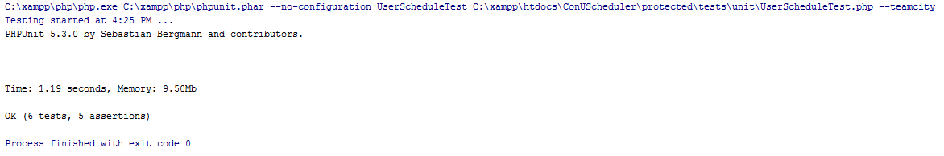

Code for LoginForm test:

**<?php  
  
require_once**(**'../../../protected/models/LoginForm.php'**);  
**require_once**(**'../../../protected/components/UserIdentity.php'**);  
$yiit=**'../../../framework/yiit.php'**;  
**require_once**($yiit);  
  
**class** LoginFormTest **extends** CTestCase  
{  
 **protected $fixture**;  
 **protected function** setUp() {  
 $this->**fixture** = **new** LoginForm;  
 $this->**fixture**->**username** = **"erin"**;  
 $this->**fixture**->**password** = **"soen341"**;  
 $this->**fixture**->**rememberMe** = **"0"**;  
 }  
  
 **protected function** tearDown() {  
 }  
  
 **public function** testRules() {  
 $stub = **array**(**array**(**'username, password'**, **'required'**),  
 **array**(**'rememberMe'**, **'boolean'**),  
 **array**(**'password'**, **'authenticate'**));  
 $results = $this->**fixture**->rules();  
 $this->assertEquals($stub,$results);  
 }  
  
 **public function** testAttributeLabels() {  
 $stub = **array**(**'rememberMe'**=>**'Remember me next time'**,);  
 $results = $this->**fixture**->attributeLabels();  
  
 $this->assertEquals($stub, $results);  
 }  
  
 **public function** testAuthenticate() {  
 $stub = $this->getMockBuilder(**'UserIdentity'**)  
 ->disableOriginalConstructor()  
 ->getMock();  
 $stub->expects($this->any())  
 ->method(**'authenticate'**)  
 ->will($this->returnValue(**'true'**));  
 }  
  
 **public function** testLogin_2() {  
 $stub = $this->getMockBuilder(**'LoginForm'**)  
 ->disableOriginalConstructor()  
 ->getMock();  
 $stub->expects($this->any())  
 ->method(**'login'**)  
 ->will($this->returnValue(**'true'**));  
 $this->assertEquals(**'true'**, $stub->login());  
 }  
}

**Results:**

LoginFormTest passed 4/4 tests, shown in the figure below:

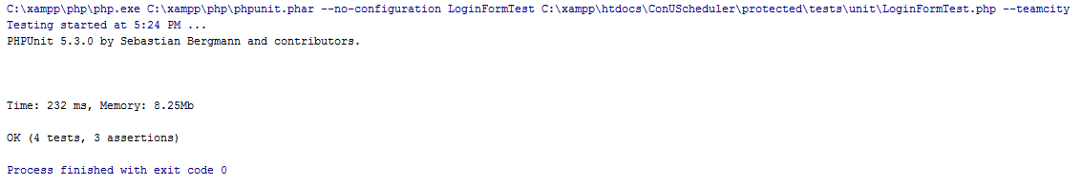

Requirements Testing

Login

|  |  |  |  |  |  |
| --- | --- | --- | --- | --- | --- |
| **UC1** | | **Login (Administrator)** | | | |
| Test ID | Description | | Expected Output | Actual Output | Result |
| 1.1 | Username: Admin  Password: 1234 | | Home Page | Home Page | **Pass** |
| 1.2 | Username: Admine  Password: 1234 | | Incorrect Username  or Password Error | Incorrect Username  or Password Error | **Pass** |
| 1.3 | Username: Admin  Password: 12345 | | Incorrect Username  or Password Error | Incorrect Username  or Password Error | **Pass** |
| 1.4 | Username: Admine  Password: 12345 | | Incorrect Username  or Password Error | Incorrect Username  or Password Error | **Pass** |

|  |  |  |  |  |  |
| --- | --- | --- | --- | --- | --- |
| **UC1** | | **Login (Student)** | | | |
| Test ID | Description | | Expected Output | Actual Output | Result |
| 1.5 | Username: Erin  Password: soen341 | | Home Page | Home Page | **Pass** |
| 1.6 | Username: Erine  Password: soen341 | | Incorrect Username  or Password Error | Incorrect Username  or Password Error | **Pass** |
| 1.7 | Username: Erin  Password: soen341 | | Incorrect Username  or Password Error | Incorrect Username  or Password Error | **Pass** |
| 1.8 | Username: Erine  Password: soen341 | | Incorrect Username  or Password Error | Incorrect Username  or Password Error | **Pass** |

Logout

|  |  |  |  |  |  |
| --- | --- | --- | --- | --- | --- |
| **UC2** | | **Logout (Administrator)** | | | |
| Test ID | Description | | Expected Output | Actual Output | Result |
| 2.1 | User clicks logout tab | | Home Page | Home Page | **Pass** |

|  |  |  |  |  |  |
| --- | --- | --- | --- | --- | --- |
| **UC2** | | **Logout (Administrator)** | | | |
| Test ID | Description | | Expected Output | Actual Output | Result |
| 2.2 | User clicks logout tab | | Home Page | Home Page | **Pass** |

Create Course Sequence

|  |  |  |  |  |  |
| --- | --- | --- | --- | --- | --- |
| **~~UC3~~** | | **~~Create Course Sequence~~** | | | |
| ~~Test ID~~ | ~~Description~~ | | ~~Expected Output~~ | ~~Actual Output~~ | ~~Result~~ |

Browse Course List

|  |  |  |  |  |  |
| --- | --- | --- | --- | --- | --- |
| **UC4** | | **Browse Course List** | | | |
| Test ID | Description | | Expected Output | Actual Output | Result |
| 4.1 | Student requests to view course list | | List of all courses in the system is displayed | List of all courses in the system is displayed | **Pass** |
| 4.2 | Student clicks on a prerequisite course | | Course information for that course is displayed | Course information for that course is displayed | **Pass** |

View Course Sequence

|  |  |  |  |  |  |
| --- | --- | --- | --- | --- | --- |
| **~~UC5~~** | | **~~View Course Sequence~~** | | | |
| ~~Test ID~~ | ~~Description~~ | | ~~Expected Output~~ | ~~Actual Output~~ | ~~Result~~ |
| ~~5.1~~ | ~~Student requests to view course sequence with no saved schedule~~ | | ~~Course sequence is displayed~~ |  |  |
| ~~5.2~~ | ~~Student requests to view course sequence after adding a course~~ | | ~~Course sequence is displayed~~ |  |  |
| ~~5.3~~ | ~~Student requests to view course sequence after dropping a course~~ | | ~~Course sequence is displayed~~ |  |  |
| ~~5.4~~ | ~~Student requests to view course sequence after dropping all courses~~ | | ~~Course sequence is displayed~~ |  |  |

Generate Schedule

|  |  |  |  |  |  |
| --- | --- | --- | --- | --- | --- |
| **UC6** | | **Generate Schedule** | | | |
| Test ID | Description | | Expected Output | Actual Output | Result |
| 6.1 | Student leaves the preferences blank and generates the schedule for a given year. | | All courses for each semester in each academic year selected is displayed. | All courses for each semester in each academic year selected is displayed. | **Pass** |
| 6.2 | Student selects a time preferences without selecting the day checkbox, then generates schedule for a given year. | | All courses for each semester in each academic year selected is displayed. | All courses for each semester in each academic year selected is displayed. | **Pass** |
| 6.3 | Student selects a day without specifying the time preferences for that day, then generates a schedule for a given year. | | No courses are displayed: ‘no result’ | No courses are displayed: ‘no result’ | **Pass** |
| 6.4 | Student selects a day and the times for that day as a preference, and generates the schedule for a given year. | | Only courses that match the time filter are shown, no result found if no classes match the time criteria. | Only courses that match the time filter are shown, no result found if no classes match the time criteria. | **Pass** |
| 6.5 | Student selects a set of time preferences, but no year and generates the schedule. | | No courses are displayed: ‘no result’. | No courses are displayed: ‘no result’. | **Pass** |
| 6.6 | Student clicks ‘generate schedule button’ with a set of time preferences and for given years, and clicks ‘validate schedule’ without choosing any tutorial and laboratory sections. | | Error message indicating to select tutorial and laboratory section pops up. | Empty error message pops up:  [] | Fail |
| 6.7 | Student choose a day, a set time preferences with the end time before the start time. | | No courses are displayed: ‘no result’ | No courses are displayed: ‘no result’ | **Pass** |

View Saved Schedules

|  |  |  |  |  |  |
| --- | --- | --- | --- | --- | --- |
| **UC7** | | **View Saved Schedules** | | | |
| Test ID | Description | | Expected Output | Actual Output | Result |
| 7.1 | Student chooses to view saved schedules | | List of saved schedules is displayed | List of saved schedules is displayed | **Pass** |
| 11.2 | Student chooses to view a specific saved schedule | | Saved schedule is displayed | Saved schedule is displayed | **Pass** |
| 14.3 | Student chooses to delete a saved schedule | | A prompt to confirm deletion is given, then after confirmation the saved schedule is removed | A prompt to confirm deletion is given, then after confirmation the saved schedule is removed | **Pass** |

View Academic Record

|  |  |  |  |  |  |
| --- | --- | --- | --- | --- | --- |
| **UC8** | | **View Academic Record** | | | |
| Test ID | Description | | Expected Output | Actual Output | Result |
| 8.1 | Student requests to view Academic Record | | Page with a record of classes passed and the student’s gpa is displayed | Page with a record of classes is displayed, but no classes on the record | **Pass** (with errors when no classes completed) |

Drop Course

|  |  |  |  |  |  |
| --- | --- | --- | --- | --- | --- |
| **UC9** | | **Drop Course** | | | |
| Test ID | Description | | Expected Output | Actual Output | Result |
| 9.1 | Student requests to drop a non-prerequisite course, and confirms the choice | | Updated schedule is produced and displayed | Updated schedule is produced and displayed | **Pass** |
| 9.2 | Student requests to drop a non-prerequisite course, and cancels the confirmation dialog box | | Same schedule is displayed | Same schedule is displayed | **Pass** |
| 9.3 | Student requests to drop a course that is a prerequisite to another course saved later in the schedule, and confirms the choice | | Message indicating that that course could not be dropped due to it being a prerequisite for a later course that’s saved is displayed | The course is successfully dropped from the schedule, and the course requiring that prerequisite stays in the schedule | Fail |

Add Course

|  |  |  |  |  |  |
| --- | --- | --- | --- | --- | --- |
| **~~UC10~~** | | **~~Add Course~~** | | | |
| ~~Test ID~~ | ~~Description~~ | | ~~Expected Output~~ | ~~Actual Output~~ | ~~Result~~ |
| ~~10.1~~ | ~~Student requests to view list of saved schedules~~ | | ~~List of saved schedules is displayed~~ | ~~List of saved schedules is displayed~~ | **~~Pass~~** |
| ~~10.2~~ | ~~Student requests to view a saved schedule~~ | | ~~A schedule is displayed~~ | ~~A schedule is displayed~~ | **~~Pass~~** |
| ~~10.3~~ | ~~Student requests to add a course to the saved schedule~~ | | ~~A search screen is displayed prompting the user to enter the name of the course~~ | *~~Not Yet Implemented~~* | *~~Not Yet Implemented~~* |

Saved Generated Schedule

|  |  |  |  |  |  |
| --- | --- | --- | --- | --- | --- |
| **UC11** | | **Save Generated Schedules** | | | |
| Test ID | Description | | Expected Output | Actual Output | Result |
| 11.1 | Student chooses to save a generated schedule | | Saved schedule confirmation is displayed | Saved schedule confirmation is displayed | **Pass** |
| 11.2 | Student chooses to save a schedule in a semester that already has a saved schedule | | Error message indicating the semester already has a schedule saved | Saved schedule confirmation is displayed | Fail |

View Weekly Schedule

|  |  |  |  |  |  |
| --- | --- | --- | --- | --- | --- |
| **~~UC12~~** | | **~~View Weekly Schedule~~** | | | |
| ~~Test ID~~ | ~~Description~~ | | ~~Expected Output~~ | ~~Actual Output~~ | ~~Result~~ |
| ~~12.1~~ | ~~Student requests to see a saved schedule.~~ | | ~~Displays a prompt message to let student select a week.~~ | ~~Not implemented~~ | ~~Not implemented~~ |
| ~~12.2~~ | ~~From the prompted message of week selection, student selects a week.~~ | | ~~Displays the student’s schedule for the selected week.~~ | ~~Not implemented~~ | ~~Not implemented~~ |

Manage Courses (Administrator)

|  |  |  |  |  |  |
| --- | --- | --- | --- | --- | --- |
| **UC13** | | **Manage Courses** | | | |
| Test ID | Description | | Expected Output | Actual Output | Result |
| 13.1 | Administrator requests to manage courses | | Course management page is displayed | Course management page is displayed | **Pass** |
| 13.2 | Administrator enters an existing course I.D. to the search bar | | Course with the given I.D. is displayed, along with an option to edit the course | Course with the given I.D. is displayed, along with the course code, course description, and an option to view, edit, or delete the course | **Pass** |
| 13.3 | Administrator enters a non-existent course I.D. to the search bar | | Message indicating that a course with that I.D. does not exist | “No results found” message is displayed | **Pass** |
| 13.4 | Administrator enters an existent course code to the search bar | | Course with the given code is displayed, along with an option to edit the course | Course with the given code is displayed, along with the course I.D., course description, and an option to view, edit, or delete the course | **Pass** |
| 13.5 | Administrator enters a non-existent course code to the search bar | | Message indicating that a course with that course code does not exist | “No results found” message is displayed | **Pass** |
| 13.6 | Administrator enters an existent course description to the search bar | | Course with the given description is displayed, along with an option to edit the course | Course with the given description is displayed, along with the course I.D., course code, and an option to view, edit, or delete the course | **Pass** |
| 13.7 | Administrator enters a non-existent course description to the search bar | | Message indicating that a course with that description does not exist | “No results found” message is displayed | **Pass** |
| 13.8 | Administrator requests to delete a course and confirms dialog box | | Updated course bank without the deleted course is produced and displayed | Updated course bank without the deleted course is produced and displayed | **Pass** |
| 13.9 | Administrator requests to delete a course and cancels dialog box | | Same course bank including the chosen course is displayed with no changes | Same screen as before requesting course deletion is displayed | **Pass** |
| 13.10 | Administrator requests to update a course | | Course editing page is displayed | Course editing page is displayed | **Pass** |
| 13.11 | Administrator edits the course code of a course | | Updated course bank with the new code is produced and displayed | Updated course details with the new course code is displayed | **Pass** |
| 13.11 | Administrator edits the course code of a course | | Updated course bank with the new description is produced and displayed | Updated course details with the new course description is displayed | **Pass** |
| 13.12 | Administrator edits the number of credits of a course | | Updated course bank with the new number of credits is produced and displayed | Updated course details is displayed, and the new number of credits is produced | **Pass** |
| 13.13 | Administrator edits the type of the course | | Updated course bank with the new course type is produced and displayed | Updated course details is displayed, and the new course type is produced | **Pass** |

Create Course

|  |  |  |  |  |  |
| --- | --- | --- | --- | --- | --- |
| **UC14** | | **Create Course** | | | |
| Test ID | Description | | Expected Output | Actual Output | Result |
| 14.1 | Administrator requests to create a course | | Course creation page is displayed | Create Course page is displayed | **Pass** |
| 14.2 | Administrator enters a course ID, description and amount of credits | | Course info is registered and displayed | Course info is registered and displayed | **Pass** |
| 14.3 | Administrator enters a description and credits, but no course ID | | Error message indicating the course ID field has been left blank | Please fix the following input errors:   * Course Code cannot be blank. | **Pass** |
| 14.4 | Administrator enters a course ID and credits, but no description | | Error message indicating the description field has been left blank | Please fix the following input errors:   * Course Description cannot be blank. | **Pass** |
| 14.5 | Administrator enters a course ID and description, but no credits | | Error message indicating the credits field has been left blank | Please fix the following input errors:   * Credits cannot be blank. | **Pass** |

View Courses (Administrator)

|  |  |  |  |  |  |
| --- | --- | --- | --- | --- | --- |
| **UC15** | | **View Courses** | | | |
| Test ID | Description | | Expected Output | Actual Output | Result |
| 15.1 | Administrator requests to view courses | | List of all courses in the system is displayed | List of all courses in the system is displayed | **Pass** |
| 15.2 | Administrator clicks the create course link | | Create course page is displayed | Create course page is displayed | **Pass** |
| 15.3 | Administrator clicks the manage course link | | Manage courses page is displayed | Manage courses page is displayed | **Pass** |
| 15.4 | Administrator clicks on a course prerequisite | | Course information for that course is displayed | Course information for that course is displayed | **Pass** |

Add User

|  |  |  |  |  |  |
| --- | --- | --- | --- | --- | --- |
| **UC16** | | **Add User** | | | |
| Test ID | Description | | Expected Output | Actual Output | Result |
| 16.1 | Administrator requests to add a user | | Create user page is displayed | Create user page is displayed | **Pass** |
| 16.2 | Administrator clicks the create button | | Error message indicating that all fields have been left blank | Error: please fix the following input errors   * Username cannot be blank * Firstname cannot be blank * Lastname cannot be blank * Net Name cannot be blank * Password cannot be blank | **Pass** |
| 16.3 | Administrator enters a firstname, lastname, netname, password, but no username. | | Error message indicating the Username field has been left blank | Error: please fix the following input errors   * Username cannot be blank | **Pass** |
| 16.4 | Administrator enters a username, lastname, netname, password, but no firstname. | | Error message indicating the Firstname field has been left blank | Error: please fix the following input errors   * Firstname cannot be blank | **Pass** |
| 16.5 | Administrator enters a username, firstname, netname, password, but no lastname. | | Error message indicating the Lastname field has been left blank | Error: please fix the following input errors   * Lastname cannot be blank | **Pass** |
| 16.6 | Administrator enters a username, firstname, lastname, password, but no netname. | | Error message indicating the Net Name field has been left blank | Error: please fix the following input errors   * Net Name cannot be blank | **Pass** |
| 16.7 | Administrator enters a username, firstname, lastname, netname, but no password. | | Error message indicating the Password field has been left blank | Error: please fix the following input errors   * Password cannot be blank | **Pass** |
| 16.8 | Administrator enters a password of less than 6 characters | | Error message indicating the Password is too short | Error: please fix the following input errors   * Password is too short | **Pass** |
| 16.9 | Administrator enters a username, firstname, lastname, netname, and a password. | | User info is registered and displayed | User info is registered and displayed | **Pass** |

Search Users

|  |  |  |  |  |  |
| --- | --- | --- | --- | --- | --- |
| **UC17** | | **Search for Users** | | | |
| Test ID | Description | | Expected Output | Actual Output | Result |
| 17.1 | Administrator leaves the search field blank and press ‘Search’ button. | | Displays all users without any filter. | Displays all users without any filter. | **Pass** |
| 17.2 | Administrator enters the ID in the ID search field of an inexistent user. | | No user found. | No user found. | **Pass** |
| 17.3 | Administrator enters the ID in the ID search field of an existent user. | | Displays a row corresponding to the user. | Displays a row corresponding to the user. | **Pass** |
| 17.4 | Administrator uses comparative operators in the ID search field. | | Displays the users according to the comparative operators. | Displays the users according to the comparative operators. | **Pass** |
| 17.5 | Administrator enters a text in the username search field which is not found in any usernames. | | No user found. | No user found. | **Pass** |
| 17.6 | Administrator enters an existing username in the username search field. | | Displays a row corresponding to the user with that username. | Displays a row corresponding to the user with that username. | **Pass** |
| 17.7 | Administrator enters a portion of an existing username in the username search field. | | Displays one or many rows which username contains the text entered. | Displays one or many rows which username contains the text entered. | **Pass** |
| 17.8 | Administrator enters an existent username in the username search field without respecting upper/lower cases of the actual username. | | Displays a row corresponding to the user with that username. | Displays a row corresponding to the user with that username. | **Pass** |
| 17.9 | Administrator enters a text in the first name search field which is not found in any first names. | | No user found. | No user found. | **Pass** |
| 17.10 | Administrator enters an existing first name in the appropriate search field. | | Displays one or many rows which user’s first name contains the text entered as search criteria. | Displays one or many rows which user’s first name contains the text entered as search criteria. | **Pass** |
| 17.11 | Administrator enters a portion of an existing first name in the appropriate search field. | | Displays one or many rows which user’s first name contains the text entered as search criteria. | Displays one or many rows which user’s first name contains the text entered as search criteria. | **Pass** |
| 17.12 | Administrator enters an existent first name in the appropriate search field without respecting upper/lower cases of the actual first name. | | Displays one or many rows which user’s first name contains the text entered as search criteria. | Displays one or many rows which user’s first name contains the text entered as search criteria. | **Pass** |
| 17.13 | Administrator enters a text in the last name search field which is not found in any last names. | | No user found. | No user found. | **Pass** |
| 17.14 | Administrator enters an existing last name in the appropriate search field. | | Displays one or many rows which user’s last name contains the text entered as search criteria. | Displays one or many rows which user’s last name contains the text entered as search criteria. | **Pass** |
| 17.15 | Administrator enters a portion of an existing last name in the appropriate search field. | | Displays one or many rows which user’s last name contains the text entered as search criteria. | Displays one or many rows which user’s last name contains the text entered as search criteria. | **Pass** |
| 17.16 | Administrator enters an existent last name in the appropriate search field without respecting upper/lower cases of the actual first name. | | Displays one or many rows which user’s last name contains the text entered as search criteria. | Displays one or many rows which user’s last name contains the text entered as search criteria. | **Pass** |
| 17.17 | Administrator enters a text in the net name search field which is not found in any last names. | | No user found. | No user found. | **Pass** |
| 17.18 | Administrator enters an existing net name in the appropriate search field. | | Displays one or many rows which user’s net name contains the text entered as search criteria. | Displays one or many rows which user’s net name contains the text entered as search criteria. | **Pass** |
| 17.19 | Administrator enters a portion of an existing net name in the appropriate search field. | | Displays one or many rows which user’s net name contains the text entered as search criteria. | Displays one or many rows which user’s net name contains the text entered as search criteria. | **Pass** |
| 17.20 | Administrator enters an existent net name in the appropriate search field without respecting upper/lower cases of the actual first name. | | Displays one or many rows which user’s net name contains the text entered as search criteria. | Displays one or many rows which user’s net name contains the text entered as search criteria. | **Pass** |

View User

|  |  |  |  |  |  |
| --- | --- | --- | --- | --- | --- |
| **UC18** | | **View User** | | | |
| Test ID | Description | | Expected Output | Actual Output | Result |
| 18.1 | Administrator clicks the magnifying glass button from a user’s row. | | Displays the profile of the corresponding user with administrative operations. | Displays the profile of the corresponding user with administrative operations. | **Pass** |

Update User

|  |  |  |  |  |  |
| --- | --- | --- | --- | --- | --- |
| **UC19** | | **Update User** | | | |
| Test ID | Description | | Expected Output | Actual Output | Result |
| 19.1 | Administrator clicks the pencil button from a user’s row. | | Displays the editable profile of the corresponding user with current data filled in the editable profile. | Displays the editable profile of the corresponding user with current data filled in the editable profile. | **Pass** |
| 19.2 | From a user’s profile viewed by an administrator, the administrator clicks on the ‘update user’ operation. | | Displays the editable profile of the corresponding user with current data filled in the editable profile. | Displays the editable profile of the corresponding user with current data filled in the editable profile. | **Pass** |
| 19.3 | Administrator attempts to save the updated profile with empty username. | | Displays an error saying that the username cannot be blank. | Displays an error saying that the username cannot be blank. | **Pass** |
| 19.4 | Administrator attempts to save the updated profile with empty first name. | | Displays an error saying that the first name cannot be blank. | Displays an error saying that the first name cannot be blank. | **Pass** |
| 19.5 | Administrator attempts to save the updated profile with empty last name. | | Displays an error saying that the last name cannot be blank. | Displays an error saying that the last name cannot be blank. | **Pass** |
| 19.6 | Administrator attempts to save the updated profile with empty net name. | | Displays an error saying that the net name cannot be blank. | Displays an error saying that the net name cannot be blank. | **Pass** |
| 19.7 | Administrator attempts to save the updated profile with empty password. | | Displays an error saying that the password cannot be blank. | Displays an error saying that the password cannot be blank. | **Pass** |
| 19.8 | Administrator attempts to save the updated profile with an already existing username. | | Displays an error saying that the username is already taken. | Displays an error saying that the username is already taken. | **Pass** |
| 19.9 | Administrator attempts to save the updated profile with an already existing net name. | | Displays an error saying that the net name is already taken. | Displays an error saying that the net name is already taken. | **Pass** |
| 19.10 | Administrator attempts to save the updated profile with a password which length is lower than six characters. | | Displays an error saying that the password is too short and that the minimum length is six characters. | Displays an error saying that the password is too short and that the minimum length is six characters. | **Pass** |
| 19.11 | Administrator attempts to save the updated profile with any combination of invalidity of test cases 19.3 to 19.10 | | Displays a list of all invalidity to be corrected. | Displays a list of all invalidity to be corrected. | **Pass** |
| 19.12 | Administrator hits the save button without changing any fields. | | Updated profile is displayed, all information including password remains unchanged. | Password has been changed | Fail |
| 19.13 | Administrator attempts to save the updated profile with an inexistent username. | | Updated profile is displayed, all remaining information have remained unchanged. | Updated profile is displayed, all remaining information have remained unchanged. | **Pass** |
| 19.14 | Administrator attempts to save the updated profile with a new first name. | | Updated profile is displayed, all remaining information have remained unchanged. | Updated profile is displayed, all remaining information have remained unchanged. | **Pass** |
| 19.15 | Administrator attempts to save the updated profile with a new last name. | | Updated profile is displayed, all remaining information have remained unchanged. | Updated profile is displayed, all remaining information have remained unchanged. | **Pass** |
| 19.16 | Administrator attempts to save the updated profile with an inexistent net name. | | Updated profile is displayed, all remaining information have remained unchanged. | Updated profile is displayed, all remaining information have remained unchanged. | **Pass** |
| 19.17 | Administrator attempts to save the updated profile with a new password which length is greater than six. | | Updated profile is displayed, password for that user has been changed. | Updated profile is displayed, password for that user has been changed. | **Pass** |
| 19.18 | Administrator changes the privilege of the user from student to administrator. | | Updated profile is displayed, user is now administrator. | Updated profile is displayed, user is now administrator. | **Pass** |
| 19.19 | Administrator clicks on the password field but does not change anything, save the profile. | | Update profile is displayed, user information and password have remained unchanged. | Password has been changed. | Fail |

Delete User

|  |  |  |  |  |  |
| --- | --- | --- | --- | --- | --- |
| **UC20** | | **Delete User** | | | |
| Test ID | Description | | Expected Output | Actual Output | Result |
| 20.1 | Administrator hit the ‘X’ button on a row associated to a user in a table of users. | | Displays a confirmation message to delete the corresponding user. | Displays a confirmation message to delete the corresponding user. | **Pass** |
| 20.2 | From the profile page of a user viewed as an administrator, the administrator clicks the ‘Delete User’ operation. | | Displays a confirmation message to delete the corresponding user. | Displays a confirmation message to delete the corresponding user. | **Pass** |
| 20.3 | The administrator hits the cancel button on the confirmation message to delete a user. | | Confirmation message disappears, user remains on the system. | Confirmation message disappears, user remains on the system. | **Pass** |
| 20.4 | The administrator hits the ‘OK’ button on the confirmation message to delete a user. | | The corresponding user is removed from the system, the administrator is brought back to the user management page with an updated table of users. | The corresponding user is removed from the system, the administrator is brought back to the user management page with an updated table of users. | **Pass** |

Browse Users

|  |  |  |  |  |  |
| --- | --- | --- | --- | --- | --- |
| **UC21** | | **Browse Users** | | | |
| Test ID | Description | | Expected Output | Actual Output | Result |
| 18.1 | Admin selects user’s tab and is populated with all the users | | List of users are displayed on screen | List of users are displayed on screen | Pass |

3.3.3 Stress Testing

We ran the JMeter tool with 300 simultaneous users and a 5-second ramp-up period (time to get all threads started). There were zero errors, and we obtained the following summary report:



*Figure 3.2.1 JMeter stress testing results*

Security Testing

SQL Inject Me LoginForm

The LoginForm passed all 58480 tests, as depicted in the figure below.

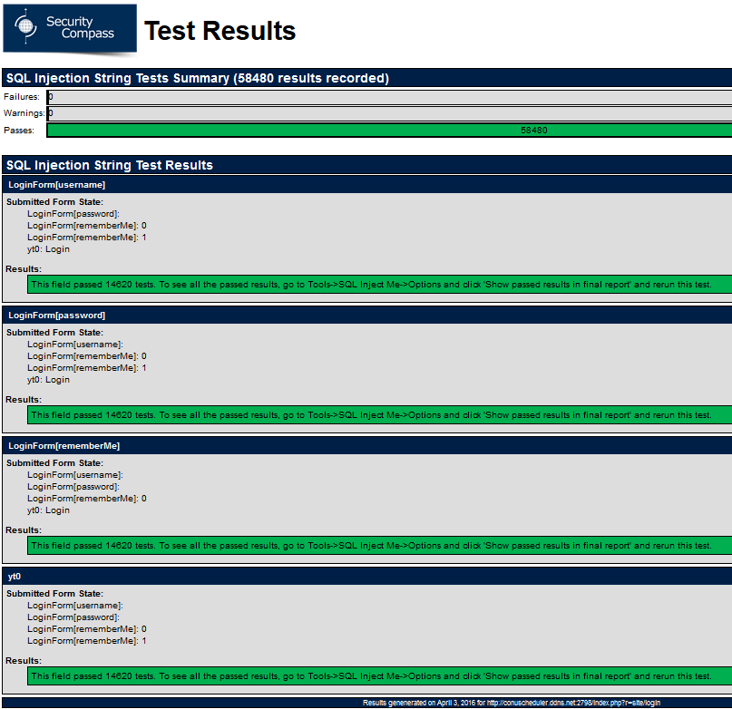

*Figure 3.2.2 SQL Inject Me tests on LoginForm*

SQL Inject Me PreferenceForm

The PreferenceForm passed all 292400 tests, as depicted in Figure 3.2.3.

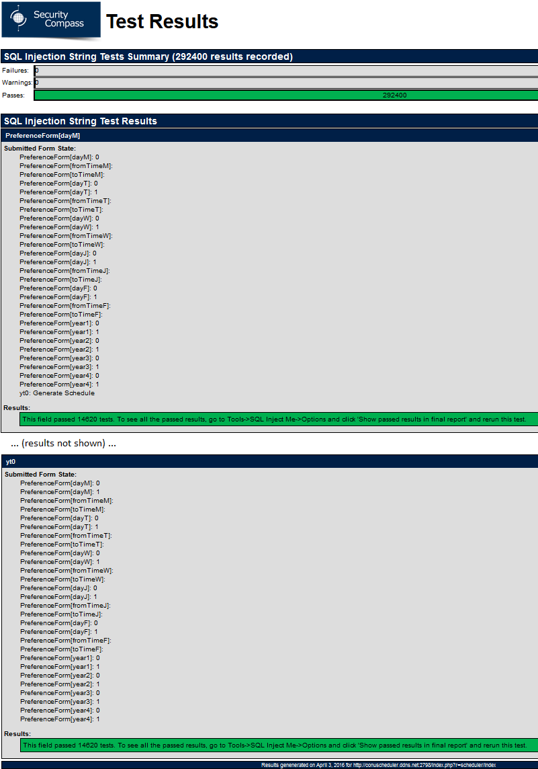

*Figure 3.2.3 SQL Inject Me tests on PreferenceForm*

Nikto results:

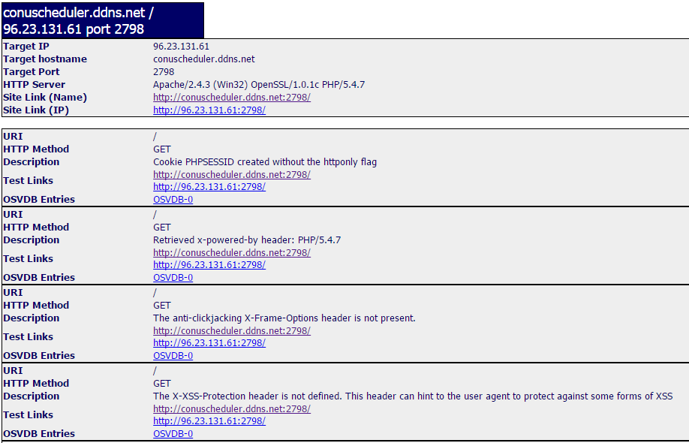

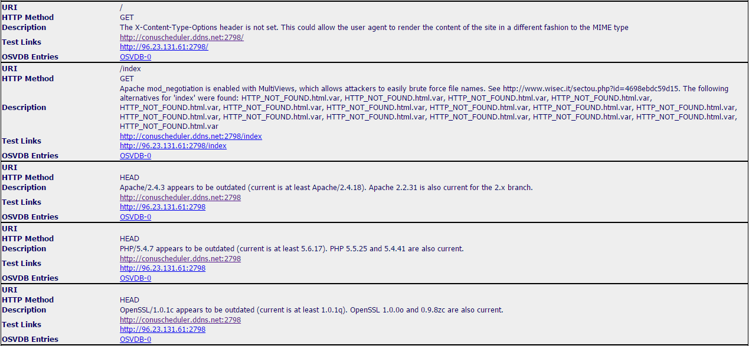

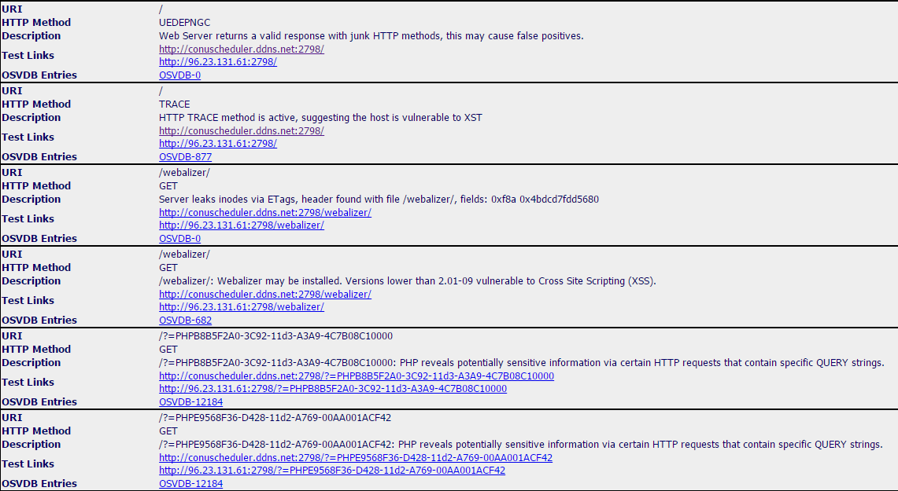

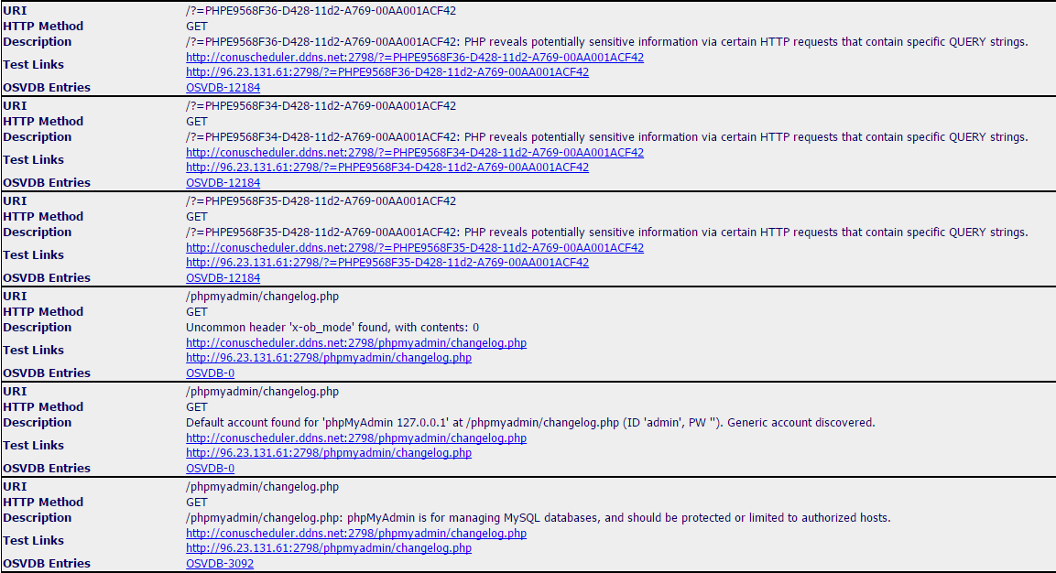

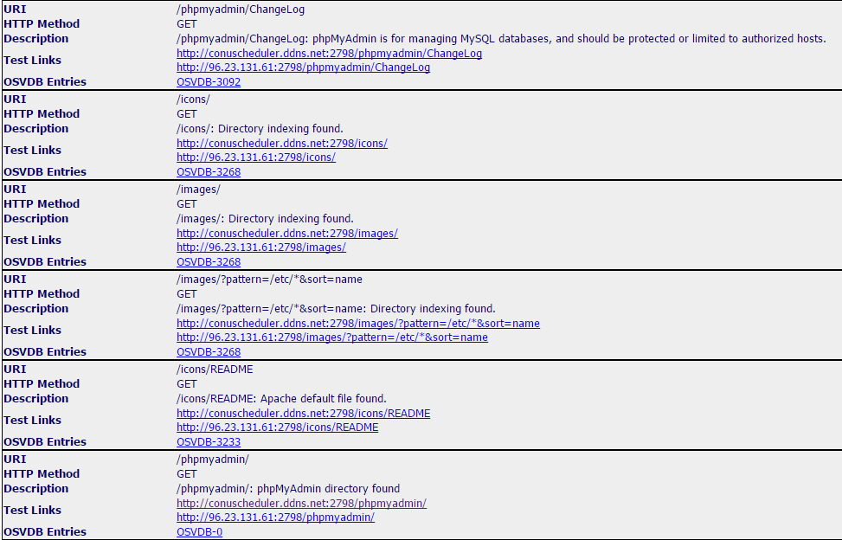

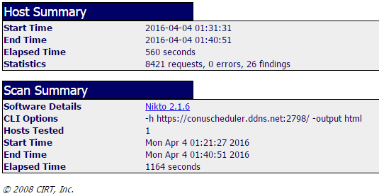

# System Delivery

## Installation Manual

Description

With this product, provided to clients as an archived or zipped folder, only a few simple steps are needed to install this on a client's server. The zip folder includes the root folder of the web application, the database file and Xampp program.

System requirements

* Minimum 2gb of ram
* Windows Vista or newer
* Database included with Xampp,.db file included in zipped folder

Installation steps

Step 1: Extract the timeturner.zip folder to your preferred location.

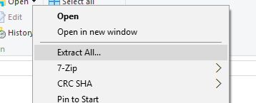

*Figure 4.1.1. Folder Extraction*

Step 2: Locate the ‘Xampp’ executable and install the program to your preferred location. No special changes made when installing, follow the installation steps

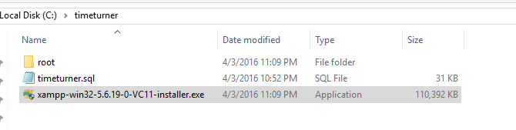

*Figure 4.1.2 Xampp location*

Step 3: Setup the Virtual Server

Step 3.1: Go to the installed ‘Xampp’ folder

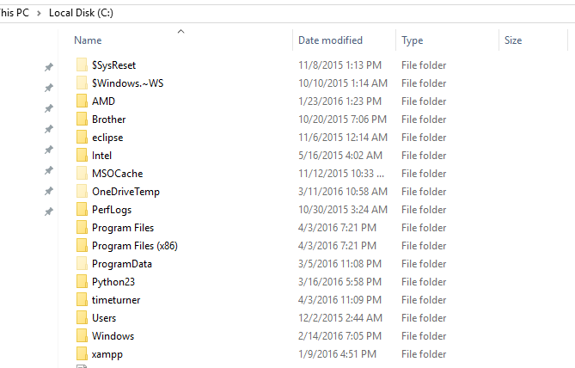

*Figure 4.1.3. Xampp folder location (last folder)*

Step 3.2: Go to the Apache folder

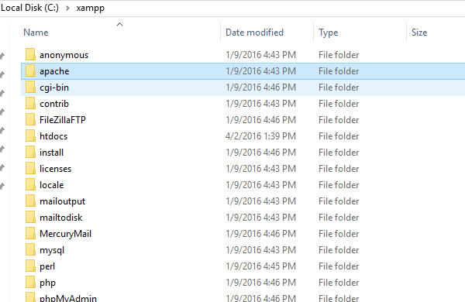

*Figure 4.1.4 Apache folder location*

Step 3.3: Locate conf folder in apache

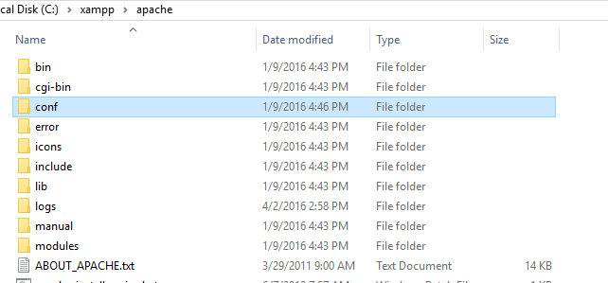

*Figure 4.1.5 conf folder location*

Step 3.4: Go to extra

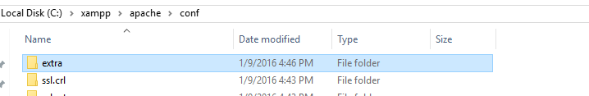

*Figure 4.1.6. Extra folder location*

Step 3.5: Open the httpd-vhost.conf file

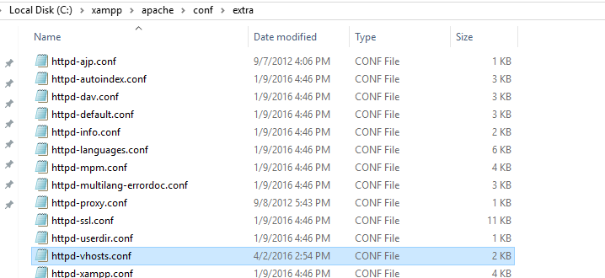

*Figure 4.1.7 httpd-vhost.conf file*

Step 3.6: Set up virtual server by including the appropriate lines of code provided and visualized in the next screen capture:

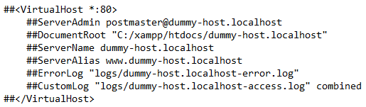

*Figure 4.1.8 Virtual server setup code*

Remove the hashtags from all the lines. The ServerName should be the name of the domain that will be used to access the application via URL. The ServerAlias allows to access the domain through a ‘www’ protocol. For example, if the preferred domain is ‘[www.mytimeturner.com](http://www.mytimeturner.com)’ the ServerName would be **mytimeturner** and the ServerAlias would be ‘[www.mytimeturner.com](http://www.mytimeturner.com)’. The DocumentRoot is the location of the web application root folder, which is provided in the zip folder of the application. The **root** folder provided in the zip file, should be extracted in the same location as the DocumentRoot location. Once provided with valid DocumentRoot location folder, extract the ‘root’ folder in that location.

Step 4: Redirecting windows hosts

Step 4.1: Once the virtual host is setup, the new domain name that was provided in the ServerAlias must be also setup in the Windows host file. To locate the Windows host file:

C:\Windows\System32\Drivers\etc\host.file

Step 4.2: Open the file and append the following lines:

127.0.0.1 [www.mytimeturner.com](http://www.mytimeturner.com)

*This simply tells the operating system to resolve the domain as the local machine. Of course,* [*www.mytimeturner.com*](http://www.mytimeturner.com) *should match exactly what was setup in the Virtual Host setup ServerAlias name. Save the file.*

**NOTE: Do NOT continue installation after this step until conducting installation testing (see Section 4.1.2).**

Step 5: Database Installation

Step 5.1: To install the database, a database file is provided in the ZIP folder called ‘timeturner.db.’ This file is to be extracted in phpmyadmin.

Step 5.2: At this point, we need to create a database in order to import the existing database file. Click on database, and create a database under the name: ‘timeturner’

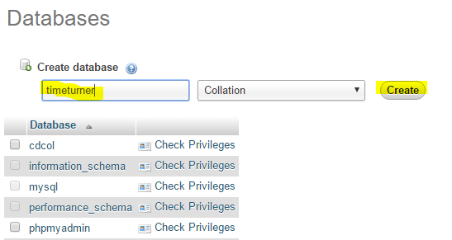

*Figure 4.1.9 Create database*

Step 5.3: Click on ‘Create’. This will create a new database that will appear on the left hand column where the rest of the databases are located. From here, the actual database needs to be imported in order for the application to run.

Step 6: Database Extraction

Step 6.1: To extract the database, click on the database name ‘timeturner’ on the left and then click on import.

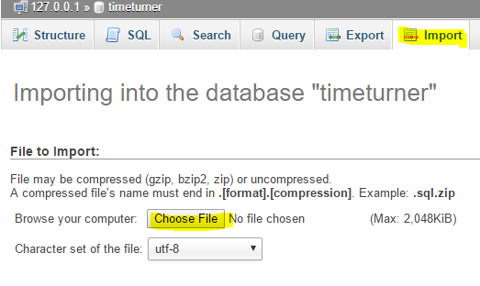

*Figure 4.1.10 Database extraction*

Step 6.2: Upload the ‘timeturner.sql’ file provided and then click on ‘Go’. At this point, all the data tables should appear in the timeturner database:

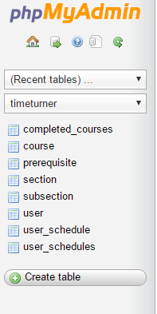

*Figure 4.1.11 Database tables*

Final Installation Testing

To run the application, open a web browser and type in the domain name provided earlier through ServerAlias, which in this case would be ‘[www.timeturner.com](http://www.timeturner.com)’

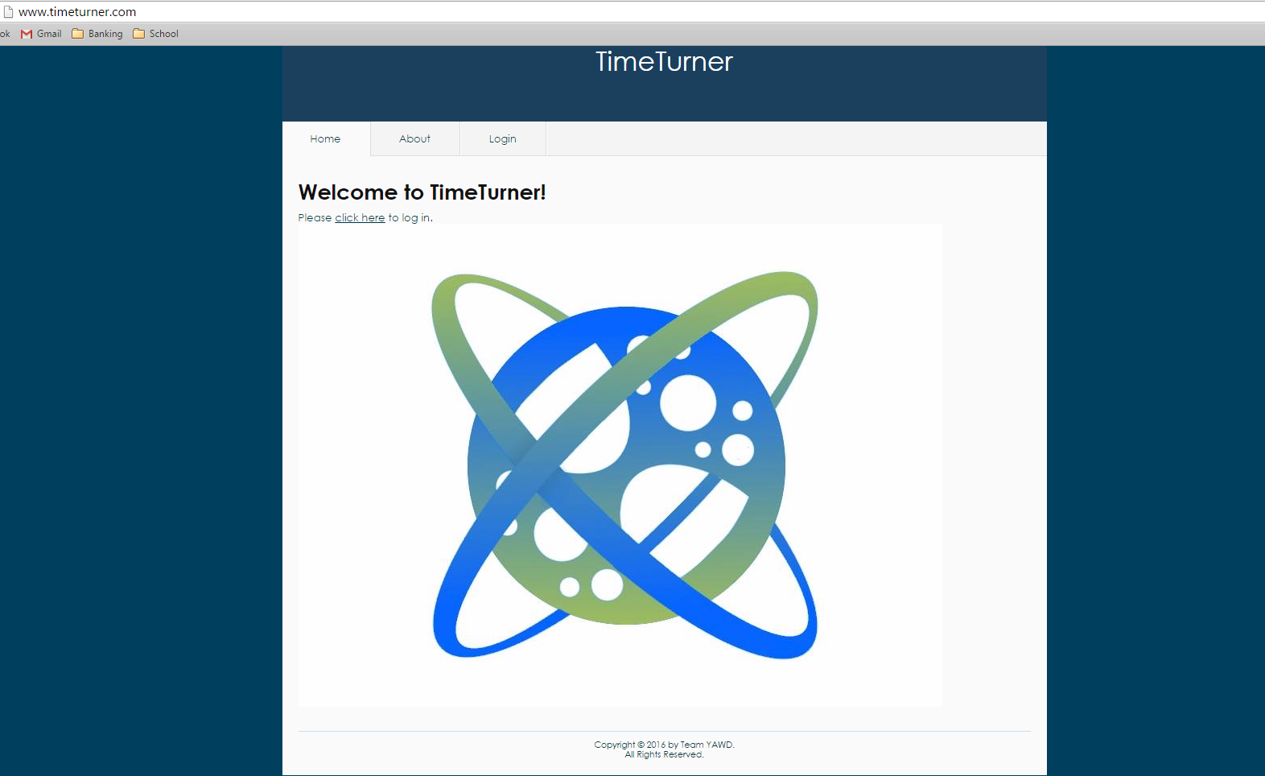

Virtual Server Installation Testing

In order to test if the virtual server was setup properly, locate the ‘XAMPP’ installation folder and locate the xampp-control.exe file:

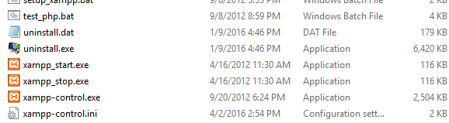

*Figure 4.1.12 xampp-control.exe file*

Once XAMPP runs, click on ‘Start’ on the Apache line. If the server was setup properly, the following should appear:

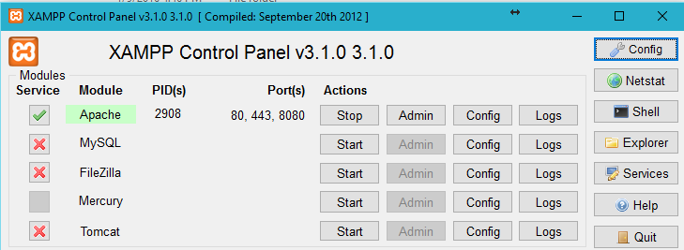

*Figure 4.1.13 Proper running of Xampp server*

A green indicator should appear on Apache.

Once the Apache server is setup, click on ‘Start’ for the MySQL line. Again, a green indicator light should highlight the MySQL. If the green light appears, click on ‘Admin’. This will open up phpmyadmin, a GUI provided by XAMPP for the MySQL database.

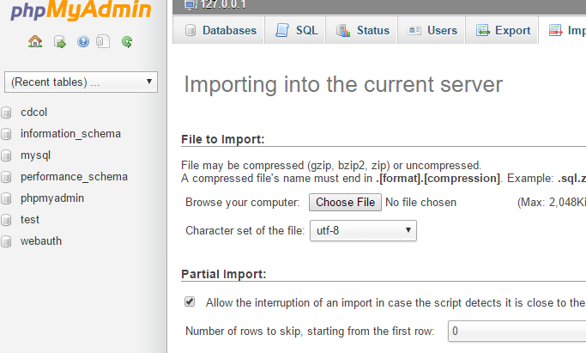

*Figure 4.1.14 phpmyadmin GUI*

## User Manual

Student Users

Login

To log in, head to the ‘Login’ tab from the main screen as outlined below and fill out the user information (see Figure . Finally, press the ‘Login’ button at the bottom, and if you wish for the browser to remember the identification, select the “Remember me next time” checkbox.

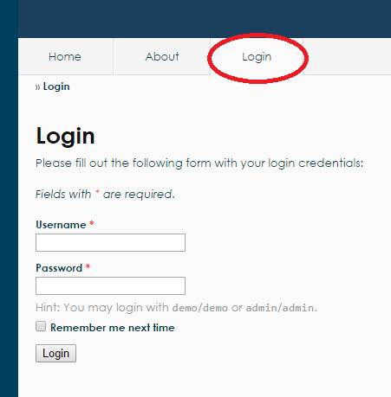

*Figure 4.2.1. Login tab when not logged into the system*

Logout

To log out, simply press the ‘Logout’ button as outlined below, and you will be redirected to the main page.

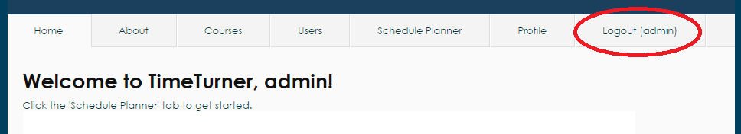

*Figure 4.2.2 Logout Tab when logged into the system*

Browse Course List

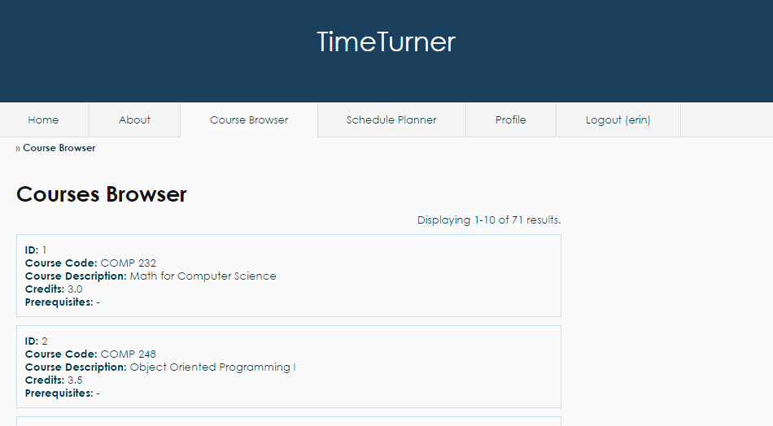

*Figure 4.2.2. Browse Course List functionality*

If the user wishes to view the list of all available courses, the user must click on the ‘Course Browser’ tab, and a list will be displayed in an interval of 10 courses (see Figure 4.2.3). To view more courses, the user may scroll down the page and click on the desired page or click ‘Next’ to view the next 10 courses (see Figure 4.2.4).



*Figure 4.2.3. View more courses*

Generate Schedule

Students can generate a schedule based on preferences. To do so, students may go to the ‘Schedule Planner’tab from the home page after logging in (see Figure 4.2.5).

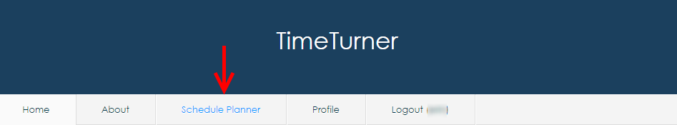

*Figure 4.2.5 Accessibility to the ‘Schedule Planner’ tab from the home page.*

Once the tab is selected, a set of preferences is displayed along with the ‘Generate Schedule’ button and a set of operations (see Figure 4.2.6).

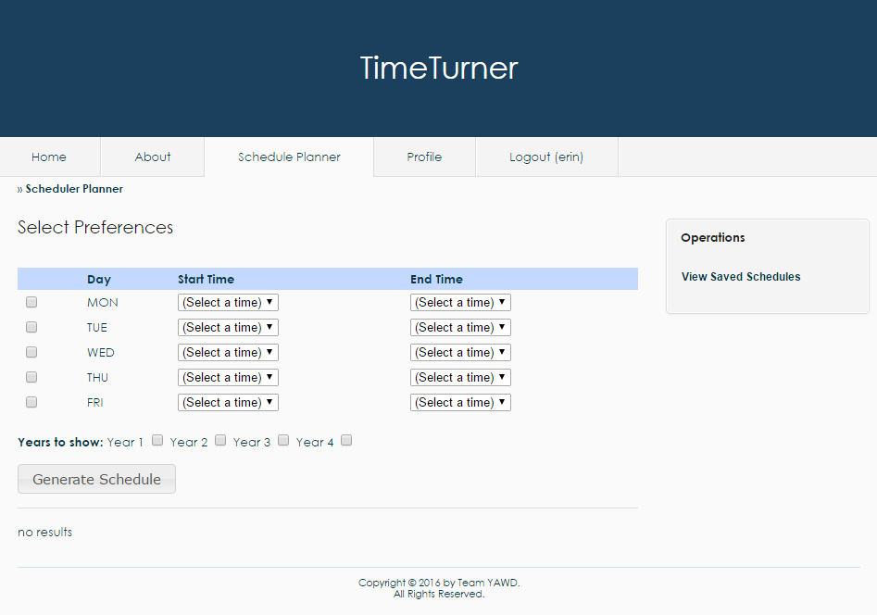

*Figure 4.2.6. Set of preferences displayed on the ‘Schedule Planner’ tab.*

The preferences include the starting and ending time at which the student would prefer having classes for each week day. Students can choose to apply the preference filters for the days desired by selecting the checkboxes corresponding to the day (see Figure 4.2.7).

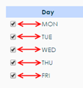

*Figure 4.2.7. Checkboxes corresponding to the day to be filtered.*

Students may then select the times at which they wish to start and end their courses by scrolling down and choosing the offered times from the drop-down menus (see Figure 4.2.8).

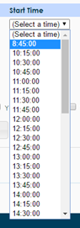

*Figure 4.2.8. Drop-down menu to select time preferences.*

Once the preferences are set, the year(s) to be displayed can be chosen by click the appropriate checkboxes (see Figure 4.2.9). The system will generate schedule based on the preferences only for the years selected.



*Figure 4.2.9. Academic years to be displayed according to the set preferences.*

The next step is then to generate the schedule by clicking the ‘Generate Schedule’button. A set of tabs, each representing an academic year, will be displayed on the bottom of the page. Each tab is divided into semesters. Every semester division contains a list of proposed lectures, tutorials and laboratories for all courses in the sequence that correspond to the time blocks selected (see Figure 4.2.10).

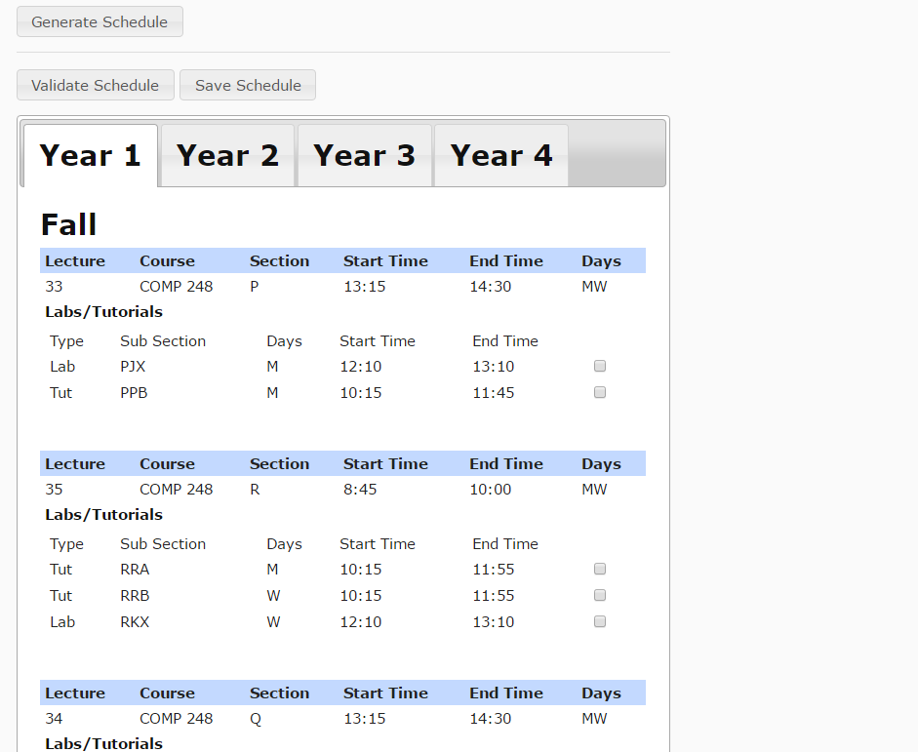

*Figure 4.2.11. Tabs representing each academic year selected with courses for each semester.*

All there is left to do is to choose the laboratory and tutorial times for each of the courses by selecting the checkbox corresponding to the desired sections (see Figure 4.2.12). Once sections are chosen, the student may click the ‘Validate Schedule’button to ensure that the times are consistent and that no overlapping occurs. *.* Note that the checkboxes for tutorials and laboratories of other lecture sections of the same course have been disabled when one lecture section has been selected.

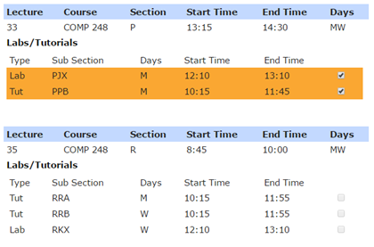

*Figure 4.2.12. Selection of the laboratory and tutorial sections*

Save Generated Schedule

While on Schedule Planner tab (located at the top of the page (See figure 4.2.13)), the Student may wish to save a schedule they have generated.

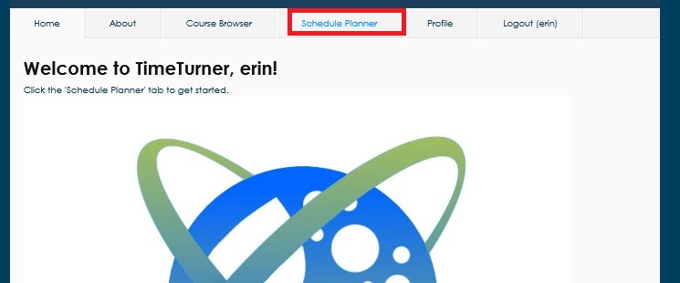

*Figure 4.2.13. Schedule Planner tab*

A schedule that adheres to the specifications requested in the preferences list must be generated firsts. After having generating the schedule for a specific year and selecting the section of choice, the schedule can be saved with the save schedule button (see Figure 4.2.14).

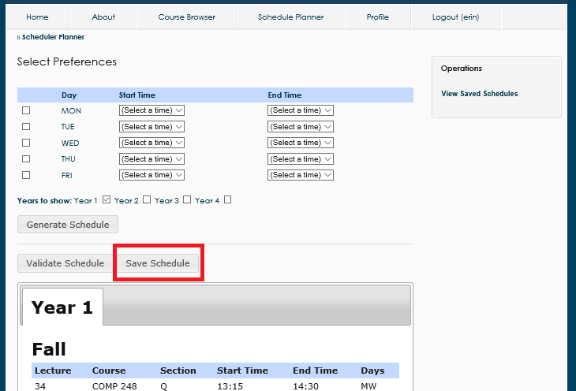

*Figure 4.2.14. Save Schedule button after generating a schedule and choosing tutorial and lab sections*

This will return a pop-up indicating confirmation that the schedule has been saved (see Figure 4.2.15).

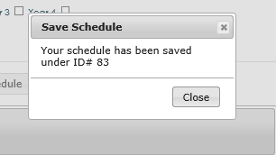

*Figure 4.2.15. Confirmation of a Saved Schedule*

View A Saved Schedule

Upon accessing the Scheduler Planner tab, generated a schedule and saved a schedule, the student may wish to view any schedules they have saved. In the operations box on the sidebar, there is a view saved schedules option (see Figure 4.2.16).

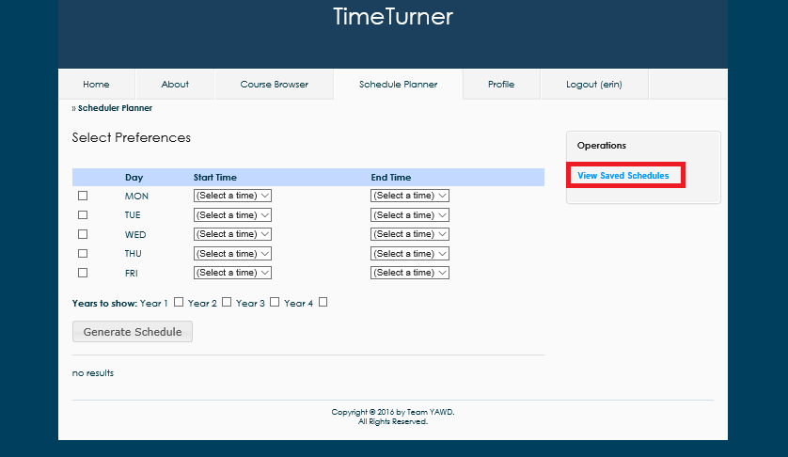

*Figure 4.2.16. View Saved Schedule option*

Upon clicking this option, a list of all saved schedules will be presented to the student. At this point they can view or delete a schedule (see Figure 4.2.17).

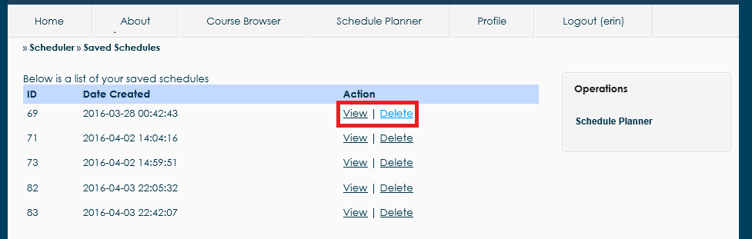

*Figure 4.2.17. Options to view or delete a schedule*

By clicking view, it returns the schedule for the given semester. By deleting it, the system asks for confirmation of deletion and then removes the schedule from the list of saved schedules (see Figure 4.2.18).

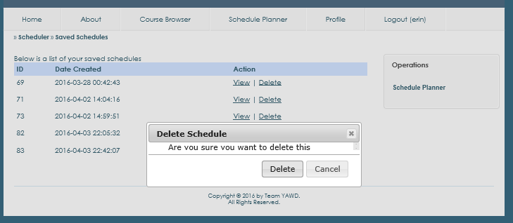

*Figure 4.2.18. Delete a schedule confirmation box.*

Drop Course

A student that is logged in the system and has at least one saved schedule containing at least one course has the option to drop a course. They can do so by clicking on the “View Saved Schedules” option in the Schedule Planner tab. The option appears on the right hand side of the Schedule Planner page (see Figure 4.2.19).

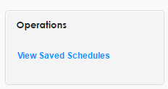

*Figure 4.2.19. View Saved Schedules operation*

A page displaying all currently saved schedules for the student is displayed. To choose the schedule from which a course will be dropped, the “View” option should be selected. It appears to the right of each saved schedule (See Figure 4.2.20).

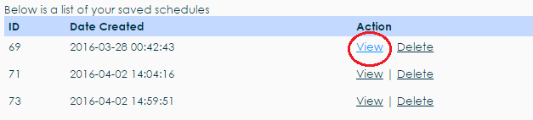

*Figure 4.2.20. View Saved Schedule action*

The selected saved schedule will load, displaying all courses that are currently in that schedule. Each course has a “Drop” option to the right of the number of credits (see Figure 4.2.21).

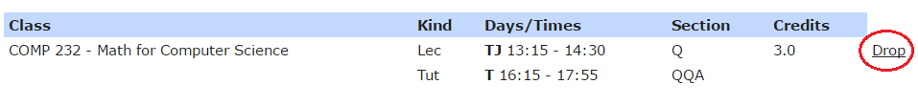*Figure 4.2.21. Drop Course action*

A dialog box prompting the user to confirm their choice will appear after clicking the Drop button. To successfully drop the selected course, the “Delete” button on the left will confirm the deletion of that course from the selected saved schedule (see Figure 4.2.22). If the student changes their mind, the cancel button will cancel the operation and the course is not dropped from the schedule.

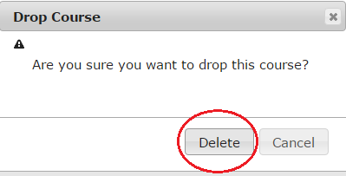

*Figure 4.2.22. Confirmation dialog box*

View Academic Record

A student wishing to view their academic record and/or GPA may do so from the ‘Profile’ tab (See Figure 4.2.23).

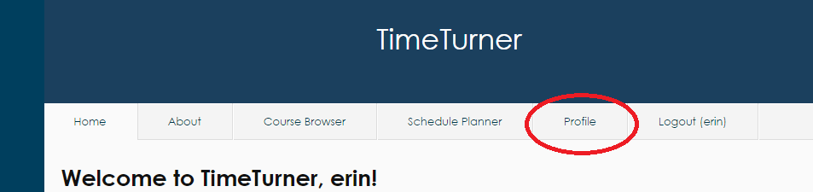

*Figure 4.2.23. Profile Tab located second from right at the top of the screen*

Once on the ‘Profile’ page, the student may click on the ‘View Academic Record’ displayed at the far right of the page (see Figure 4.2.24). Clicking this link will result in the display of all classes that the student has completed, as well as their grades for each course, and their GPA.

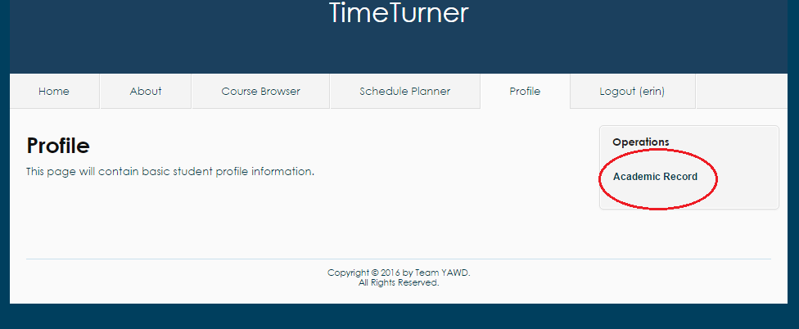

*Figure 4.2.24. Academic Record link in ‘Operations’ on far right of ‘Profile’ screen*

Administrator Users

Login

Administrators are simply privileged users. As such, logging in as an Administrator is performed much as logging in as a student. See section 4.2.1.1.

Logout

Administrators are simply privileged users. As such, logging in as an Administrator is performed much as logging in as a student. See section 4.2.1.2.

Manage Courses (Administrator)

An administrator that is logged in the system will have the option to manage courses. This option is found in the Courses tab, on the right hand side of the page (see Figure 4.2.25).

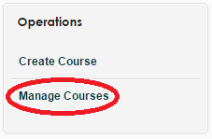

*Figure 4.2.25. Manage Courses operation*

Clicking the manage courses option will display the manage courses page. There are many possible actions for the administrator to take from here.

Search User

If the Administrator wishes to manage a specific course, the search bars above the table containing all the courses may be used to search for a course (see Figure 4.2.26), or the “Advanced Search” setting may be used (see Figure 4.2.27).

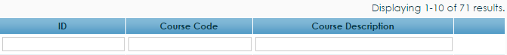

*Figure 4.2.24. Course search bars*

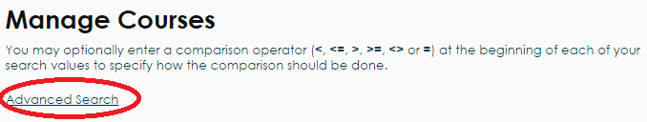

*Figure 4.2.27. Advanced search setting*

The advanced search setting will display two search bars on the page which will accept a course I.D. and/or course code to search the system (see Figure 4.2.28). Clicking the search button will perform the search.

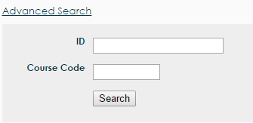

*Figure 4.2.28. Advanced search bars*

Once a course is searched and found, the administrator has the options of viewing, editing or deleting the course. These options can be seen on Figure 4.2.29, in the respective order.

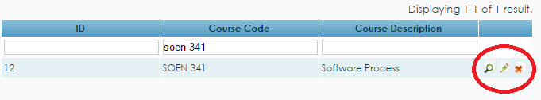

*Figure 4.2.29. View, edit, and delete buttons*

View Course

The view option will produce a page that displays the details of the course, including course I.D., course code, and course description (see Figure 4.2.30)

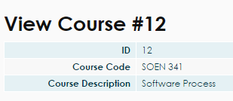

*Figure 4.2.30. View course table*

Edit Course

The edit function is selected by clicking the pencil icon to the right of the view button. Clicking the edit button will produce the update course page, which can edit the course code, description, number of credits, and type of the course (see Figure 4.2.31). Any changes made will be finalized by clicking the “Save” button below the editing boxes.

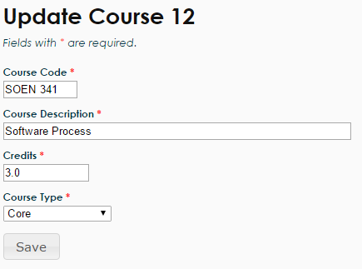

*Figure 4.2.31. Update course boxes*

Delete Course

The final operation that an administrator can do to manage a course is to delete a course, which can be performed by clicking the red “X” button to the right of the update course icon. Clicking the X icon will produce a dialog box that prompts the administrator to confirm their decision. To confirm their choice, the “OK” button should be pressed and the course will be deleted from the course bank (see Figure 4.2.32). If the administrator does not want to delete the course, they can simply press the cancel button or exit the dialog box.

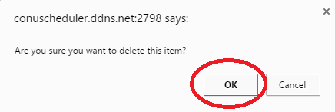

*Figure 4.2.32. Confirmation dialog box for course deletion*

Create Course

An administrator may wish to create a course to add to the database of courses that students can take. In order to do so, the administrator must first click on the ‘Courses’ tab to find themselves on the courses database page (see Figure 4.2.33). From here, the administrator must click the ‘Create Course’ link located on the far right of the page; this action will display the course creation page (see Figure 4.2.34).

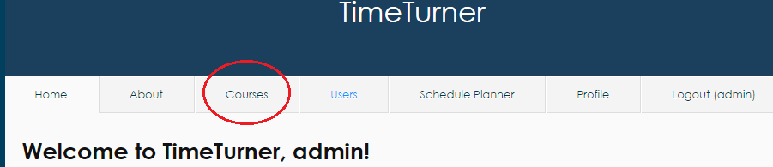

*Figure 4.2.33. Courses tab on top of page when logged in as Administrator*

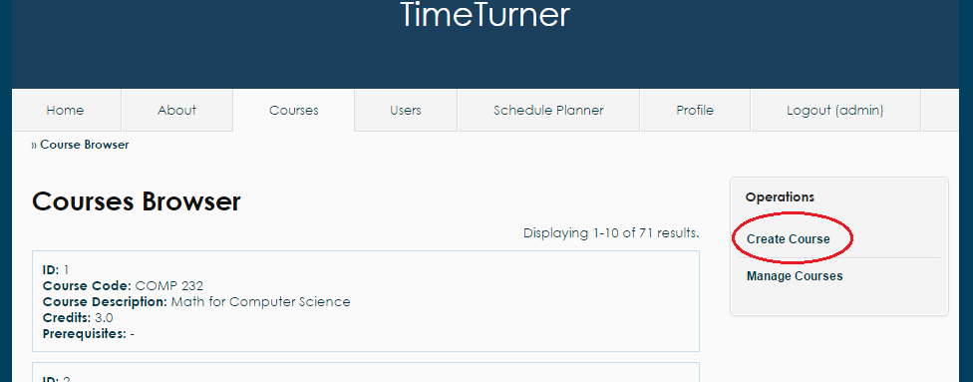

*Figure 4.2.34. Create course link on far right of Course Browser page*

This page will ask for the course code, the course description, and the amount of credits awarded by the course (see Figure 4.2.35 for example input). Once the administrator enters the appropriate course information, the system will log such information in the database, and the course information for the newly created course will be displayed on screen, along with the course’s newly assigned ID.

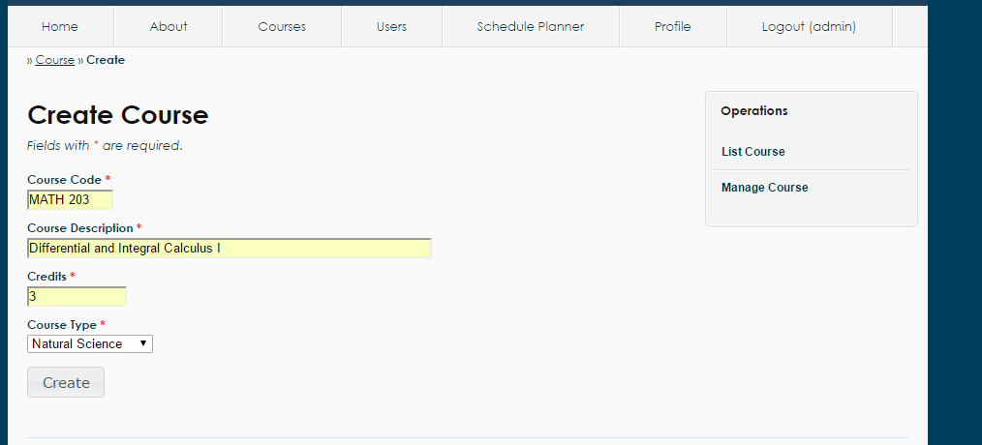

*Figure 4.3.35. Sample input for Create Course functionality*

Browse Courses

While logged in, the administrator may wish to view the database of courses in the system. To accomplish this, the administrator may simply click on the Courses tab; this will cause the list of all courses to be displayed on screen (see Figure 4.2.33). Courses are grouped by page, 10 to a page. If the administrator wishes to view more courses, he may scroll down to the bottom of the page and click on the desired page number.

While on the Courses tab, the administrator may navigate away by clicking the two links located in the ‘Operations’ box to the right of the page: Create Course and Manage Course. Clicking these links will bring the administrator to those respective pages where other activities and actions may be carried out.

If the administrator wishes to view the prerequisite information of a course, he may simply click on the name of the prerequisite to that course (see Figure 4.2.36). Clicking on the name of the prerequisite will display the course information of the prerequisite.

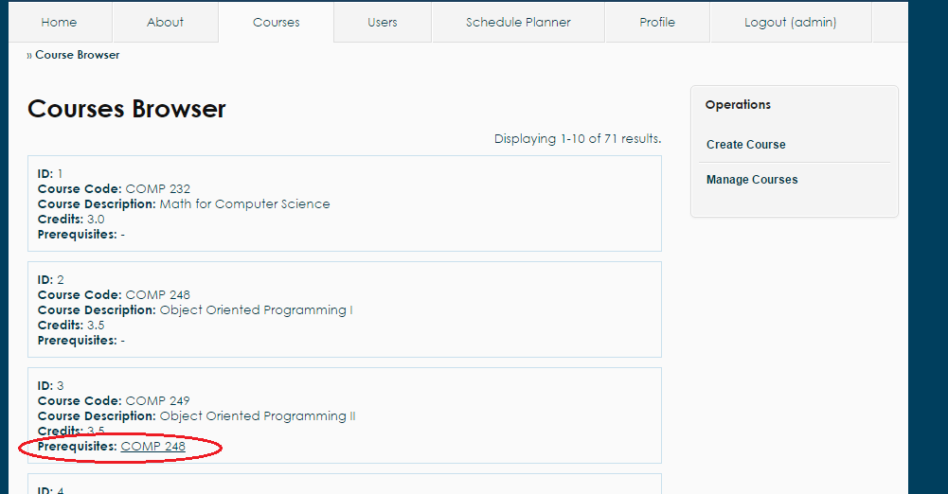

*Figure 4.2.36. Prerequisites for each Course located in the course information box*

Add User

Once logged in, the administrator can add a new user into the system by first clicking on the ‘Users’ tab.

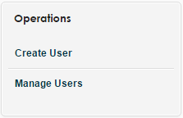

*Figure 4.2.37. Create user operation*

A new page will be loaded, displaying a list of users. On the right side menu, clicking on the ‘Create User’ link (see Figure 4.2.37) will redirect the administrator to another page where information about the new user can be entered. (see Figure 4.2.38).

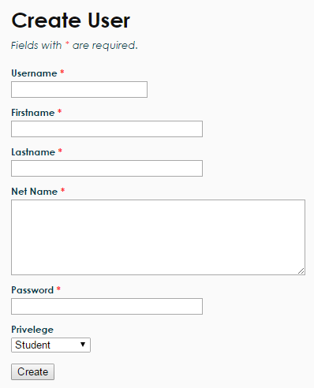

*Figure 4.2.38. Create user form*

All fields of the form must be completed to be valid. The password must be at least 6 characters long and this will be the password used to log into the system for the user, along with the username. The privilege options allow the administrator to select whether the new user is a student or an administrator.

Upon completing all fields of the form, the administrator may click on the ‘Create’ button at the bottom to submit it. If the user was successfully created, the newly created user’s information will be displayed on another page to the administrator, along with an ID number (see Figure 4.2.39).

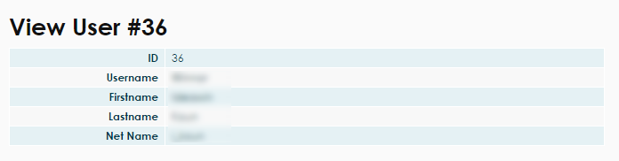

*Figure 4.2.39. View the newly created user’s information*

Manage Users

When logged in as an administrator, users of the system can be managed. More precisely, search can be conducted on the system in order to find one or more specific users; information about those users can be viewed and updated, and users can be deleted through this managing section.

In order to manage users, the administrator must first go to the ‘Users’tab from the home page (see Figure 4.2.40).

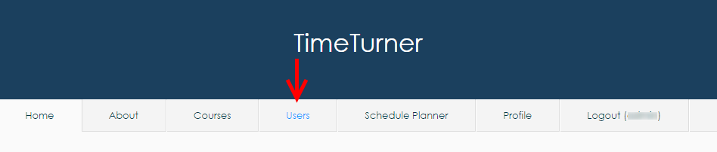

*Figure 4.2.40. ‘Users’ tab from the main menu when logged in as an Administrator*

The administrator will then see a list of users on the system, along with a list of operations that the administrator is allowed to perform. To access the user management page, the administrator must click on the ‘Manage Users’operation (see Figure 4.2.41).

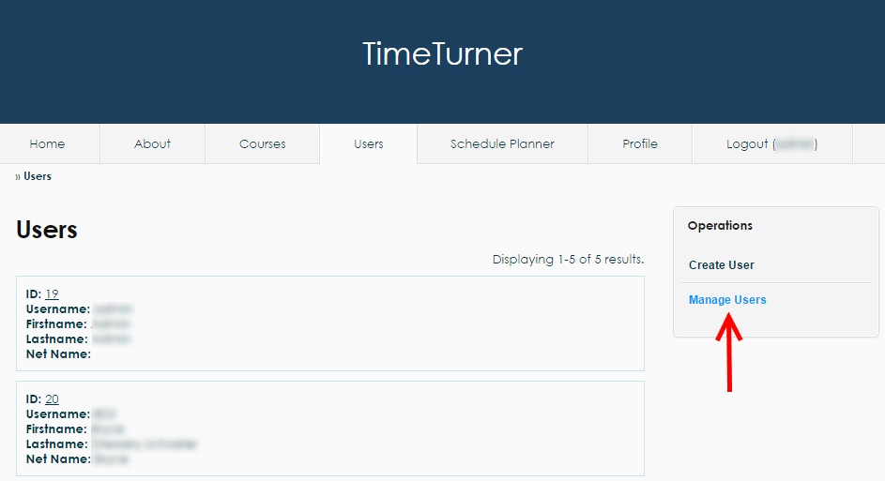

*Figure 4.2.41. ‘Manage Users’ operation found on the ‘Users’ tab*

The administrator should then land on the user management page where multiple search operations are presented with a default search result containing a list of editable users (see Figure 4.2.42).

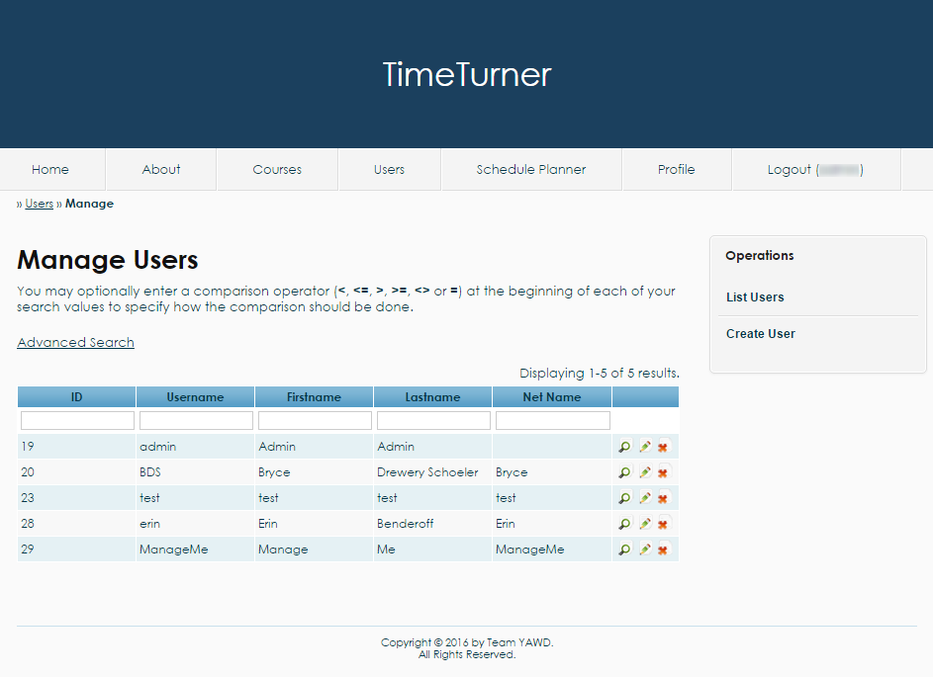

*Figure 4.2.42. User management page with a default table of users*

The following next operations will be performed from the user management page.

Search for Users

From the user management page, users can be found using the textboxes located on the second row of the table of users. For instance, if an administrator is looking for the user whose ID is 29, the ID number would be typed on the textbox in the ‘ID’ column (see Figure 4.2.43).

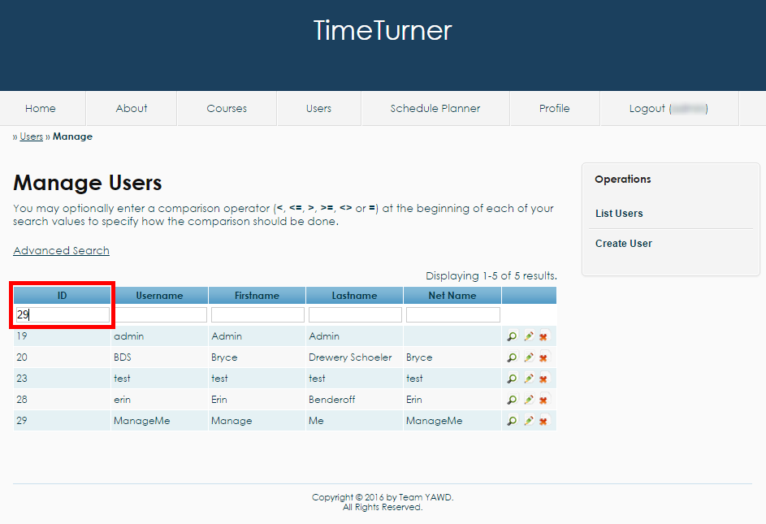

*Figure 4.2.43 Entering the desired search criteria in the corresponding textbox*

Once the field is completed, the administrator can press ‘enter’ or simply click outside of the textbox to refresh the search table. As a result, the user with the matching ID will be displayed on the table (see Figure 4.2.44). If no users have been found to match the search criteria, the table of users will be replaced with a message indicating that no results have been found.

Note that many criteria can be entered in the various textboxes. In such case, the table will reload every time a textbox is out of focus or the key ‘enter’ is pressed. Also, comparison operators can be used in those textboxes, for example to filter all users having an ID less than 30. Another feature is that all search fields except for ID based on a ‘contains’ relationship, so for example, if we are looking for all usernames containing the letter ‘t’, ‘t’ could be written in the username search field. The search is also case insensitive.

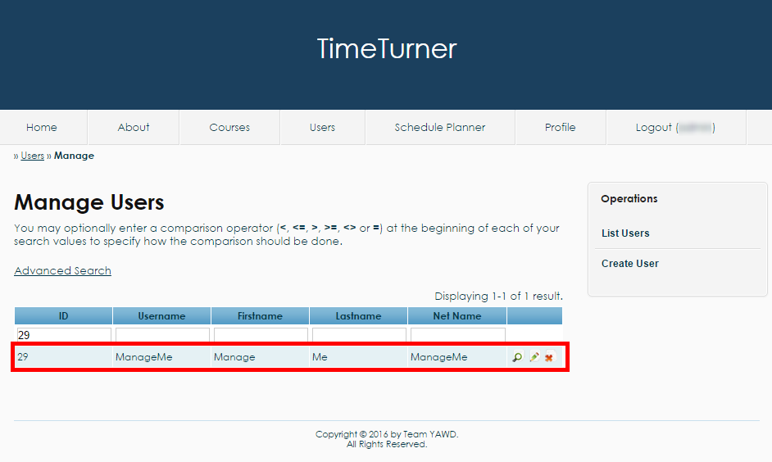

*Figure 4.2.44 Result of the simple search by ID*

Advanced Search for Users

An administrator may decide to perform an advanced search if many criteria are to be used in the search, and the administrator does not wish the table to constantly refresh. To do so, the administrator may click on the ‘Advanced Search’ link (see Figure 4.2.45).

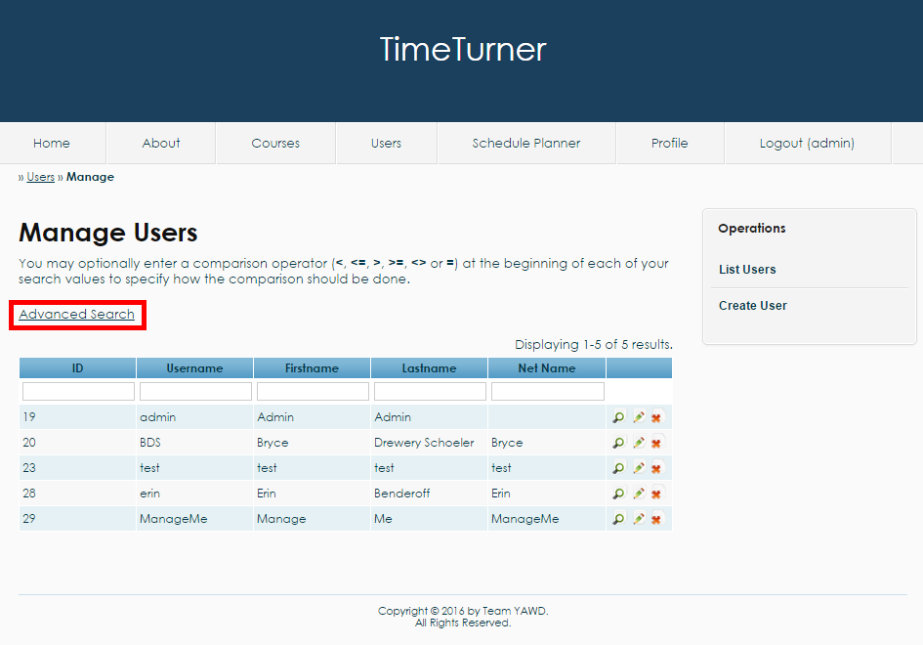

*Figure 4.2.45. The ‘Advanced Search’ link*

An advanced search form should appear once the link has been clicked. The form allows the administrator to look for a user using a combination of multiple criteria by filling up the fields that the administrator wishes to use (see Figure 4.2.46).

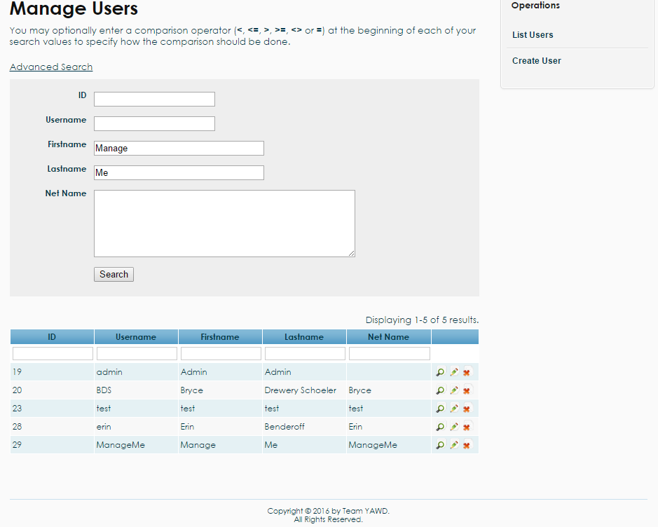

*Figure 4.2.46 Usage of the advanced search fields*

Once all the criteria have been entered, the administrator can hit the ‘search’ button at the bottom of the advanced search form. A table should be loaded with the user(s) that match the criteria (see Figure 4.2.47). Notice also that the search criteria have been copied into the textboxes for the simple search for clarity.

Like the simple search, the advanced search textboxes support comparison operators and will also display a message that no results have been found if the system fails to find a user based on the specified criteria. The searches are also based on a ‘contains’ relationship, meaning that all users which search field(s) contain the search criteria will be displayed. The text entered in the search fields are case insensitive.

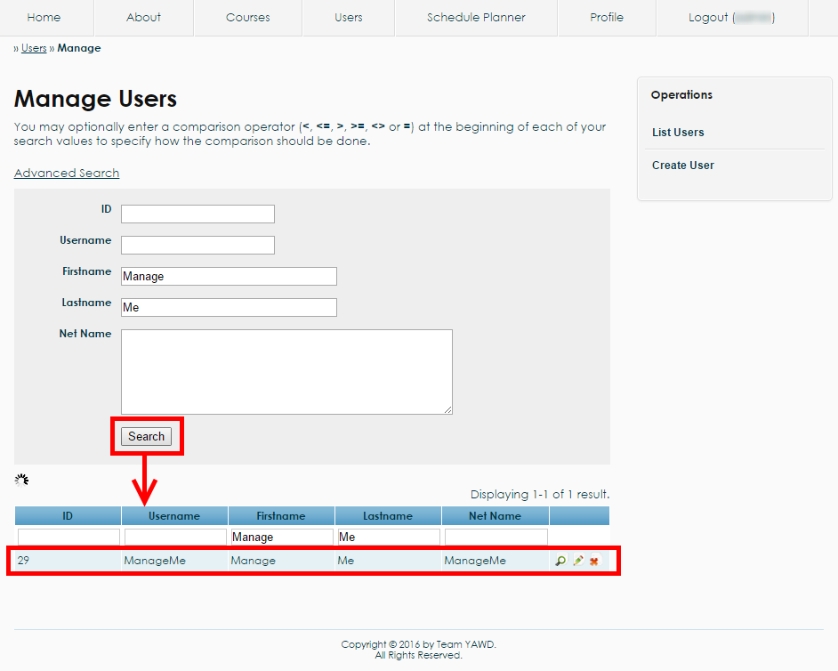

*Figure 4.2.47. Post-advanced search results*

View User

Whenever a table of users is displayed, the administrator may decide to view the profile of a user. To consult the profile of a user, the administrator may click on the magnifying glass found on the right of row corresponding to the user (see Figure 4.2.48).

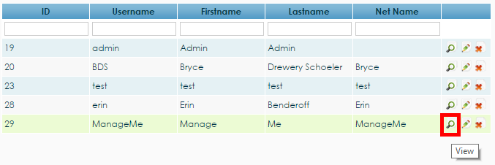

*Figure 4.2.48. The view magnifying glass corresponding to the user 29 allowing administrators to consult the profile of this user*

Once the magnifying glass has been clicked, the profile of the user should be displayed among with a list of available operations that will be discussed in the following sections (see Figure 4.2.49).

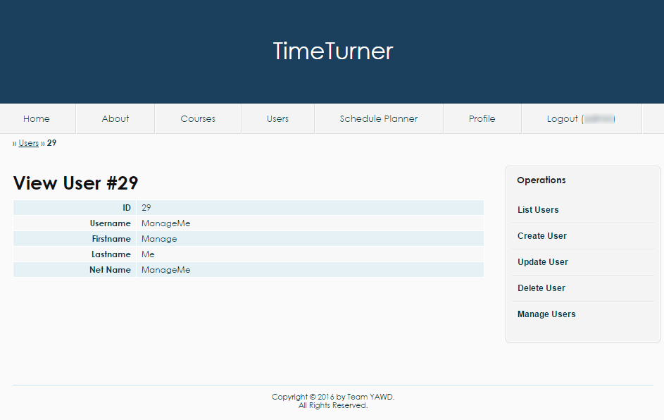

*Figure 4.2.49 The profile of a user with a set of operations on the right*

Update User

Users’ information can be updated through the user management page. More precisely, updating users’ information can be either be done through the table of users, or through consulting the profile of a user.

To update a user’s information through the table of users, the pencil button found on the right of the row corresponding to the user to be updated should be clicked (see Figure 4.2.50).

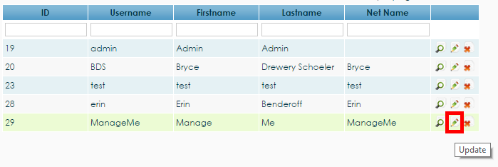

*Figure 4.2.50 Pencil button to update the user 29*

To update a user’s information through the user’s profile view, the administrator needs to choose the ‘Update User’ operation from the list of operations found on the left of the page (see Figure 4.2.51).

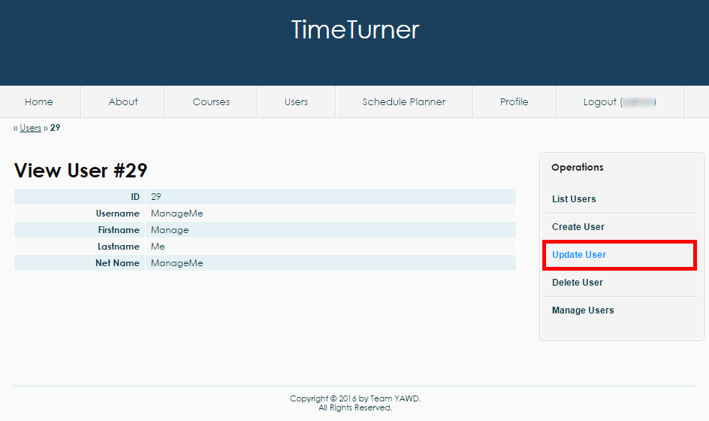

*Figure 4.2.51 The operation ‘Update User’ found on the user’s profile page view by an administrator*

From either method, the ‘Update User’ page should now be displayed. The page contains a form which fields are completed with the user’s current information. The administrator can decide to change any of those field and save the changes by clicking the ‘Save’ button (see Figure 4.2.52).

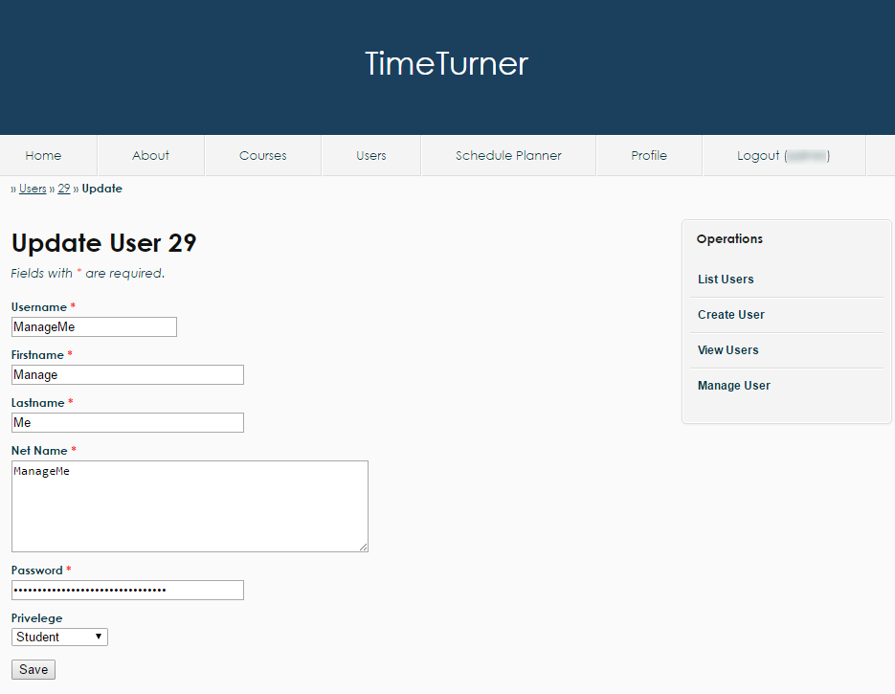

*Figure 4.2.52. The ‘Update User’ page having fields that contain the user’s initial information and that can be modified by the administrator once the ‘Save’ button has been clicked*

Once the save button has been clicked, the updated profile of the user should be displayed. Otherwise, some conditions about the fields might have been violated and the administrator needs to correct those violation before updating the user.

Delete User

The administrator also has the power to delete a user through the user management page. Once again, deleting a user can be done either through the table of users or through the profile of the user.

To delete a user using the table of users, the administrator should click the ‘X’ button found on the same row as the user to be deleted (see Figure 4.2.53).

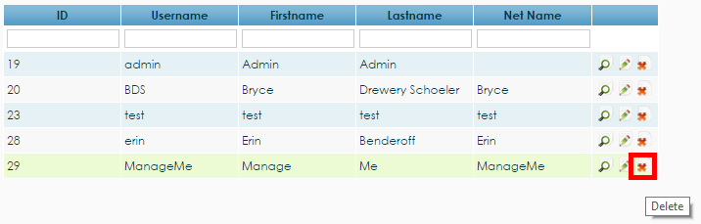

*Figure 4.2.53. The ‘X’ button to delete user 29*

To delete a user through the user’s profile page, the operation ‘Delete User’ should be clicked from the list of operations found on the right (see Figure 4.2.54).

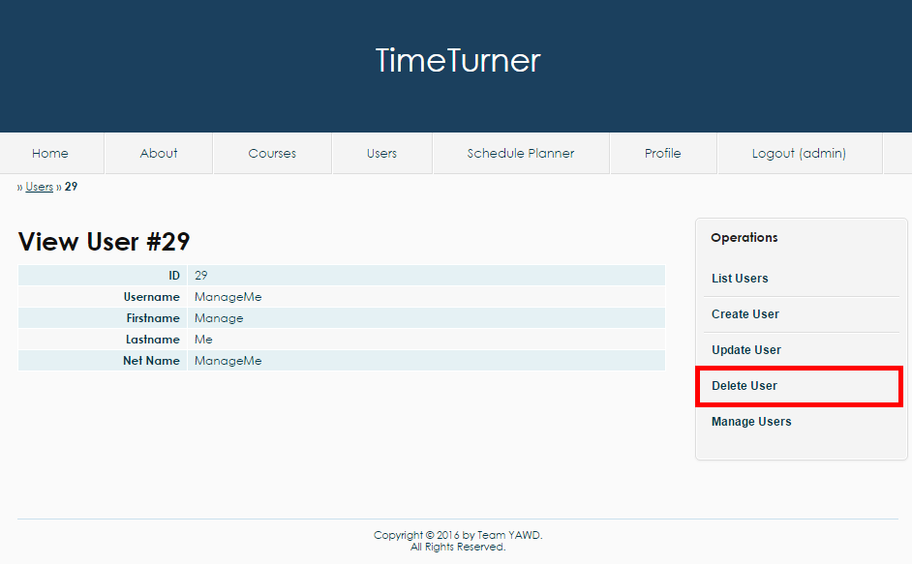

*Figure4.2.54. The operation ‘Delete User’ on the user’s profile page viewed by an administrator*

When either the ‘X’ button or the ‘Delete User’ operation is clicked, a message should pop up to confirm the administrator’s decision (see Figure 4.2.55).

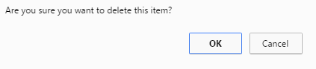

*Figure 4.2.55. Confirmation by the system to delete a user*

The administrator should press the ‘OK’ button on the confirmation box to delete the user. Once deleted, the administrator will be brought back to the user management page with an updated table of users.

Viewing Users

An administrator can view all users currently in the database. To do so, he/she can select the user’s tab from the home page, once they have logged in (shown in Figure 4.2.56)

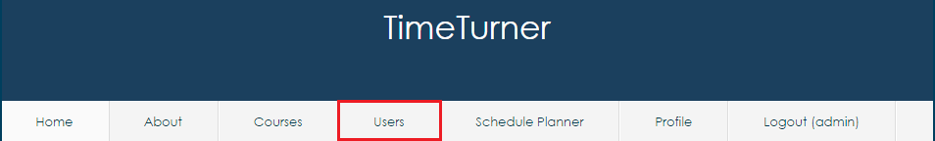

*Figure 4.2.56: Accessibility to the ‘User’ tab from the home screen*

Once the tab has been selected, all the users will be displayed on screen. The users are sorted by ID and displayed are each user’s specific credentials, such as, first and last name and their net names (shown in figure 4.2.57)

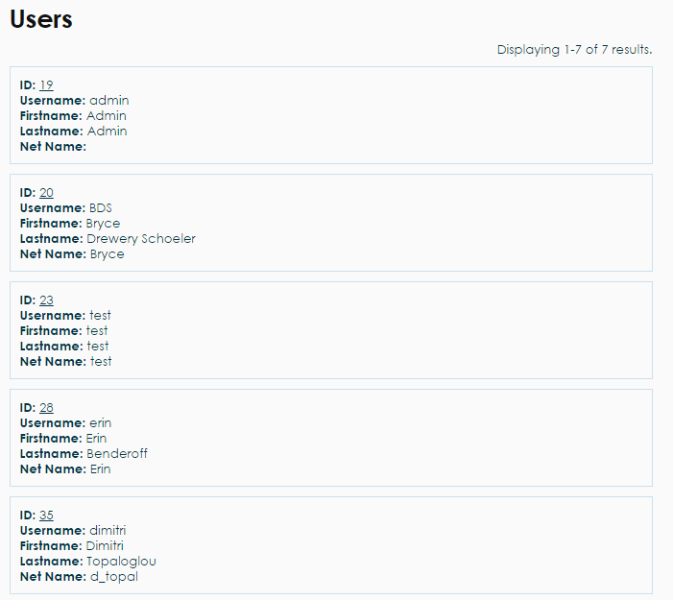

*Figure 4.3.57. All users displayed on the ‘User’ tab*

# Final Cost Estimation

Final Estimations

Deliverable 0 Estimation

|  |  |  |  |
| --- | --- | --- | --- |
| **Task Names** | **Cost (Hours)** | **Revised Cost (Hours)** | **Final Cost (Hours)** |
| Domain Model | 6 | 6 | 6 |
| Identification of Technologies | 12 | 12 | 12 |
| Team Members | 0.5 | 0.5 | 0.5 |
| Implementation Discussion | 5 | 5 | 5 |
| DMO Descriptions | 6 | 6 | 6 |
| **Total** | **29.5** | **29.5** | **29.5** |

Deliverable 1 Estimation

|  |  |  |  |
| --- | --- | --- | --- |
| Task Names | Cost (Hours) | Revised Cost (Hours) | Final Cost (Hours) |
| Requirements | 10 | 10 | 36 |
| Use Case Diagrams/Models | 8 | 8 | 20 |
| Resources | 5 | 5 | 8 |
| Scope | 5 | 5 | 8 |
| Architecture | 7 | 7 | 15 |
| Learning Technologies | ---- | ---- | 137.85 |
| **Total** | **35** | **35** | **224.85** |

Deliverable 2 Estimation

|  |  |  |  |
| --- | --- | --- | --- |
| Task Names | Cost (Hours) | Revised Cost (Hours) | Final Cost (Hours) |
| Programming Architecture | 100 | 116.4 | 125.5 |
| Subsystem Specification | 50 | 33.95 | 43.95 |
| Dynamic Design Scenarios | 25 | 29.1 | 30 |
| Estimation | 15 | 9.7 | 8.44 |
| Prototyping and Risk | **----** | 4.85 | **5** |
| **Total** | **190** | **194** | **212.89** |

Deliverable 3 Estimation

|  |  |  |  |
| --- | --- | --- | --- |
| Task Names | Cost (Hours) | Revised Cost (Hours) | Final Cost (Hours) |
| Execute Test Cases | 30 | 29.1 | 29.1 |
| Debugging/Optimizing code based on test cases | 15 | 29.1 | 30 |
| User Performance Test | 20 | 33.95 | 35 |
| Security and Stress Testing | 10 | 4.85 | 4.47 |
| **Total** | **75** | **97** | **98.57** |

Deliverable 4 Estimation

|  |  |  |  |
| --- | --- | --- | --- |
| Task Names | Cost (Hours) | Revised Cost (Hours) | Final Cost (Hours) |
| Review and Edit past work | 20 | 29.1 | 29.1 |
| Compiling data into one file | 30 | 9.7 | 9.7 |
| Final Test on System | 10 | 9.7 | 9.7 |
| **Total** | **60** | **48.5** | **48.5** |

Final Estimations

|  |  |  |  |
| --- | --- | --- | --- |
| **Deliverable Names** | **Cost (Hours)** | **Revised Cost (Hours)** | **Final Cost (hours)** |
| Deliverable 0 | 29.5 | 29.5 | 29.5 |
| Deliverable 1 | 35 | 35 | 224.85 |
| Deliverable 2 | 190 | 194 | 212.89 |
| Deliverable 3 | 75 | 97 | 98.57 |
| Deliverable 4 | 60 | 48.5 | 48.5 |
| **Total** | **389.5** | **404** | **614.31** |

|  |  |  |  |  |  |  |  |  |  |  |  |  |
| --- | --- | --- | --- | --- | --- | --- | --- | --- | --- | --- | --- | --- |
|  | Claudia | Dimitri | Daniel | Lori | Erin | Bryce | Aline | Philip | Ideawin | Ryan | Marc | Kevin |
| Deliverable 1 | 19.3 | 27 | 20 | 22 | 19 | 20 | 16.4 | 16.15 | 14 | 16 | 20 | 15 |
| Deliverable 2 | 23.06 | 34 | 22 | 11.6 | 11.5 | 15 | 19.6 | 12.13 | 15 | 20 | 15 | 14 |
| Deliverable 3 | 9.7 | 8 | 12 | 11.3 | 14.67 | 10 | 5.4 | 8.3 | 7 | 5 | 10 | 5.5 |

Updated Gantt Chart

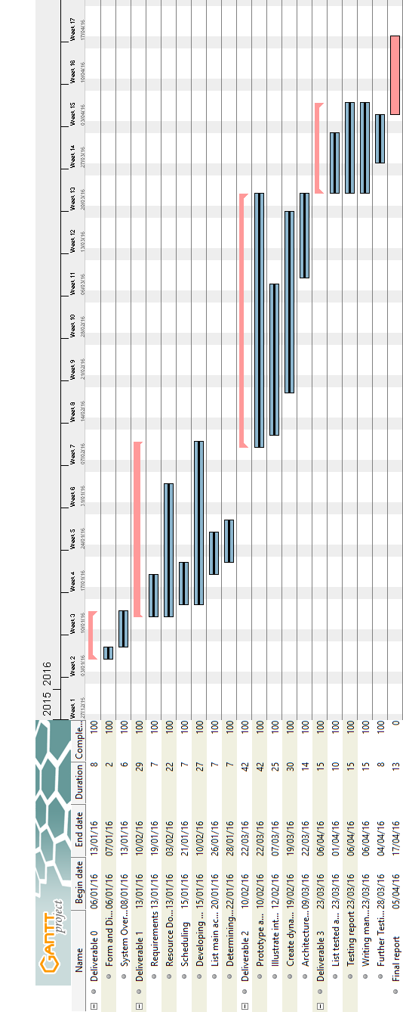

*Figure 5.2.1 Updated Gantt chart*